PL100867

Ontario Municipal Board
Commission des affaires municipales de l’Ontario
ISSUE DATE:

April 5, 2012

IN THE MATTER OF subsection 34(19) of the Planning Act, R.S.O. 1990, c. P.13, as amended
Appellant: | Austin Boake
Appellant: | Suzanne Steeves
Appellant: | Paul Vorstermans
Subject: | By-law No. 10-50
Municipality: | Township of Clearview
OMB Case No.: | PL100867
OMB File No.: | PL100867

IN THE MATTER OF subsection 17(36) of the Planning Act, R.S.O. 1990, c. P.13, as amended
Appellant: | Austin Boake
Appellant: | Paul Vorstermans
Subject: | Proposed Official Plan Amendment No. OPA #9
Municipality: | Township of Clearview
OMB Case No.: | PL100867
OMB File No.: | PL101264

IN THE MATTER OF subsection 34(19) of the Planning Act, R.S.O. 1990, c. P.13, as amended
Appellant: | Austin Boake
Appellant: | Rosie & Roy Symes
Appellant: | Paul Vorstermans
Subject: | By-law No. 11-30
Municipality: | Township of Clearview
Municipal File No.: | ZB 2011-004
OMB Case No.: | PL100867
OMB File No.: | PL110462

IN THE MATTER OF subsection 17(36) of the Planning Act, R.S.O. 1990, c. P.13, as amended
Appellants: | Austin and Christine Boake
Appellant: | Paul Vorstermans
Subject: | Proposed Official Plan Amendment No. OPA #11
Municipality: | Township of Clearview
OMB Case No.: | PL100867
OMB File No.: | PL110660

APPEARANCES:

Parties  Creemore Spring Brewery Limited | Counsel  M. Green and B. Ogunmefun
Township of Clearview  County of Simcoe | I. Rowe  M. Green and B. Ogunmefun
Austin and Christine Boake | V. Bacher
Paul Vorstermans
MEMORANDUM OF ORAL DECISION DELIVERED BY SYLVIA SUTHERLAND ON MARCH 19, 2012 AND ORDER OF THE BOARD
___________________________________________________________________

Creemore Spring Brewery Limited (the “Brewery”) proposes to expand its facility at 121 Mill Street (subject property) in the Village of Creemore (Creemore), in the Township of Clearview (Township) in the Country of Simcoe (County). For this purpose, the Township adopted four planning instruments: two amendments to its Official Plan (OP) and two to Zoning By-law No. 06-24 (ZBL)
Neighbours Austin Boake, Christine Boake and Paul Vorstermans (Appellants) appealed the OP and ZBL amendments to the Board. The Township and County defended the four planning instruments.
A pre-hearing conference was held on October 5, 2011 related to the appeals, and a hearing on the merits was scheduled for five weeks commencing on March 19, 2012. On January 10 and 11, 2012, the Board conducted a two day mediation session with the parties.
The Board was informed at the commencement of this hearing that Minutes of Settlement (MOS) (Exhibit 3) have since been signed by all the Parties. The Board then heard expert land use planning evidence and opinion from James Dyment in support of the MOS. Gordon Fuller, a biologist, and Vice President of Production at the Brewery, addressed issues related to the proposal. Participants Michael Bennett and Dave Huskinson spoke in support of the Settlement.
Both participants spoke of the importance of the Brewery to the economic health of Creemore. Mr. Bennett, a local businessman and landowner, and past president of the Business Improvement Area, spoke of the Brewery as being “a huge asset to the village.” He pointed to the number of tourists who visit Creemore because of the Brewery. He said he was impressed with the MOS, with which he had been circulated, and thanked all the parties at having arrived at a settlement that will benefit everyone.
Mr. Huskinson said the Brewery was Creemore’s “anchor business”, and that it contributed greatly to the health of the village’s downtown. He spoke of the coast to coast promotion of Creemore by the Brewery, and of its support of many local events and charities, and its commitment to the citizens of Creemore. Mr. Huskinson recommended approval of the MOS.
Mr. Dyment outlined the process that had been gone through leading to the planned expansion of the Brewery, including the purchase of two abutting properties to facilitate loading operations and staff parking and the public consultations that had taken place. He stressed the effort on the part of the Brewery to work with the community to guarantee that the expanded facility will complement the historic nature of Creemore’s Mill Street streetscape.
Mill Street is Creemore’s downtown. It is historic and it is charming, with a largely Victorian streetscape comprised of several small locally owned shops, dining establishments and a fine book store. The Brewery, located at the south end of the business district, is a major employer in the community.
Mr. Dyment took the Board through the relevant planning instruments. He pointed out that the Provincial Policy Statement (PPS) stressed the need for the long term prosperity, health and safety, with a focus on existing settlement areas. Mr. Dyment told the Board that the Brewery expansion will mean upwards of an additional 80 jobs. He said the Growth Plan (GP) had a similar focus on the economic health of communities, and employment within communities. It was his opinion that the applications were consistent with the PPS and complied with the GP.
The County is the approval authority for the Township. Mr. Dyment said that the proposal meets the intent and purpose of the County’s OP (COP). It enhances commercial activity in the core of Creemore, while maintaining the character of the community. The necessary studies related to traffic, noise and odour have been done. He said issues such as noise and traffic have been addressed, and that odour is in the process of being dealt with to the satisfaction of the Ministry of the Environment. It was Mr. Dyment’s opinion that the applications meet the intent and purpose of the COP.
Among the objectives of the Township’s OP is the development and expansion of existing industrial entities. The OP also stresses compatibility with the historic features and cultural attractiveness of Creemore’s downtown. It was Mr. Dyment’s opinion that the applications meet the intent and purpose of the OP.
Mr. Dyment explained that proposed OPA 9 (Exhibit 1, Tab 6) re-designates lands previously designated Residential to Commercial, while proposed OPA 11 (Exhibit 1, Tab 7) extends a Commercial designation to the southern portion of a block of land that had been designated Residential.
The ZBL changes necessary to implement OPA 9 and OPA 11 are outlined on a diagram in Tab 12 of Exhibit 1.
Mr. Dyment explained that the Township is in the process of finalizing its review of the proposed Site Plan, which adds an additional 20,000 square feet to existing operation. He also explained that there may be further “tweaks” made to the ZBLs, including the possibility of a single ZBL crafted to the satisfaction of all.
Mr. Dyment stressed the positive impact the expansion of the Brewery will have on Creemore, including the provision of a meeting room to be made available to the public.
Mr. Dyment recommended approval of the planning instruments, stating that they represented planning that was both appropriate and desirable.
Counsel for the Township and the Boakes took no issue with Mr. Dyment’s opinion or recommendation, nor did Mr. Vorstermans. Ms. Bacher told the Board that her clients operate a business across from the Brewery and that their main concern was the maintenance of the character of the street, noise and odour. She said they were content that satisfactory solutions had been found to these issues, including an increased buffer for landscaping.
Mr. Fuller said approval of the planning instruments will secure the Brewery’s future in the village. He stressed that negotiations with the other parties “were never acrimonious.”
The Order
Having heard the unchallenged expert opinion of Mr. Dyment, and the support of the neighbours and the community, as spoken by the two Participants, as well as Mr. Fuller’s explanation of the way the Brewery is addressing local issues, the Board Orders that the appeals are allowed in part and Amendment No 9 and Amendment No. 11 to the Official Plan for the Township of Clearview is approved.
The Board further Orders that Zoning By-law 06-54 is amended as set out in Attachments “1” and “2” to this Decision and Order.
At the request of the parties, the Board withholds its Order until being advised by the Township that the Final Site Plan is in a form acceptable to the Township, and is in substantial conformity with the Draft Site Plan attached as Schedule C. to the Minutes of Settlement (Exhibit 3), or is in a form acceptable to the Township, even though it may not be considered in substantial conformity with the Draft Site Plan attached as Schedule E, but which the parties agree is otherwise acceptable.
The process for determining the above shall be as follows:
- The solicitor of the Township shall advise the Appellants when it is prepared to approve the Final Site Plan, and will provide copies of that Site Plan to the Appellants.
- Each of the Appellants and the Brewery will advise the Township and each other in writing whether they consider the Final Site Plan to be substantially in conformity with Schedule E, or whether it is otherwise acceptable to them, within 21 days of receiving a copy of the Final Site Plan.
- If all parties agree that the Final Site Plan is substantially in conformity with Schedule E, then the Township Solicitor shall advise the Board accordingly and request a hearing via teleconference to obtain issuance of the Board’s Order.
- If either of the Appellants concludes that the Final Site Plan is not in substantial conformity with Schedule E, and is not otherwise acceptable, either of the Appellants may request that the Board be spoken to regarding the issuance of its Order.
- Further, if the Site Plan to be approved requires modification to the Planning Instruments, the Board may be requested to reconvene.
So Orders the Board.
“Sylvia Sutherland”

SYLVIA SUTHERLAND
MEMBER

ATTACHMENT #1

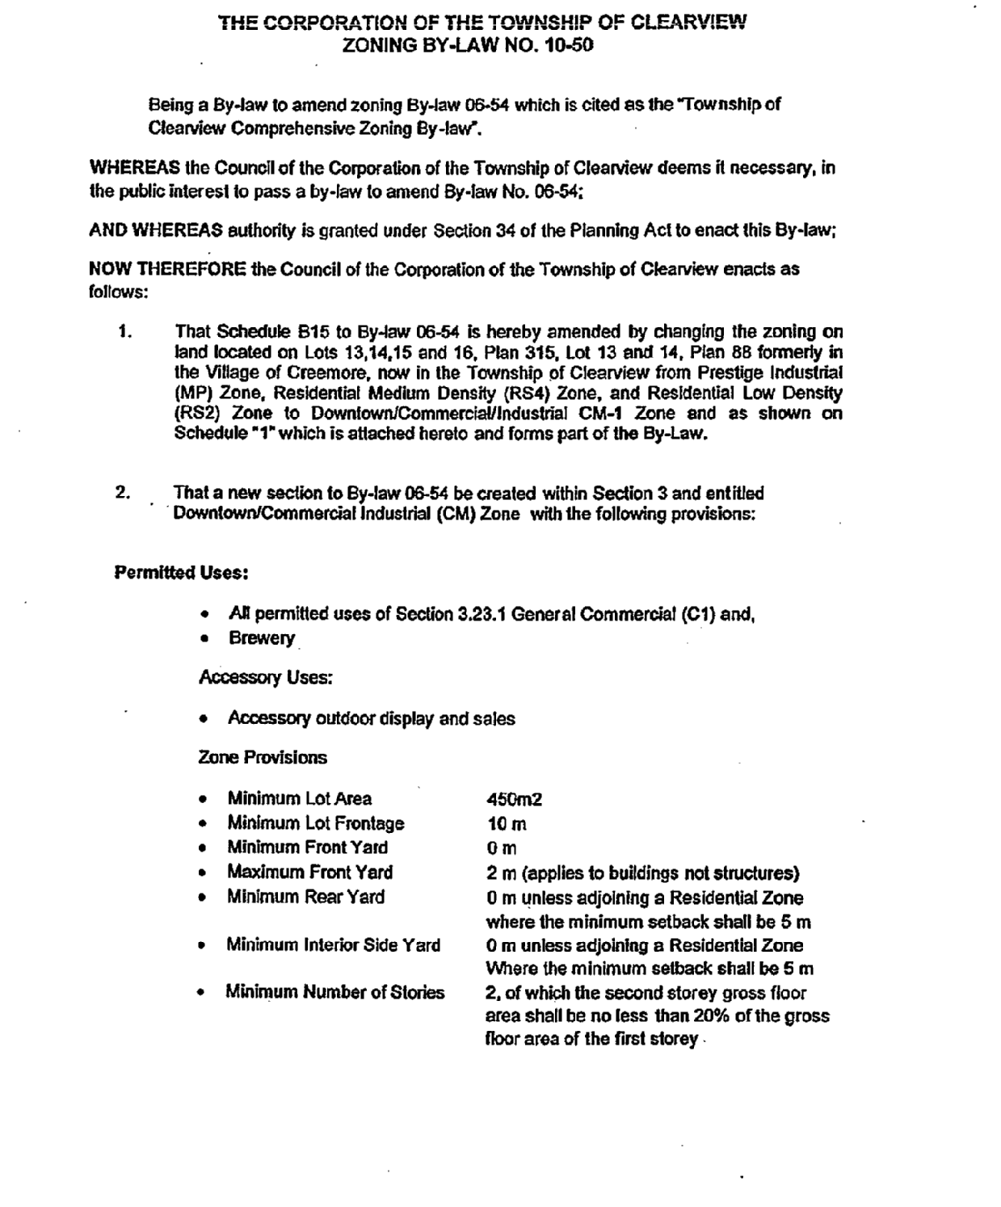
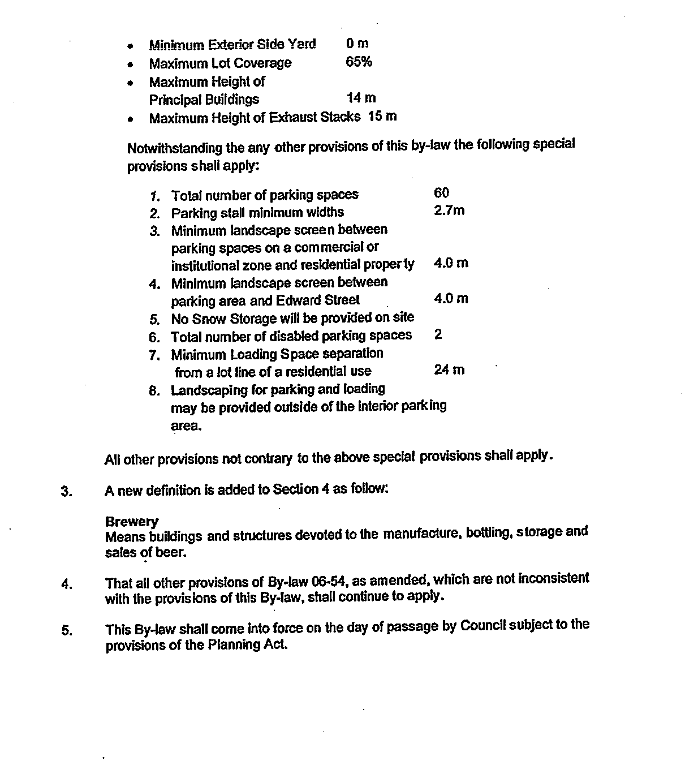
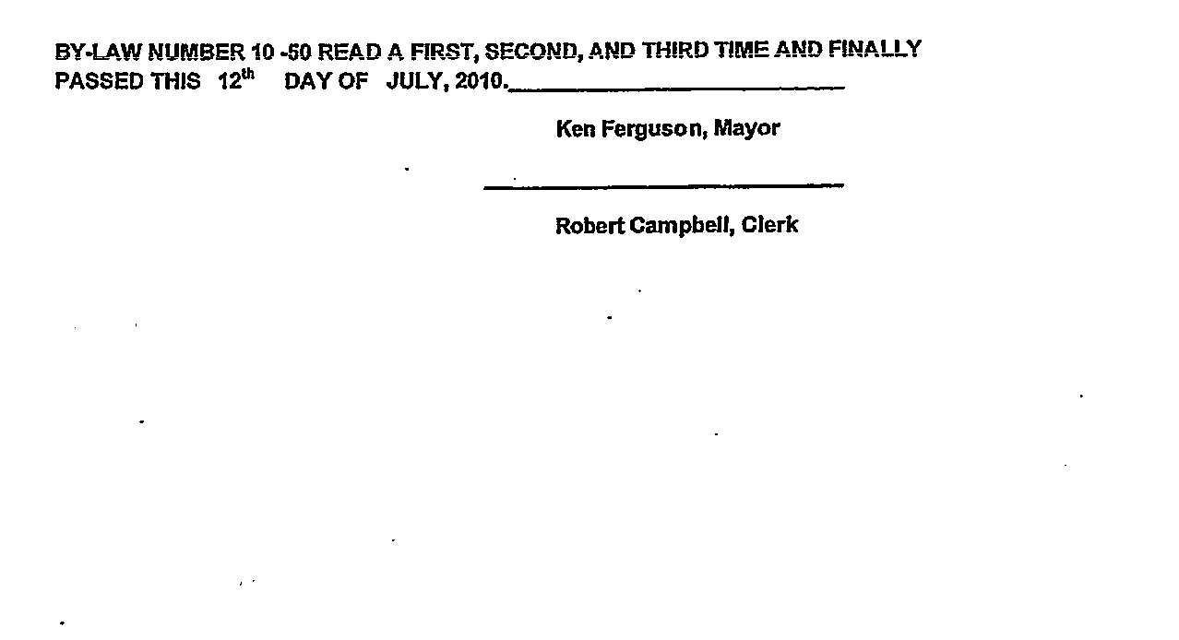
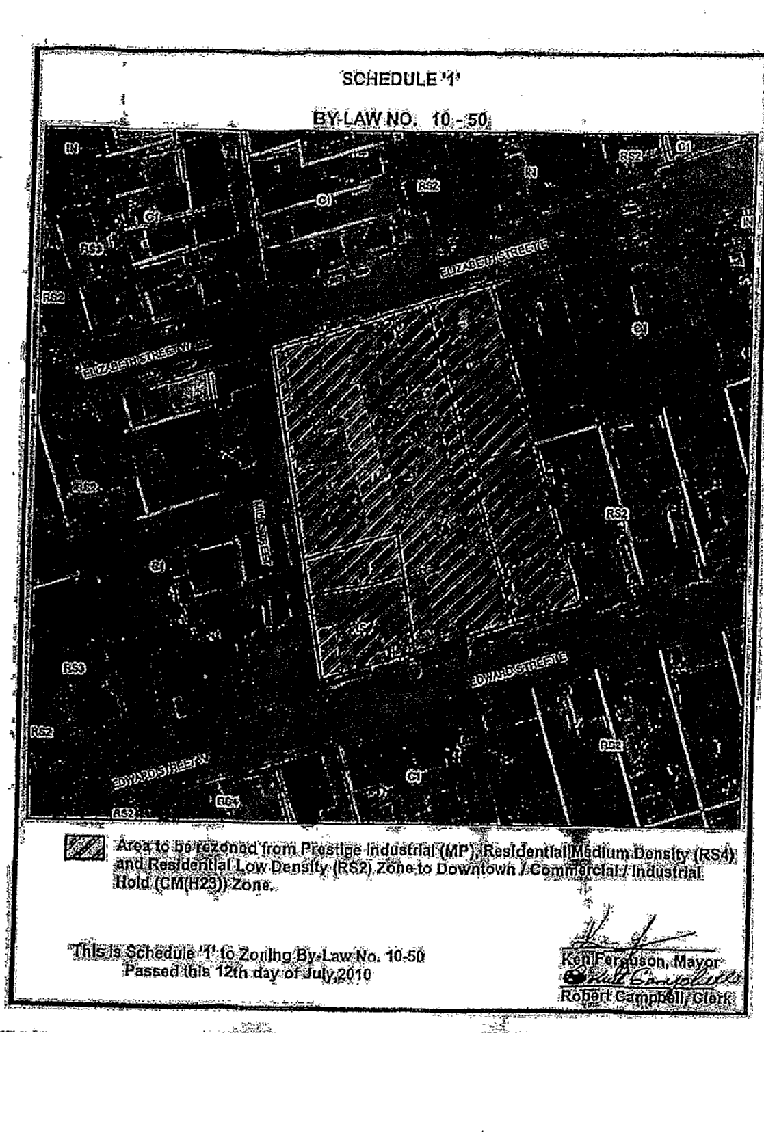
ATTACHMENT #2



