
Ontario Municipal Board
Commission des affaires municipales de l’Ontario
ISSUE DATE:

February 25, 2013
PL100867

IN THE MATTER OF subsection 34(19) of the Planning Act, R.S.O. 1990, c. P.13, as amended
Appellant: | Austin Boake
Appellant: | Suzanne Steeves
Appellant: | Paul Vorstermans
Subject: | By-law No. 10-50
Municipality: | Township of Clearview
OMB Case No.: | PL100867
OMB File No.: | PL100867

IN THE MATTER OF subsection 17(36) of the Planning Act, R.S.O. 1990, c. P.13, as amended
Appellant: | Austin Boake
Appellant: | Paul Vorstermans
Subject: | Proposed Official Plan Amendment No. OPA #9
Municipality: | Township of Clearview
OMB Case No.: | PL100867
OMB File No.: | PL101264

IN THE MATTER OF subsection 34(19) of the Planning Act, R.S.O. 1990, c. P.13, as amended
Appellant: | Austin Boake
Appellant: | Rosie & Roy Symes
Appellant: | Paul Vorstermans
Subject: | By-law No. 11-30
Municipality: | Township of Clearview
Municipal File No.: | ZB 2011-004
OMB Case No.: | PL110462
OMB File No.: | PL110462

IN THE MATTER OF subsection 17(36) of the Planning Act, R.S.O. 1990, c. P.13, as amended
Appellants: | Austin and Christine Boake
Appellant: | Paul Vorstermans
Subject: | Proposed Official Plan Amendment No. OPA #11
Municipality: | Township of Clearview
OMB Case No.: | PL110660
OMB File No.: | PL110660
APPEARANCES:

Parties | Counsel
Creemore Spring Breweries Limited  Township of Clearview  County of Simcoe  Christine and Austin Boake  Paul Vorstermans | Marshall Green  Arianna Pilkington  Marshall Green

MEMORANDUM OF ORAL DECISION DELIVERED BY SYLVIA SUTHERLAND ON JANUARY 23, 2013 AND ORDER OF THE BOARD
BACKGROUND
- In a decision issued on April 5, 2012, the Board withheld its order allowing the appeals in part of Creemore Spring Brewery Limited (“Brewery”) and approving Amendment No. 9 (“OPA 9”) and Amendment No. 11 (“OPA11”) to the Official Plan of the Township of Clearview (“Township”), as well as the amendment of Zoning By-law (“ZBL”) 06-54, until being advised by the Township that the Final Site Plan was in a form acceptable to the Township, and was in substantial conformity with the Draft Site Plan, attached as Schedule C to the Minutes of Settlement, or is in a form acceptable to the Township, even though it may not be in substantial conformity with the Draft Site Plan attached a Schedule E, but with which the parties agree is otherwise acceptable. The purpose of the above was to allow for the expansion of the Brewery.
- The purpose of the current hearing was to hear evidence leading to the release of the Board’s Order.
EVIDENCE
- At the hearing, James Dyment gave expert land use planning evidence and opinion in support of the proposed expansion of the Brewery in downtown Creemore through the policies of Official Plan Amendment 9 (“OPA 9”) and Official Plan Amendment 11 (“OPA 11”) and ZBL 11-30, as revised and supported by all parties to the appeal. The revised documents are to be found in Mr. Dyment`s affidavit (Exhibit 1).
- The site plan has been modified on many occasions, and the copy of the plan found in Mr. Dyment`s affidavit, and Mr. Dyment has been advised that upon approval of the OPAs and ZBL that are the subject of this hearing, the Township is prepared to give final approve to the Site Plan. Austin and Christine Boake and Paul Vorstermans told the Board that they have no objections to the site plan before the Board in Exhibit 1.
- Mr. Dyment outlined the salient factors of OPAs 9 and 11 and ZBL 11-30 stating that effect of these three instruments is to ensure that the development of the Brewery is compatible with the neighbouring land uses and the historic character of downtown Creemore. In his opinion, they are consistent with the Provincial Policy Statement and the Growth Plan for the Greater Golden Horseshoe. He further stated that the expansion of the Brewery is in conformity with County of Simcoe Official Plan and the Official Plan of the Township of Creemore.
- It was his opinion that approval of the OPA 9, OPA 11 and ZBL 11-30 represents good planning for the subject lands and the Township, and is in the public interest.
DISPOSITION AND ORDER
- Having heard the expert opinion of Mr. Dyment and the consent of the other parties to the revised documents, the Board orders that the appeals are allowed in part and Amendment 9 and Amendment 11 to the Official Plan of the Township of Clearview as set out in Exhibit 1 are approved.
- The Board further orders that Zoning By-law 06-54 is amended as set out in Attachment 1 to this Order.

“Sylvia Sutherland”

SYLVIA SUTHERLAND
MEMBER
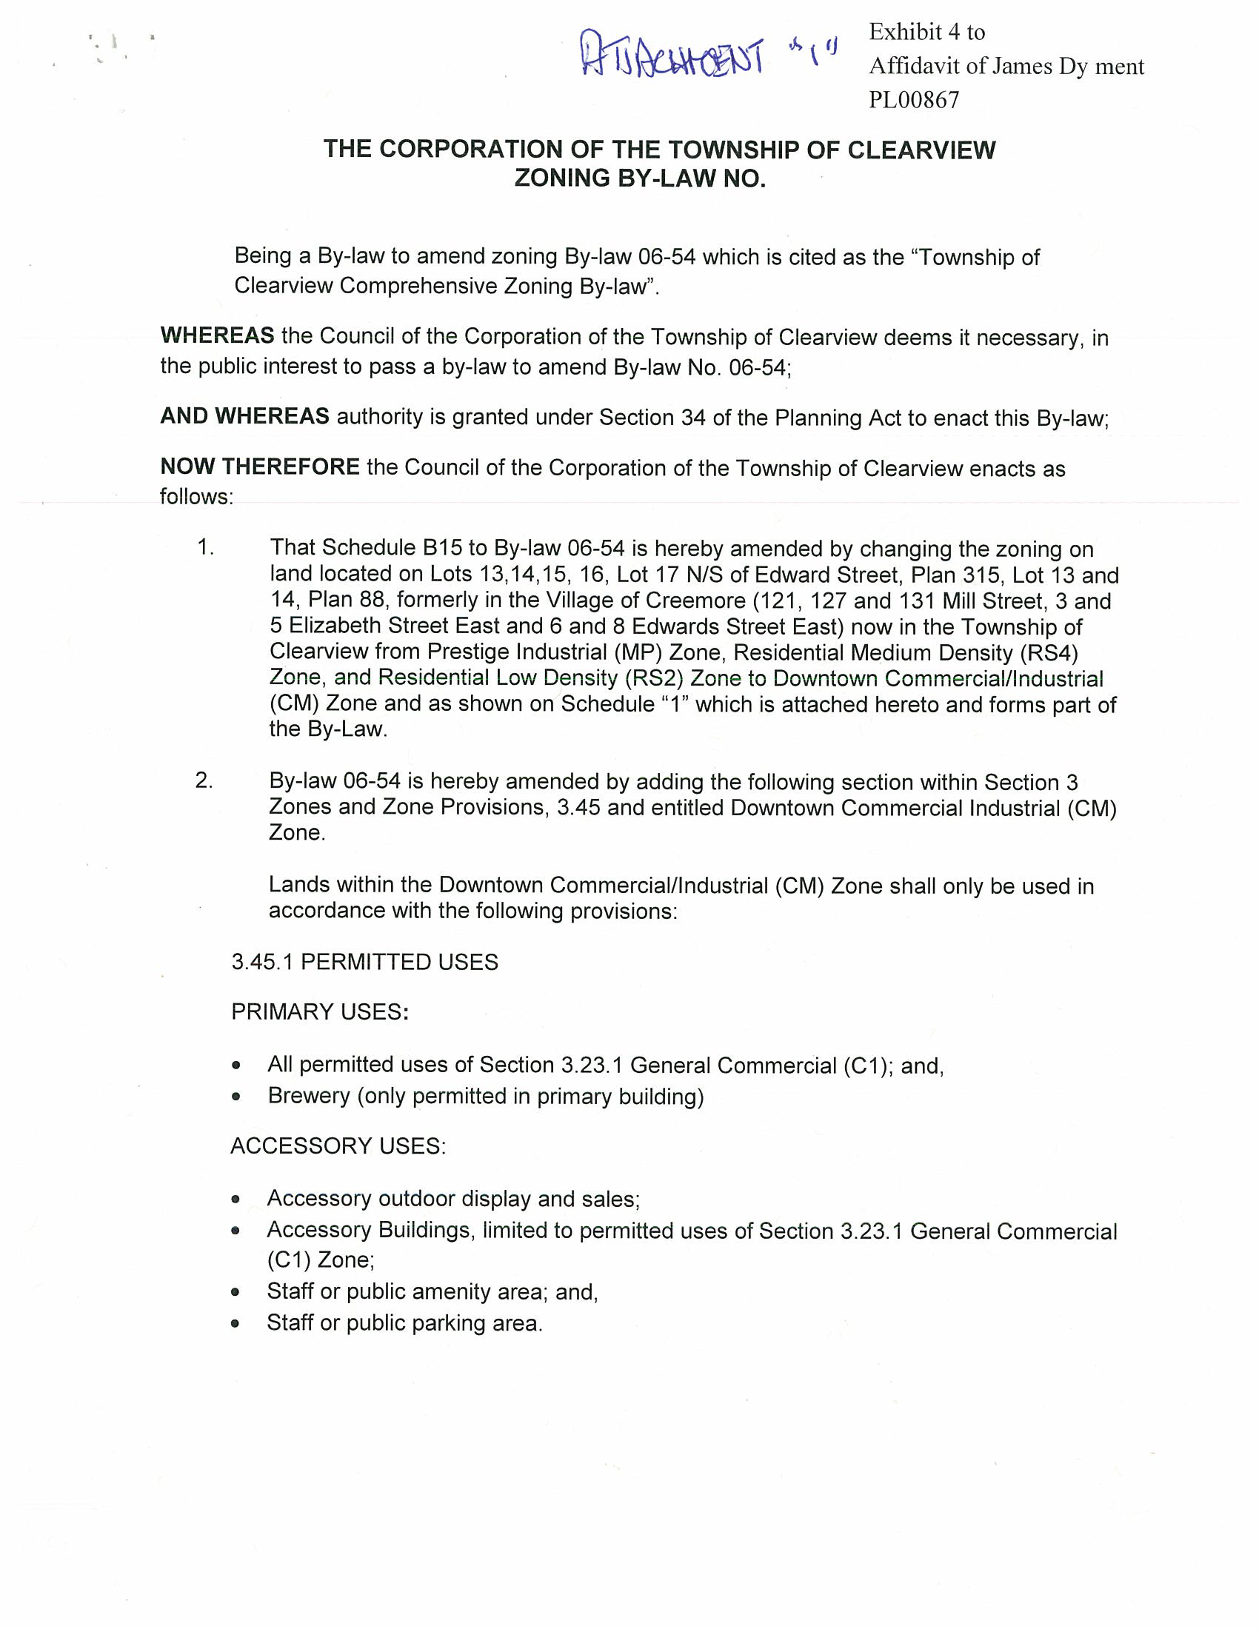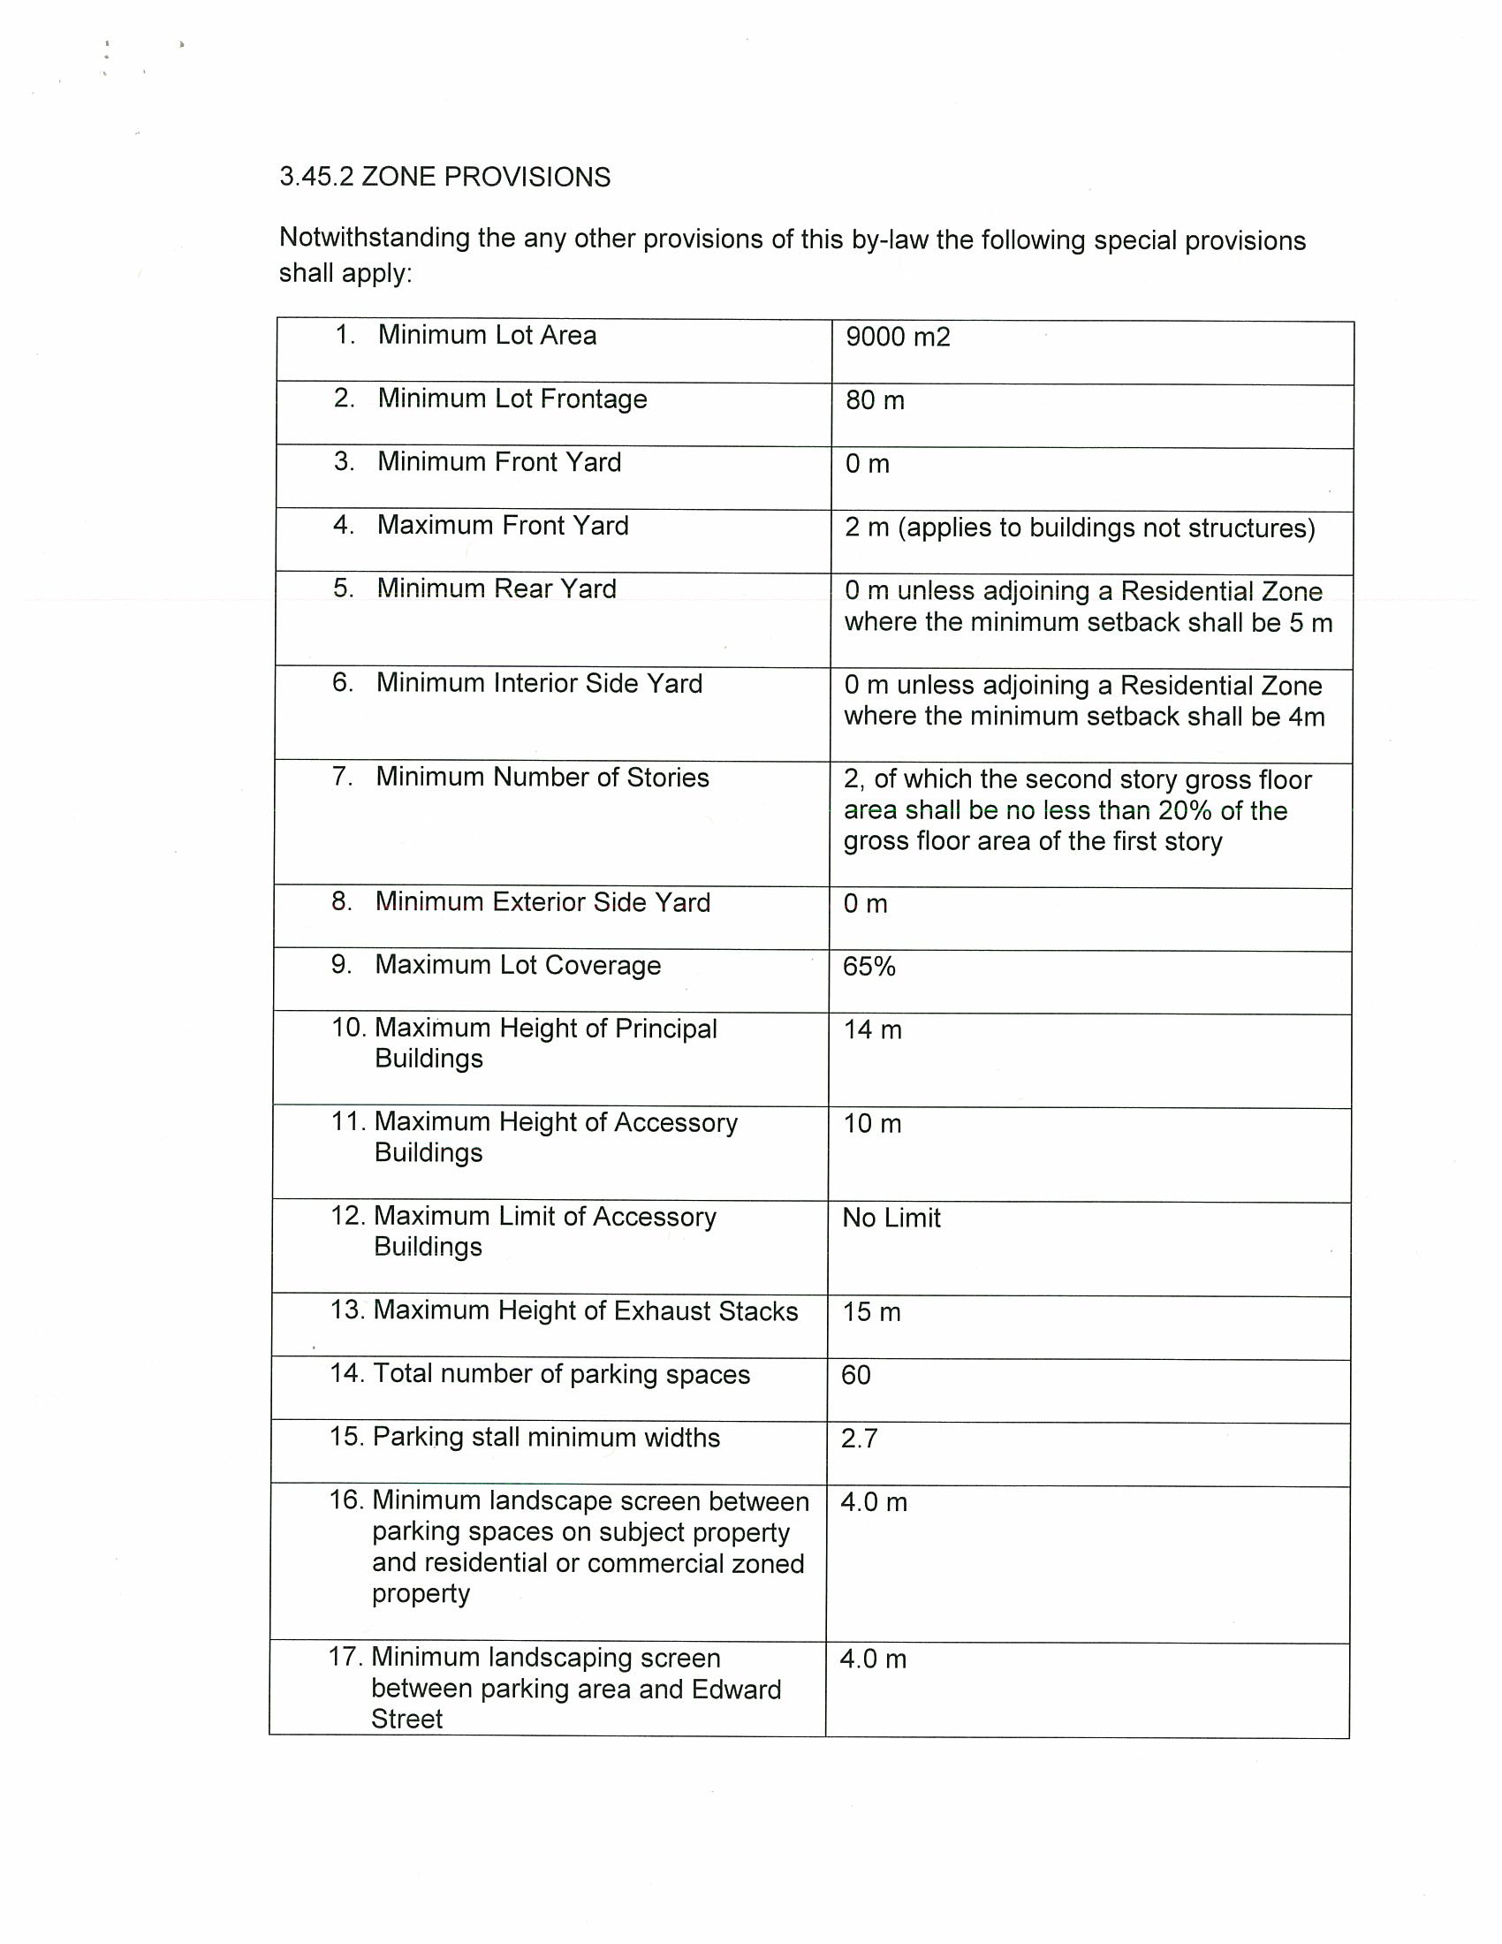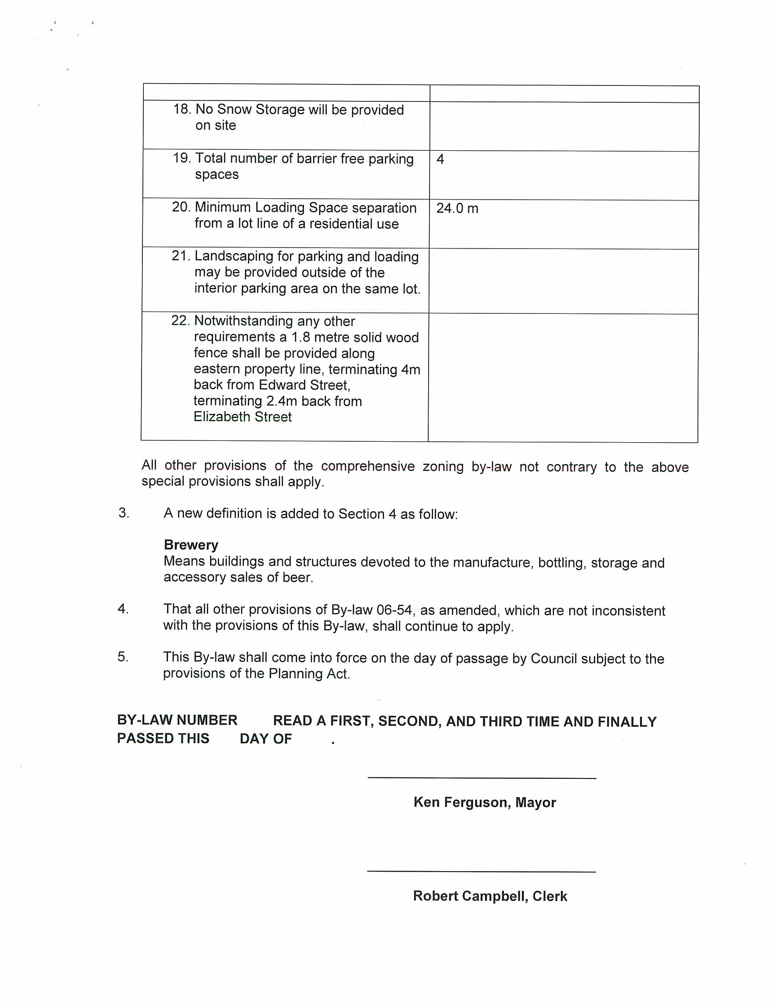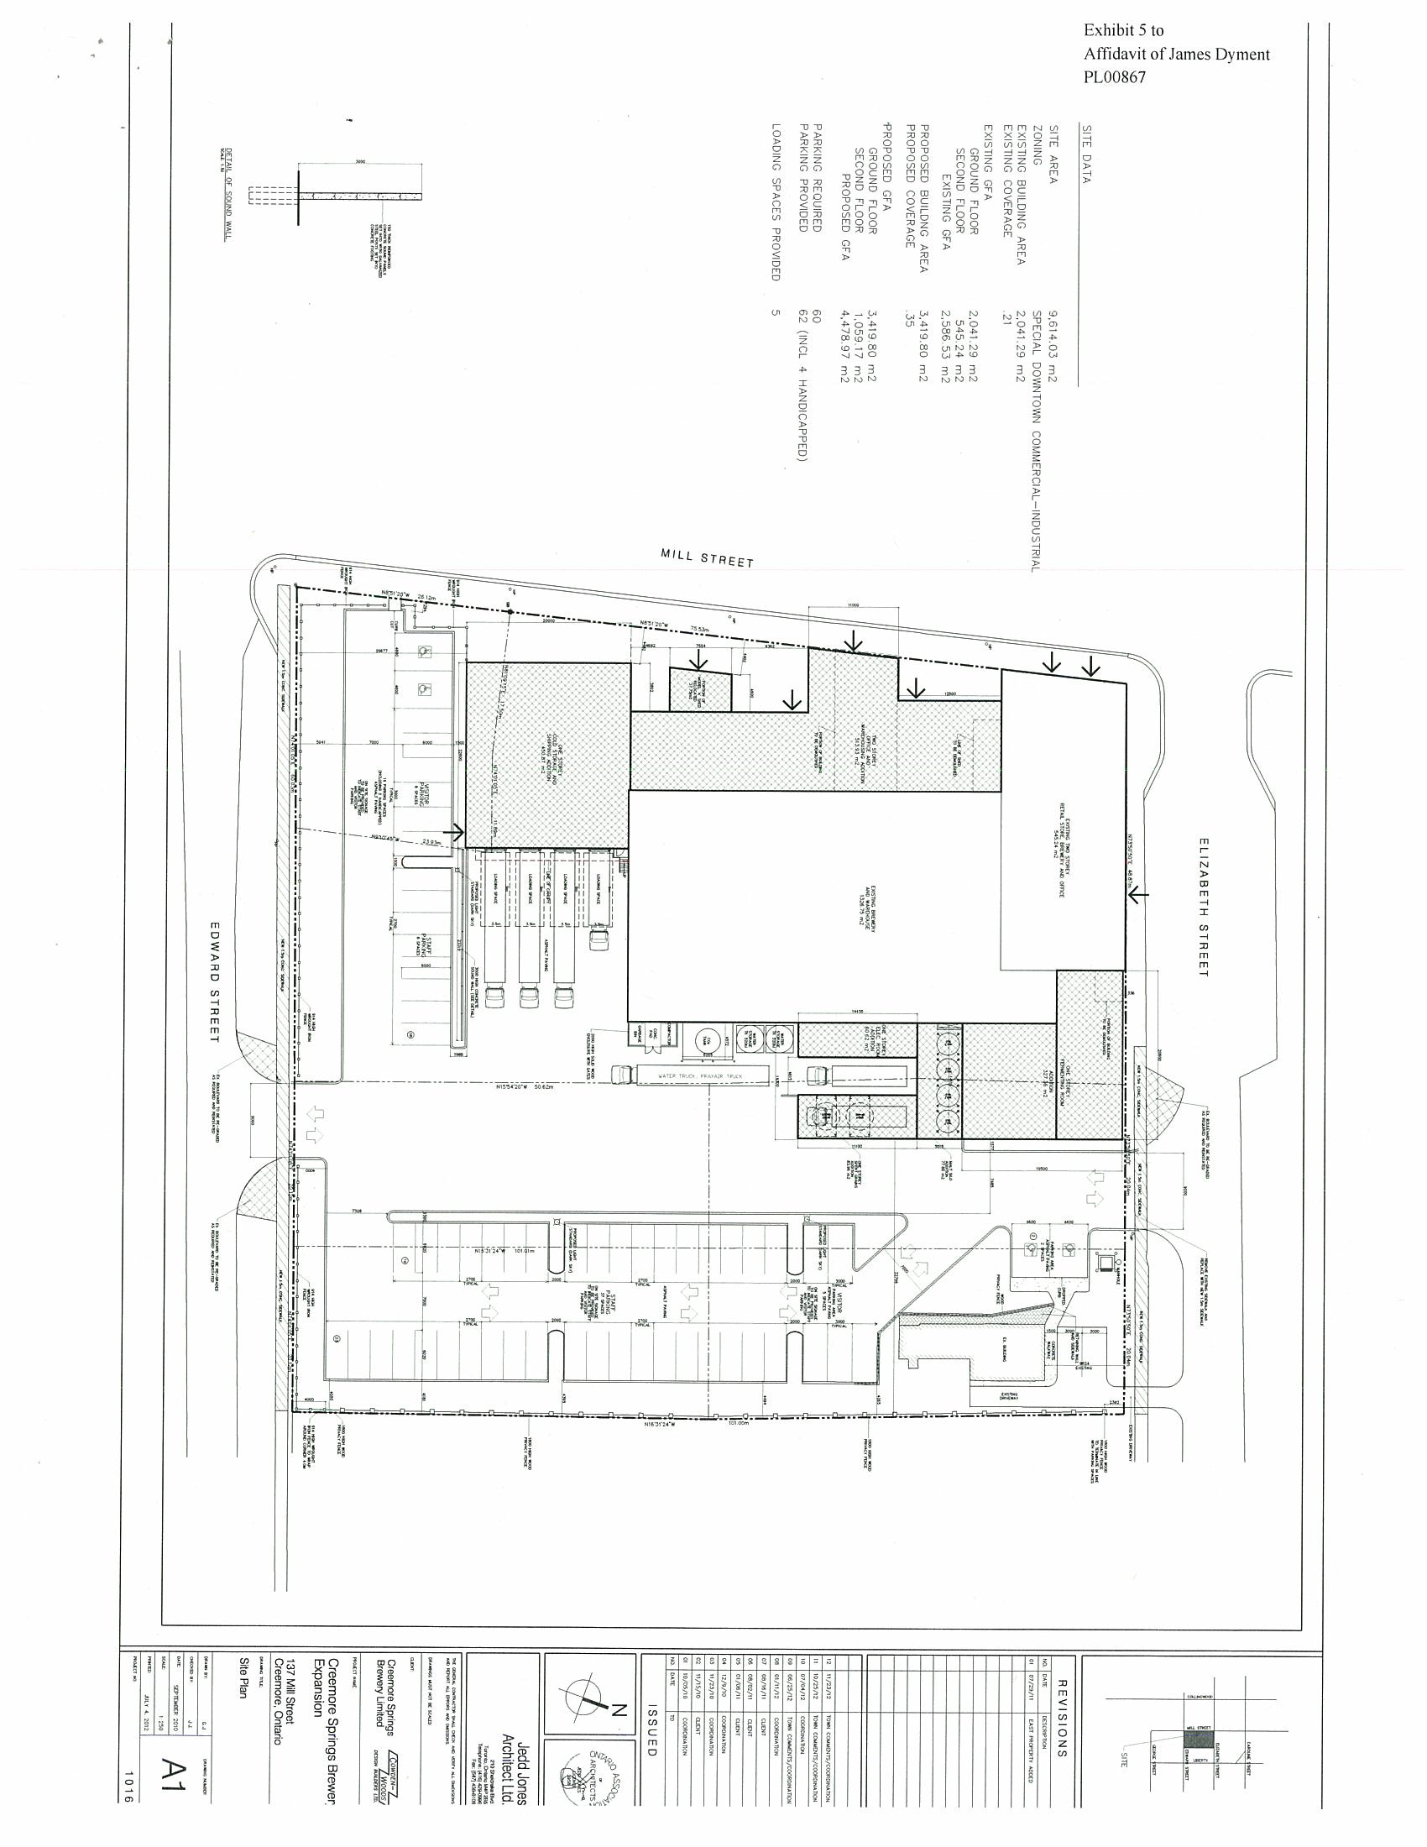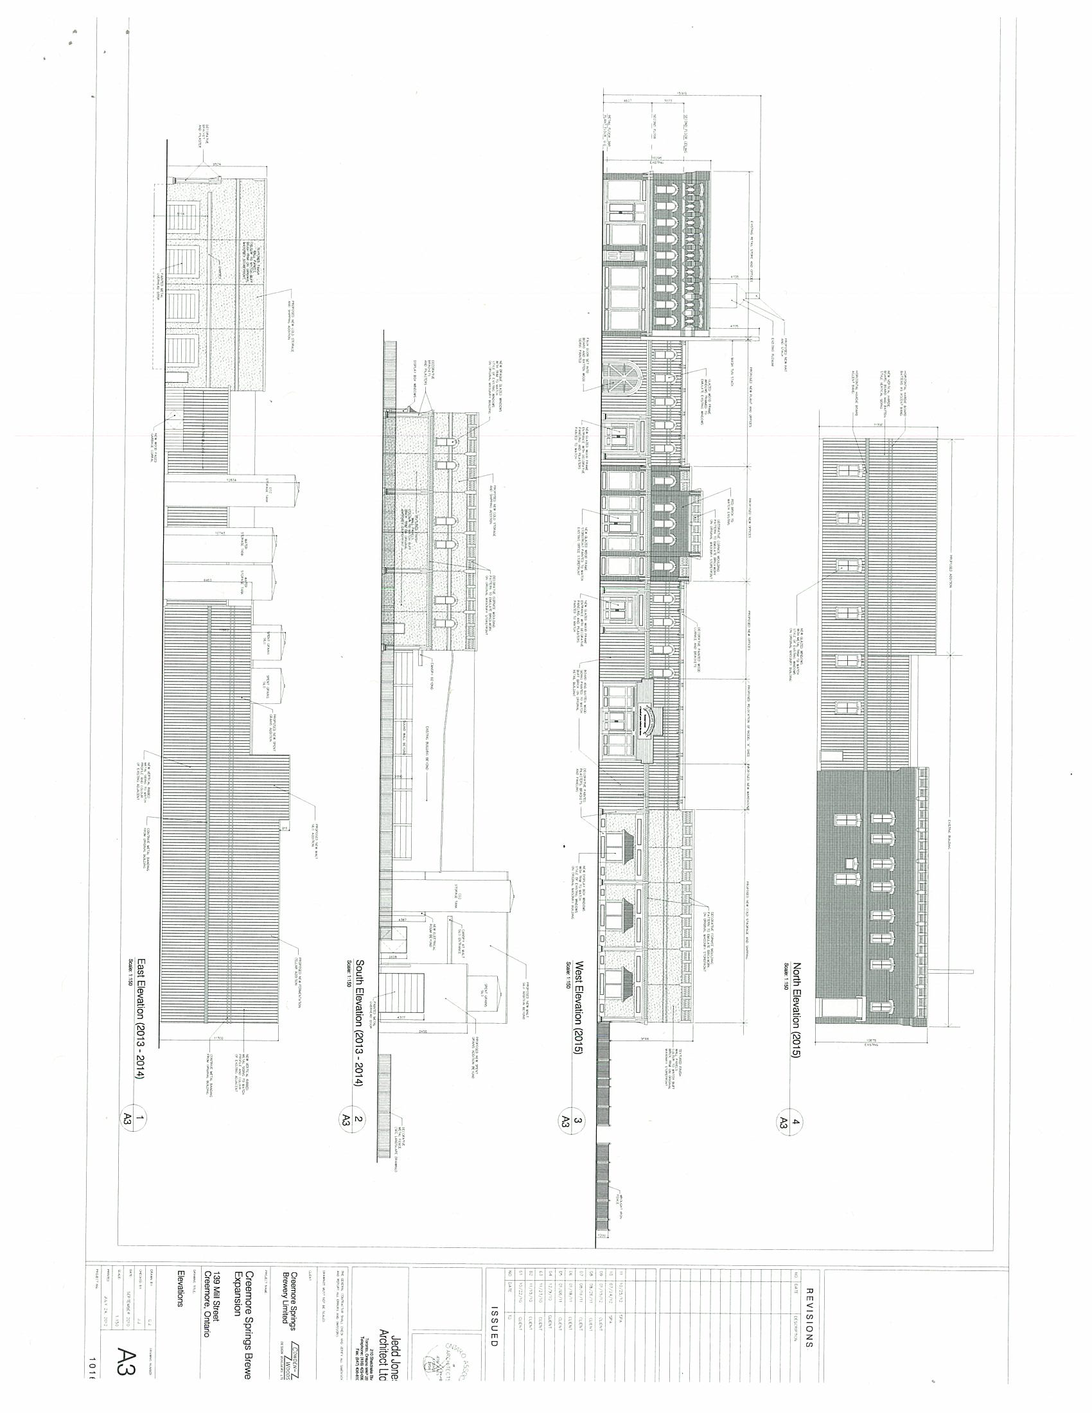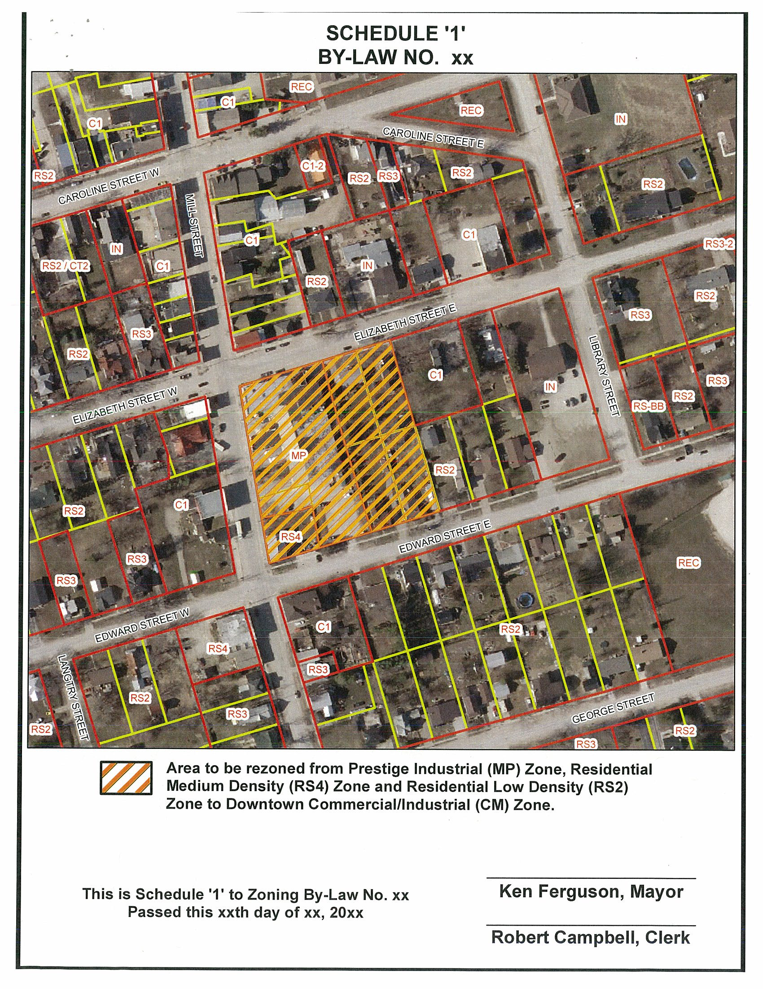
ATTACHMENT 1

