PL110524

Ontario Municipal Board
Commission des affaires municipales de l’Ontario
ISSUE DATE:

June 26, 2013

Paletta International (1990) Inc. has appealed to the Ontario Municipal Board under subsection 22(7) of the Planning Act, R.S.O. 1990, c. P.13, as amended, from Council's refusal or neglect to enact a proposed amendment to the Official Plan for the City of Niagara Falls to redesignate land at 4825 Pettit Avenue from Industrial to Residential with a Special Policy Area to permit a future development
OMB File No.: PL110524

Paletta International (1990) Inc. has appealed to the Ontario Municipal Board under subsection 34(11) of the Planning Act, R.S.O. 1990, c. P.13, as amended, from Council’s refusal or neglect to enact a proposed amendment to Zoning By-law 79-200 of the City of Niagara Falls to rezone lands respecting 4825 Pettit Avenue from L1 to R3 and R5D to permit a future development
OMB File No.: PL110521

APPEARANCES:

Parties | Counsel
Paletta International (1990) Inc.  City of Niagara Falls | S. Snider  K. L. Beaman

DECISION DELIVERED BY SUSAN de AVELLAR SCHILLER AND ORDER OF THE BOARD
- Paletta International (1990) Inc. (“Paletta) wishes to redevelop a vacant parcel in the City of Niagara Falls (“City”). The subject site was occupied previously by an industrial use. Paletta wishes to develop the site for residential uses.
- At the pre-hearing conference in these matters, a large number of interests sought and received participant status. Of these, only Mark Stirtzinger advised the Board that he wished to withdraw as a participant and would not attend the hearing of the merits.
- Victor Panczuk is the only participant to file a participant statement in accordance with the requirements of the Procedural Order. Mr. Panczuk attended the entire hearing, listening carefully to the evidence being presented. The Board commends the care and patience Mr. Panczuk took to inform himself on the evidence and reports being presented to the Board. When Mr. Panczuk addressed the Board he indicated that he wished to amend some of the points made in his participant statement as a result of the evidence that was put before the Board in the hearing.
- There is no site plan before the Board. A conceptual site plan was filed to illustrate the way in which the proposed official plan amendment and the proposed zoning by-law amendment might be implemented on the site.
- The site is irregular in shape and roughly triangular. It is located at the northwest intersection of Pettit Avenue and Cropp Street. Pettit Avenue is the eastern boundary and Cropp Street is the southern boundary. A CN rail line travels diagonally from the southwest of the site to the northeast and forms the northern boundary.
- Dorchester Road is the main north-south arterial just to the west. Morrison Street is the main east-west arterial just to the north of the rail line. Access to Dorchester Road, and then Morrison Street, is from Cropp Street.
- The site is adjacent to, but not part of, the Burdette neighbourhood. In form, the neighbourhood is composed primarily of single family detached and semi-detached housing east of Pettit Avenue and south of Cropp Street. For statistical purposes, the City groups single family detached housing, semi-detached housing, duplexes, triplexes and single family houses with secondary suites as “single family”. Single family row townhouses are placed in the “apartment” category.
- The conceptual site plan calls for singles, semis and street townhouses along Cropp Street and Pettit Avenue. Behind these house forms would be four-storey and six-storey apartments. Access to the site is at the northeast of the site from Pettit Avenue and from Cropp Street to the south. The Cropp Street access point is aligned with University Avenue, which runs north to Cropp Street.
- A statement of agreed facts was signed by the expert planners called to testify by Paletta and by the City in these proceedings. That agreed statement of facts was filed as Exhibit 2. Both expert planners indicated that they continued to stand by that statement, which included agreement on the following points, among others:
- A mix of uses on the site that includes apartments, singles, semis and townhouses represents good planning;

- Singles, semis and townhouses along the Cropp Street and Pettit Avenue frontages provides a compatible interface with the existing community, represents a good transition from the community and is a good buffer for the intensification of the site;

- Apartments are an appropriate use and those of four and six storeys in height are a good transition from the street level frontages toward the rail line at the rear of the site;

- Driveway locations are appropriate;

- Traffic generated from the site is not an issue, nor is the parking that is proposed for the uses on the site.
- The planners went on to agree that the only issue remaining was the question of the number of units being proposed for the site. Paletta proposes 456 units; the City proposes 210 units.
- There is no dispute that the subject site is appropriate for intensification and redevelopment for residential uses. The issue is how much intensification is appropriate.
- While there is no site plan before the Board, the site is subject to site plan control. Final details of the deployment of uses on the site are matters for the site plan stage. While conceptual, the site plan filed as Exhibit 2 provides the important basis for the agreement between the expert planners on matters that speak to compatibility between the proposed intensification of the subject site and the neighbourhood to the south and to the east.
- The Board finds that there is no issue of compatibility.
- The traffic generated is acceptable and can be accommodated by the existing street pattern. Parking on site is appropriate and sufficient. There are no issues of loss of sunlight or sky view or of shadowing. The density proposed by Paletta can be accommodated with street related housing along Cropp Street and Pettit Avenue, providing an appropriate transition in height and form from these street frontages to the apartments that are interior to the site.
- The City’s objections to the Paletta proposal, and the City’s support for lesser intensification of the site, rest on two assertions:
- The proposed development would alter the character of the neighbourhood; and
- The proposed development would result in an undue concentration of higher density units.
- Both of these objections rest on the interpretation and application of s.1.7 and s. 1.4.3 of the City of Niagara Falls Official Plan (“OP”).
- Section 1.7 states:
…Single detached housing will continue to dominate the character and identity of residential neighbourhoods, although an increasing demand for various types of multiple residential accommodation is recognized. In providing for these demands, varieties of residential types will not be mixed indiscriminately, but will be arranged in a gradation of building heights and densities…
- Section 1.4.3 of the OP states:
…Undue concentration of any particular housing type shall be avoided…
- The Board will deal first with s.1.7. The Paletta proposal meets the policy intent of this section in three important ways.
- First, on the question of the character of the residential neighbourhood, the subject lands are not within the residential neighbourhood. These lands are derelict industrial lands that sit at the edge of the residential neighbourhood. As such, the Paletta proposal changes the character of these obsolete industrial lands but it does not change the character of the adjacent residential neighbourhood. That character is predominately singles and semi-detached house forms and will remain as such regardless of the development of the subject lands.
- When Mr. Panczuk addressed the Board he spoke of character in a slightly different way. Mr. Panczuk emphasized the large number of seniors that live in the neighbourhood, many of whom have been long-term residents who raised their families here and have established long-term friendships. The ability to walk along a neighbourhood street and know one’s neighbours is an important defining element of the character of this residential neighbourhood.
- While planning cannot guarantee that people will get to know one another and get along, there are steps that can be taken to encourage interaction and friendly discourse. One such step has already been noted and that is ensuring that the outer edges of the subject lands are developed with grade related house forms that complement the existing adjacent neighbourhood. With an aging population in the existing residential neighbourhood, an opportunity to remain close to friends and in familiar surroundings increases in importance for residents. Paletta indicated that provision might be made for some senior citizen apartments and Mr. Panczuk indicated that such units would be a welcome addition.
- The second way the Paletta proposal meets the policy intent of s.1.7 is that, even if the subject lands were within the residential neighbourhood, the proposal does not in any way represent an indiscriminate mix of residential forms. The proposed deployment of residential forms is deliberate and provides for a careful gradation of building heights and densities that respect the adjacent residential neighbourhood while recognizing the desirability of building a new community on obsolete industrial lands.
- Finally, the City suggested that the Paletta proposal represents an undue concentration of higher density units and for this reason the City’s lower unit count is preferable.
- The concern about an undue concentration of higher density units arises from a concern about a change to the character and identity of the existing residential neighbourhood which s. 1.7 of the OP seeks to protect. It also arises from the language of s.1.4.3, noted above.
- The mix of residential forms in the existing residential neighbourhood is about 70% singles, semi-detached, triplexes and those with secondary units, and about 30% row townhouses and apartments. The City suggested that the Paletta proposal would result in the existing neighbourhood’s mix becoming 40% singles, semi-detached, triplexes and those with secondary units, and about 60% row townhouses and apartments.
- The City acknowledged that adding the City’s suggested mix to the existing neighbourhood would result in a ratio of approximately 52% singles, semi-detached, triplexes and those with secondary units, and about 48% row townhouses and apartments.
- The first weakness in this analysis is that the subject lands are not in the existing residential neighbourhood. Developing the subject lands, then, does not change the concentrations and percentage allocation of residential forms in the existing residential neighbourhood.
- The second weakness in this analysis is that, even if one were to conclude that the subject lands are within the existing residential neighbourhood, the Board finds no persuasive evidence to conclude that 52% to 48% is acceptable but 60% to 40% is undue concentration. This is particularly the case when the Board considers that the concentrations in the existing residential neighbourhood are 70% to 30% (singles, etc., to row townhouses and apartments) and this concentration of singles is not considered to be an undue concentration by the City.
- The second basis for the City’s concern about an undue concentration of high density units arises in part from the explicit caution in s.1.4.3 and in part from a misinterpretation of a 2007 urban Metrics report that dealt with housing forecasts in the City.
- The City interpreted this report as recommending a split of 60% to 40% (singles, etc., to row townhouses and apartments). This report did not recommend such a split. Rather, the report simply forecast that future growth in the City would likely result in this split. In addition, the City acknowledged that there is no recommendation for a particular percentage in the OP.
- The Board finds that the proposed OP amendment and the proposed zoning by-law amendment do not conflict with the policy regime of the OP and do not represent an undue concentration of higher density units.
- The Board further finds that the proposed OP amendment and the proposed zoning by-law amendment provide for development on obsolete industrial lands that maintains the character of the adjacent existing residential neighbourhood and is compatible with that neighbourhood.
- Section 2 of the Planning Act, R.S.O. 1990, c. P.13, sets out several matters of provincial interest to which the Board must have regard when considering matters before it that arise under the Act.
- This section of the Act calls for, among other things, the efficient use of land, water, energy and infrastructure; the provision of a full range of housing; the orderly development of safe and healthy communities and the appropriate location of growth and development.
- Both the Provincial Policy Statement (“PPS”) and the Growth Plan for the Greater Golden Horseshoe (“GGH”) emphasize these matters of provincial interest and encourage intensification to support complete communities, to provide a range and variety of housing, to ensure a more efficient use of land and existing infrastructure, and to provide opportunities for transit supportive development.
- Intensification itself does not have primacy over other policies. Both the PPS and the GGH require these documents to be read in their entirety and all relevant policies considered and applied to any particular circumstance. In this case, there is no conflict between the proposed intensification and policies designed to protect the environment, natural heritage or cultural heritage, or those designed to ensure that appropriate servicing is available.
- The Board finds that the proposed OP amendment appropriately implements matters of provincial interest as identified in s.2 of the Act, is consistent with the PPS and conforms to the GGH.
- The Niagara Region Policy Plan (“RPP”) identifies the City as an urban area. For developments within the urban area, the RPP calls for the efficient use of land, resources, services and infrastructure. It also calls for a variety and mix of housing and compatibility between uses with a minimization of conflicts between otherwise incompatible uses.
- The Board finds that the proposed OP amendment conforms to the RPP.
- Section 2.1 of the Act requires the Board to have regard to the decision of Council in this matter and to any supporting information and material that Council considered in making its decision.
- The decision of Council, as recorded in its minutes of April 18, 2011, and filed as Tab 9 of Exhibit 11(a) in these proceedings, is:
…that the application be denied, as the application proposed is an over intensification of a residential area that is not compatible with the surrounding neighbourhood and that the density proposed does not conform with the City‘s Official Plan…
- The planning report recommended approval of the OP amendment, subject to a reduction in the number of units per hectare but endorsing apartment heights of six storeys and single detached, semi-detached and row townhouses along the frontages of Cropp Street and Pettit Avenue.
- The Board, through the foregoing analysis in this decision, has had regard to and closely analyzed both the decision of Council and materials from planning staff that were considered by Council and presented as evidence in these proceedings.
- Finally, the Board finds that the proposed zoning by-law amendment conforms to the OP, as amended by the proposed OP amendment.
- The appeals by Paletta are allowed.
- The OP is modified in accordance with Attachment 1 and By-law 79-200 is amended in accordance with Attachment 2.
ORDER
- The Board orders that the appeals by Paletta are allowed and that:
- The Official Plan of the City of Niagara Falls is modified in accordance with the proposed Official Plan amendment found at Attachment 1; and

- The City of Niagara Falls By-law No. 79-200 is amended in accordance with the proposed zoning by-law amendment found at Attachment 2.

“Susan de Avellar Schiller”

SUSAN de AVELLAR SCHILLER
VICE CHAIR

ATTACHMENT 1

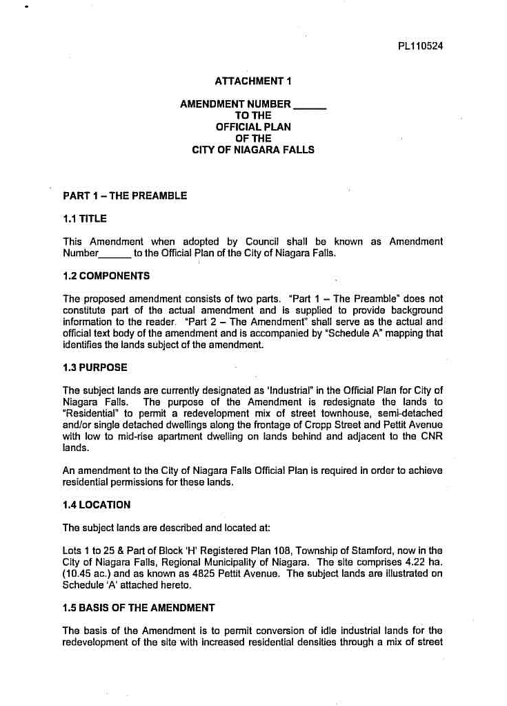
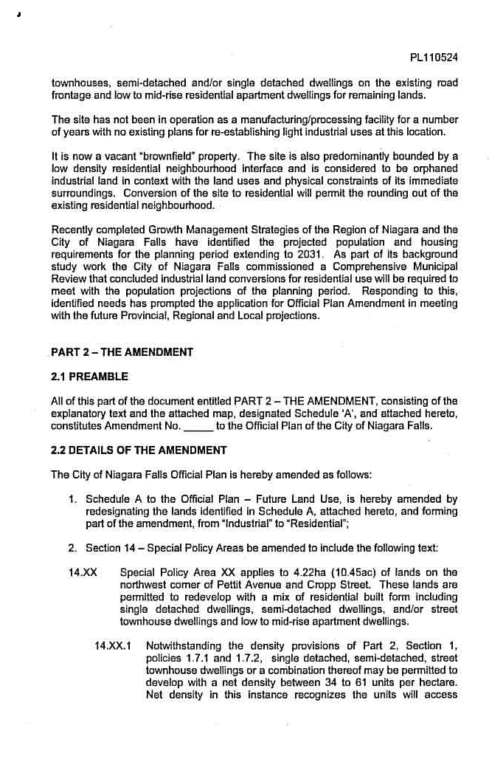
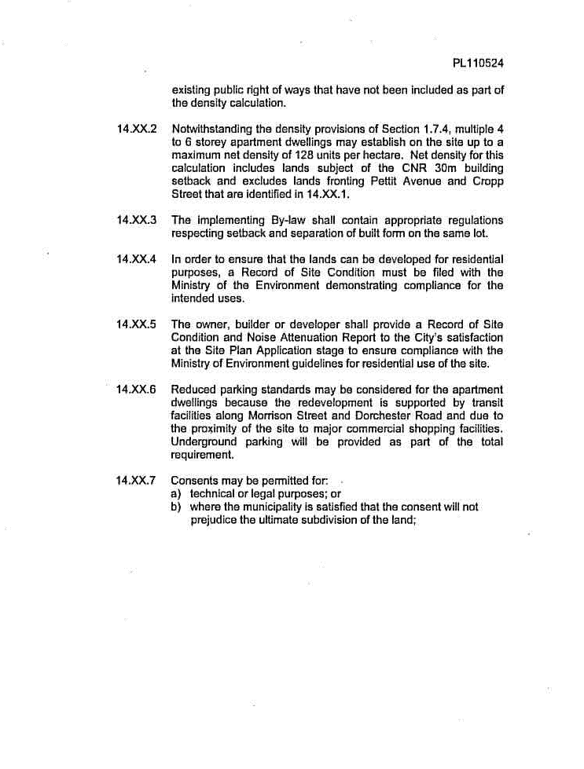

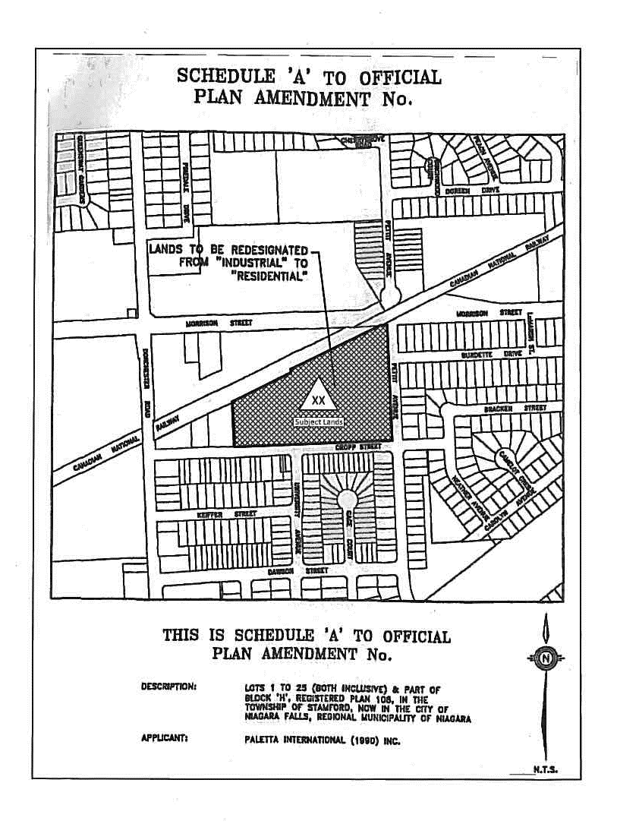

ATTACHMENT 2



