PL111331

Ontario Municipal Board
Commission des affaires municipales de l’Ontario
ISSUE DATE:

Aug. 13, 2012

IN THE MATTER OF subsection 34(19) of the Planning Act, R.S.O. 1990, c. P.13, as amended
Appellant: | A & W Food Services of Canada Inc.
Appellant: | McDonald’s Restaurants of Canada Limited
Appellant: | Ontario Restaurant Hotel & Motel Association
Appellant: | The TDL Group Corp.; and other
Subject: | By-law No. 2011-137
Municipality: | City of Niagara Falls
OMB Case No.: | PL111331
OMB File No.: | PL111331

IN THE MATTER OF subsection 34(19) of the Planning Act, R.S.O. 1990, c. P.13, as amended
Appellant: | A & W Food Services of Canada Inc.
Appellant: | McDonald’s Restaurants of Canada Limited
Appellant: | Ontario Restaurant Hotel & Motel Association
Appellant: | The TDL Group Corp.; and other
Subject: | By-law No. 2011-136
Municipality: | City of Niagara Falls
OMB Case No.: | PL111331
OMB File No.: | PL111332

APPEARANCES:

Parties | Counsel
A & W Food Services of Canada Inc.  McDonald’s Restaurants of Canada Limited  Ontario Restaurant Hotel & Motel Association  The TDL Group Corp.  Wendy’s Restaurants of Canada Inc. | D. Baker
City of Niagara Falls | K. Beaman

MEMORANDUM OF ORAL DECISION DELIVERED BY J. V. ZUIDEMA
ON JULY 12, 2012 AND ORDER OFTHE BOARD
__________________________________________________________

At an initial pre-hearing conference (PHC), the Board was told that the parties were working towards a settlement. A disposition outlining the circumstances of the appeals launched and the progress being made by the parties was issued on June 14, 2012 flowing from that first PHC and the reader is directed to that disposition for background leading to this settlement telephone conference call (TCC).
Mr. Beaman, counsel to the City of Niagara Falls (City) provided a summary overview of what had transpired since the last appearance before the Board, and true to his word, a settlement had been achieved which he recommended to the Board. In that respect, he called upon Kenneth Mech, in-house land use planner with the City to provide opinion evidence in support of the settlement. Mr. Mech was qualified and accepted as an expert in land use planning and he provided an Affidavit (filed as Exhibit 2) which set out his opinions on the proposed zoning by-laws.
Specifically Mr. Mech explained that the language of section 4.6 of By-law 2011-136 had been revised to clarify that no rights were being taken away and the following language was included to provide such certainty: “ .. nothing in section 4.6 shall be interpreted or applied such as to restrict the rights attached to any land or buildings pursuant to subsection 34(9) of the Planning Act, R.S.O. 1990, c. 13 or any successor thereto.” The section deals with the ability to reconstruct when there has been a fire or other such significant damage. He also pointed out that a typographical error had been noticed in section 13 dealing with road widenings. The proposed revisions addressed both of these concerns.
Mr. Mech then addressed By-law 2011-137 and specifically section 4.3.4 dealing with drive through facilities. He explained that drive through facilities had been permitted in the Neighbourhood Commercial (NC) zone in the past and the NC zone has been included but that the language has been clarified so that the measurement for separation distances is to be taken from the speaker-box located at the drive through. By addressing this issue, Ms. Baker indicated that her clients’ concerns had been adequately addressed. As such, she did not cross examine or otherwise object to the evidence presented.
Mr. Mech opined that the proposed by-laws were consistent with the Provincial Policy Statement, conformed to the Regional and City Official Plans, represented good planning and were in the public interest. He recommended their approval to the Board.
The Board provided an oral decision allowing the appeal in order to amend the zoning by-laws as requested. The Board’s decision was based on the uncontested evidence of Mr. Mech, who provided testimony jointly on behalf of the parties. For ease of reference, the amended zoning by-laws are attached to this decision.
THEREFORE THE BOARD ORDERS that the appeals are allowed and By-laws 2011-136 and 2011-137 are hereby amended in the manner set in Attachments #1 and #2 to this Order.
This is the Board’s Order.
“J. V. Zuidema”

J. V. ZUIDEMA
VICE-CHAIR
ATTACHMENT # 1

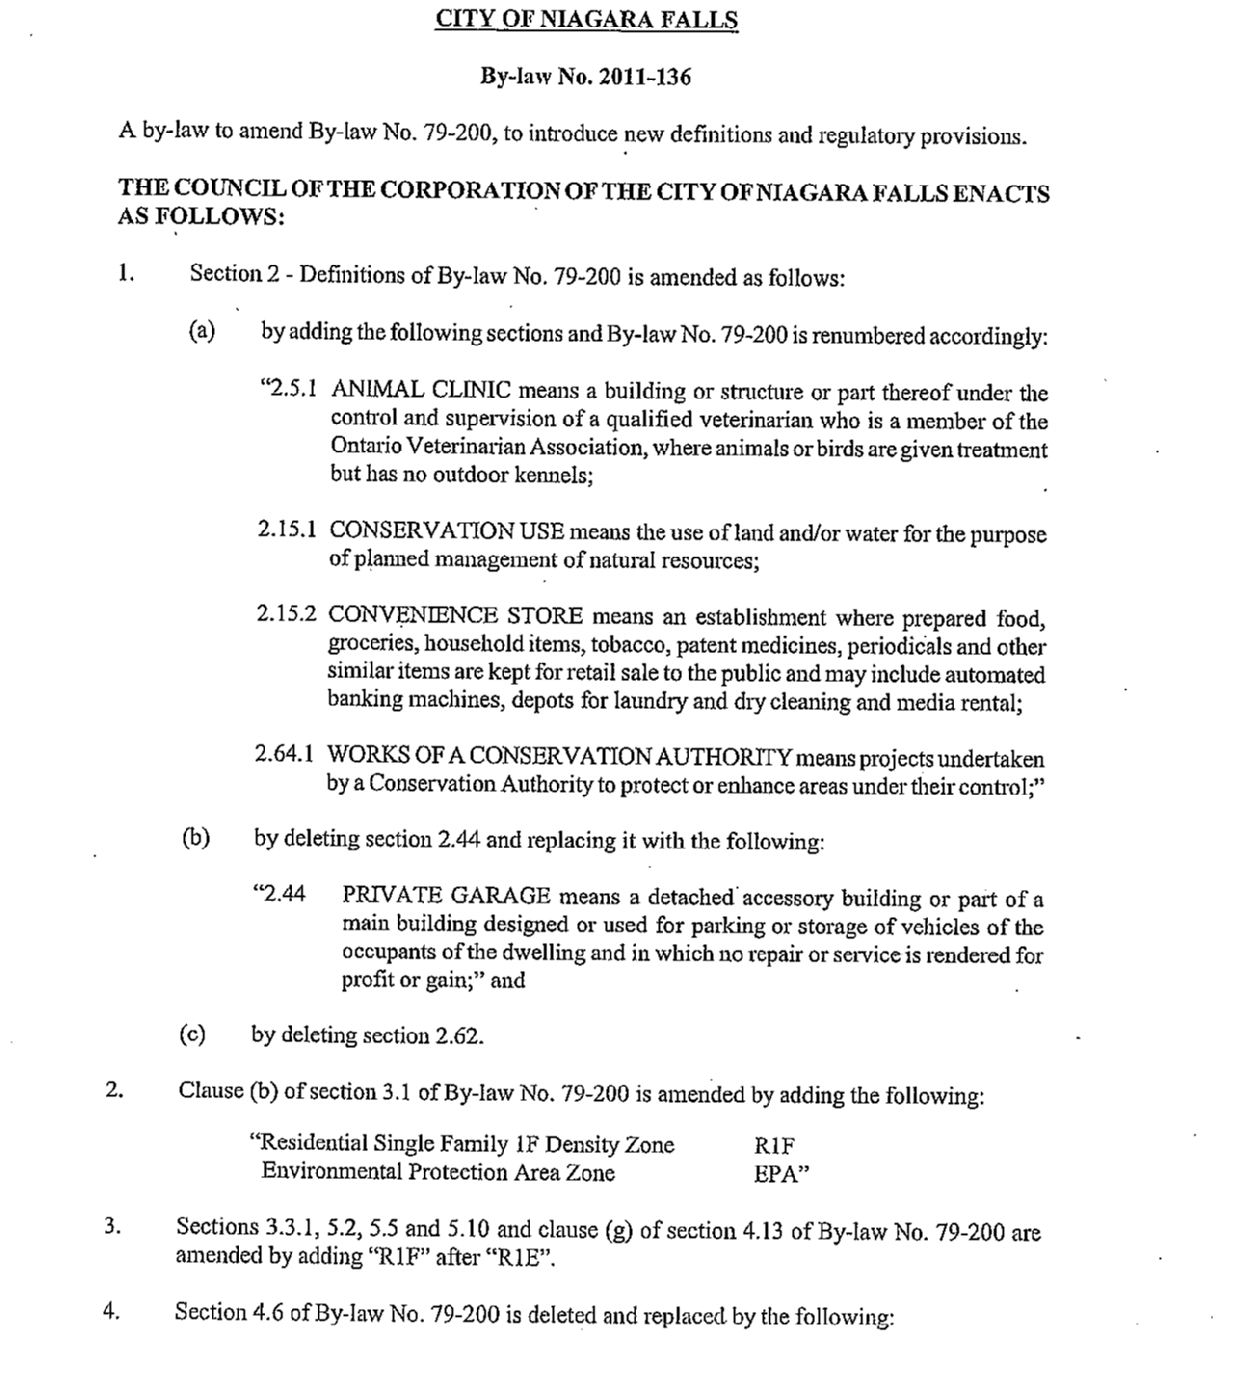
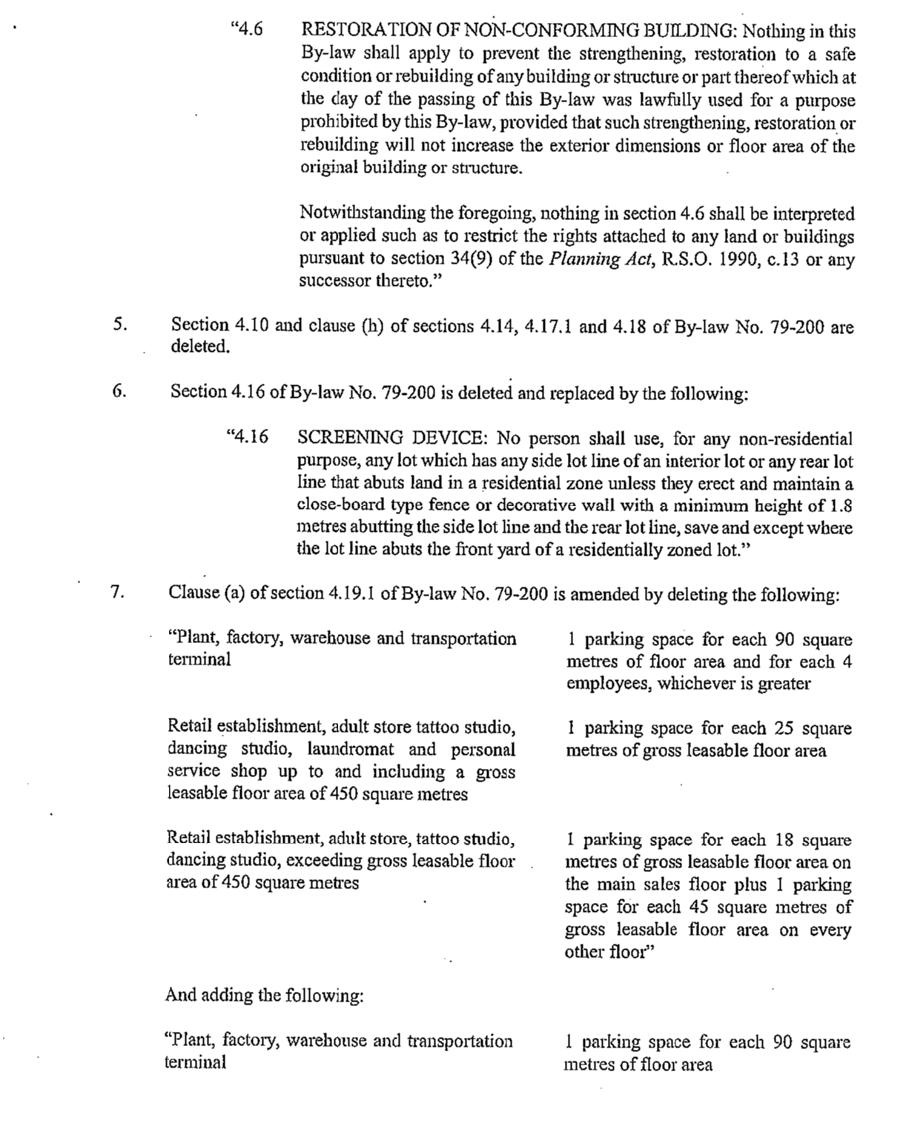
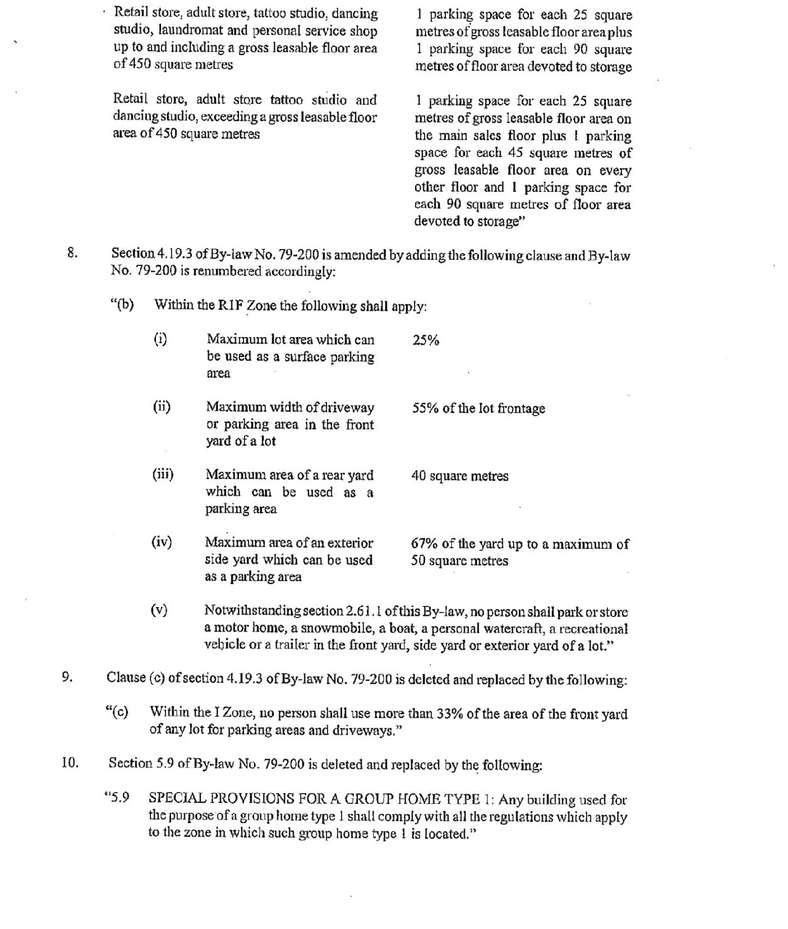
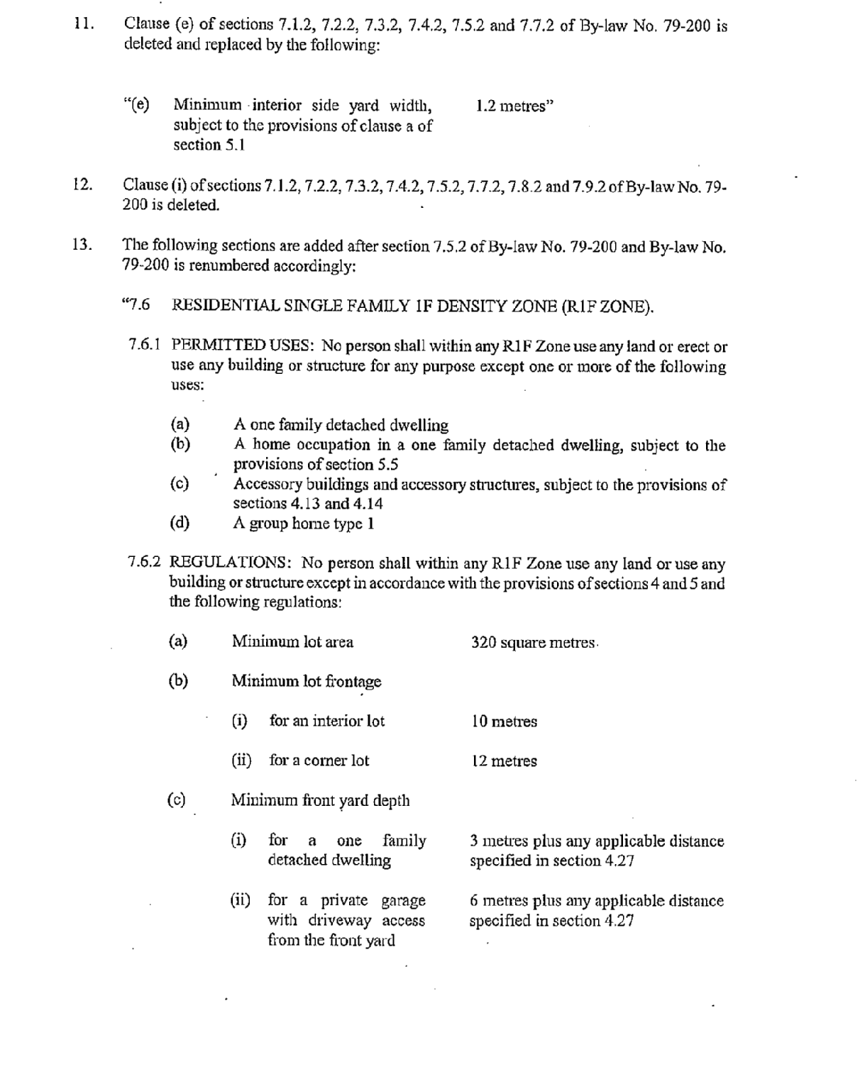
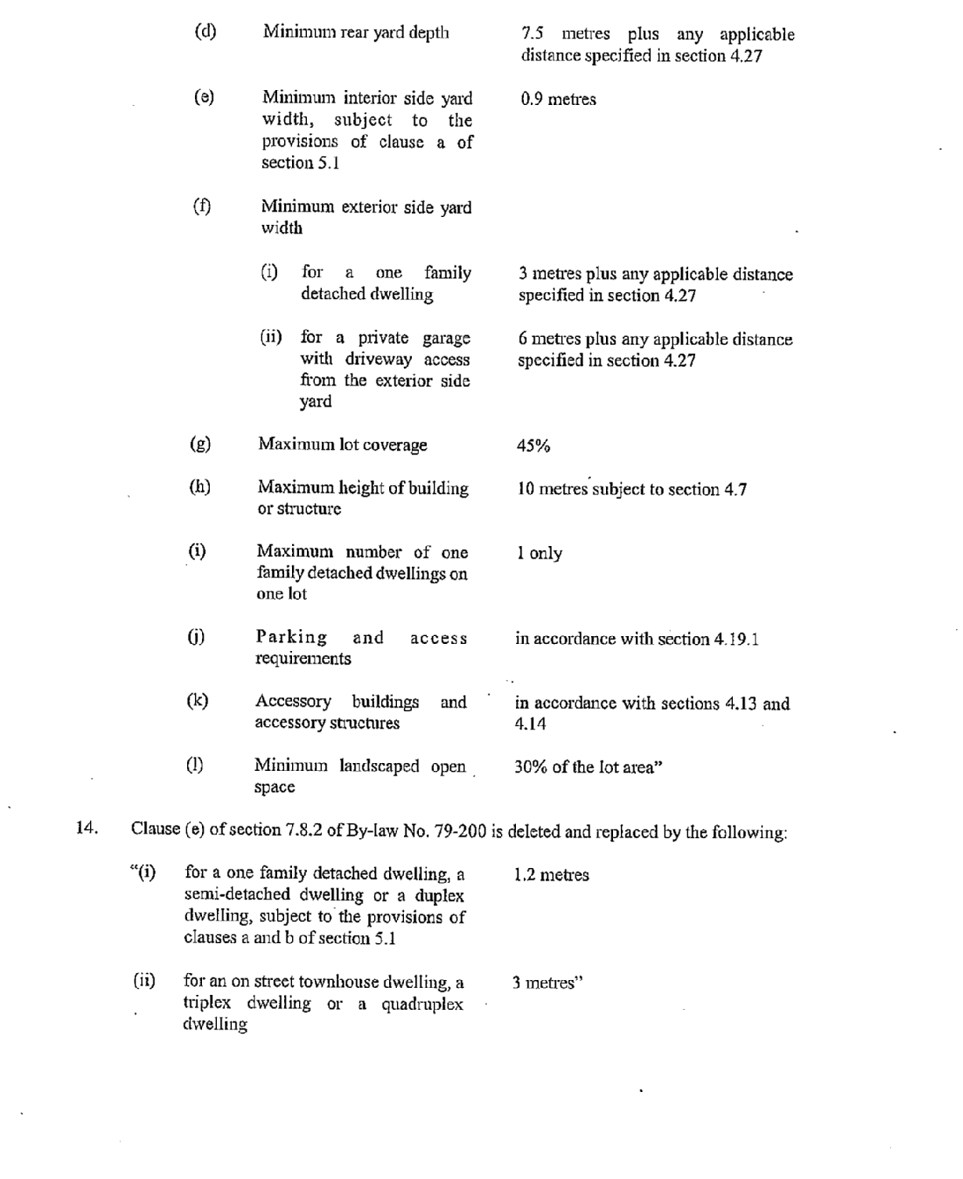
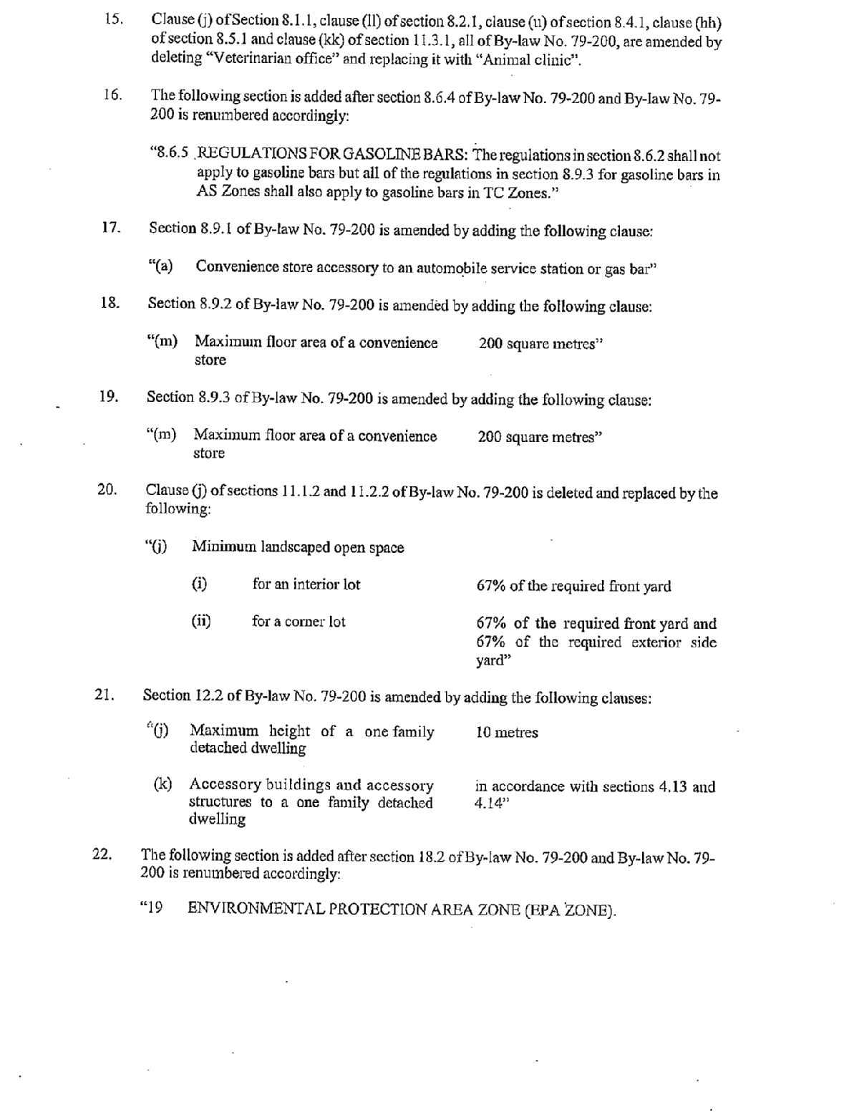
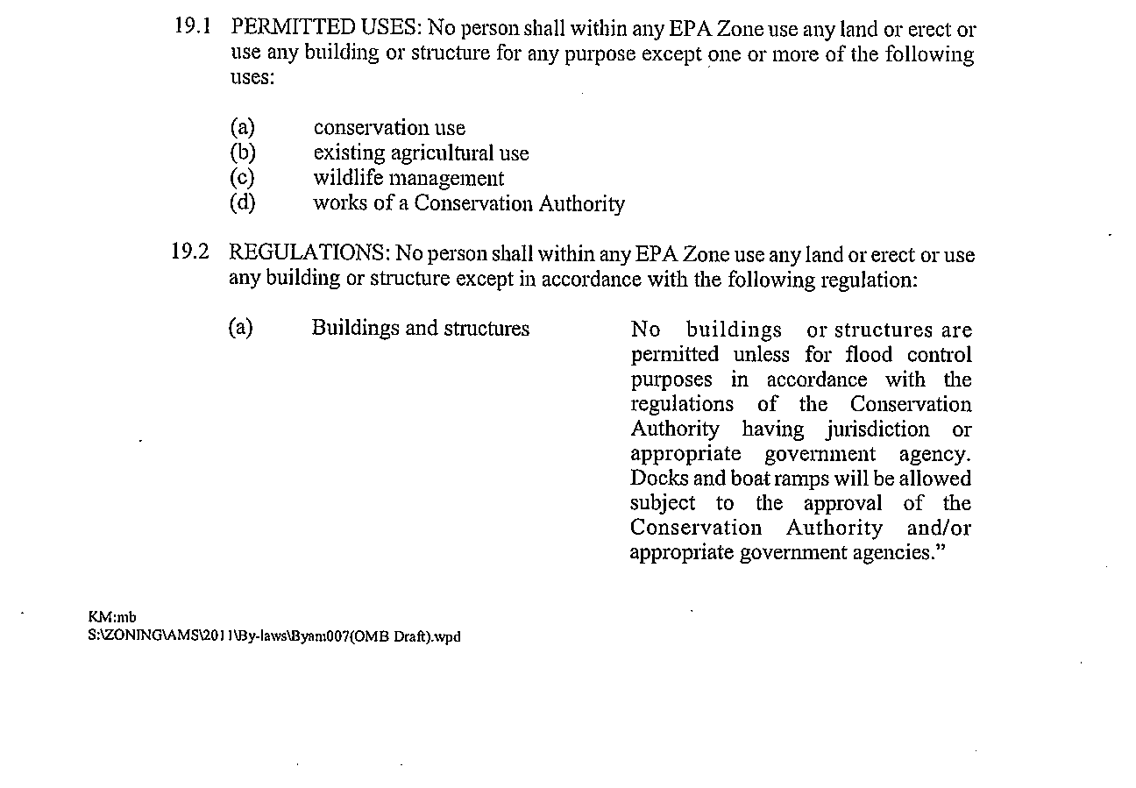
ATTACHMENT #2

CITY OF NIAGARA FALLS

By-law No. 2011-137

A by-law to amend By-law No. 79-200, to introduce regulatory provisions for drive-through
facilities.

THE COUNCIL OF THE CORPORATION OF THE CITY OF NIAGARA FALLS ENACTS AS FOLLOWS:

1. Section 2 - Definitions of By-law No. 79-200 is amended by adding the following thereto:
“2.16.1 DRIVE-THROUGH FACILITY means an establishment that is accessory to a restaurant, retail store or financial institution where products or services are dispensed by an attendant or an automated machine, to persons who remaining vehicles that are in a designated queuing lane.”

2. Clause (a) of section 4.19.1 of By-law No. 79-200 is amended by adding the following
thereto:

“A drive-through facility accessory to a restaurant or retail store 12 spaces in a queuing lane, measured from where products are dispensed, each with a minimum length of 6 metres and a minimum width of 2.75 metres, a drive-through facility accessory to a financial institution 3 spaces in a queuing lane, measured from where services are dispensed, each with a minimum length of 6 metres and a minimum width of 2.75 metres”

3. Section 4 - General Provisions of By-law No. 79-200 is amended by adding the following
thereto:

“4.34 DRIVE-THROUGH FACILITIES: A drive-through facility is permitted in a NC Zone, a GC Zone, a SC Zone, a TC Zone and an AS Zone and shall be separated from the boundary of a residential zone by a minimumperpendicular distance of 10 metres, measured from the speaker box.”

