PL121211

Ontario Municipal Board
Commission des affaires municipales de l’Ontario
ISSUE DATE:

November 22, 2013

Eco Building Inc. has appealed to the Ontario Municipal Board under subsection 34(11) of the Planning Act, R.S.O. 1990, c. P.13, as amended, from Council’s refusal to enact a proposed amendment to Zoning By-law 3581-86 of the City of Hamilton to rezone lands respecting 24 Brock Street North from “RM1-‘H’” (Low to Medium Density Multiple Dwelling – Holding) Zone, modified, to the “RM3” (Medium to High Density Multiple Dwelling) Zone, modified, to permit the development of a 6 storey tiered residential building
OMB File No.: PL121211

APPEARANCES:

Parties |  | Counsel
Eco Building Inc. (“Applicant”)  Jane Lowry and William Hilson (“Objectors”)  City of Hamilton (“City”) |  | Stephen D’Agostino  Michael Connell  Michael Kovacevic

MEMORANDUM OF ORAL DECISION DELIVERED BY STEVEN STEFANKO ON NOVEMBER 6, 2013 AND ORDER OF THE BOARD
- At the commencement of this Prehearing, I was advised that an agreement had been reached as to the contents of the by-laws required to facilitate the construction of an apartment building at 24 Brock Street North.
- The agreement in question is reflected by Minutes of Settlement dated November 6, 2013 (“MOS”) executed by the Applicant, the Objectors and certain other affected individuals who reside in the immediate area of the site. Although the City is not a signatory to the MOS, it does support the by-laws which have been agreed upon.
- One by-law (“Dundas By-law”) amends Zoning By-law No. 3581-86 (“ZBL 3581”) for the Town of Dundas (“Dundas”).The Dundas By-law is annexed hereto and marked as Attachment 1. Among other things, it sets out the performance standards for the apartment building to be constructed. The other by-law (“City By-law”) amends Zoning By-law No. 05-200 (“ZBL 05”) for the City. It is annexed to this decision and marked as Attachment 2. Its purpose is to state that the permitted use for a portion of the subject property is Conservation.
- Stephen Fraser, a planner with A.J. Clarke & Associates Ltd., provided expert land use planning evidence in support of the agreement reached. He pointed out that the property was formerly used for industrial purposes but is currently vacant and is underutilized. In his opinion, the proposal represents the type of intensification contemplated by the Provincial Policy Statement, 2005 (“PPS”) and the Growth Plan for the Greater Golden Horseshoe (“Growth Plan”) and is within the policy provisions of the Dundas Official Plan (“OP”). According to Mr. Fraser, what is proposed is consistent with the PPS, conforms to the Growth Plan and the OP and represents good planning.
- Only one participant spoke in opposition to the agreement reached, that being John Parcher. Mr. Parcher resides a short distance away from the development at 238 Melville Street. In his view, there is not sufficient parking in the area to accommodate the proposal and he is concerned that additional traffic will be generated. Although I have no doubt that Mr. Parcher’s views are sincerely held, they do not override the planning evidence of Mr. Fraser, the MOS and the position of the City in this matter.
- Based on all of the foregoing therefore, it is ordered that ZBL 3581 is amended in accordance with the Dundas By-law and that ZBL 05 is amended in accordance with the City By-law.

“Steven Stefanko”

Steven Stefanko
Vice Chair
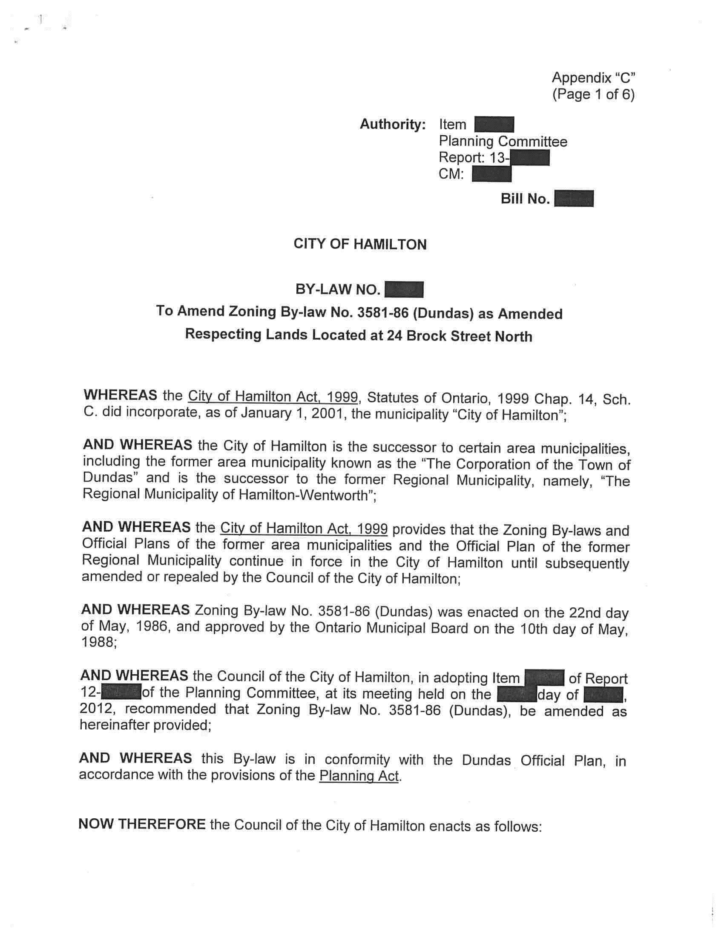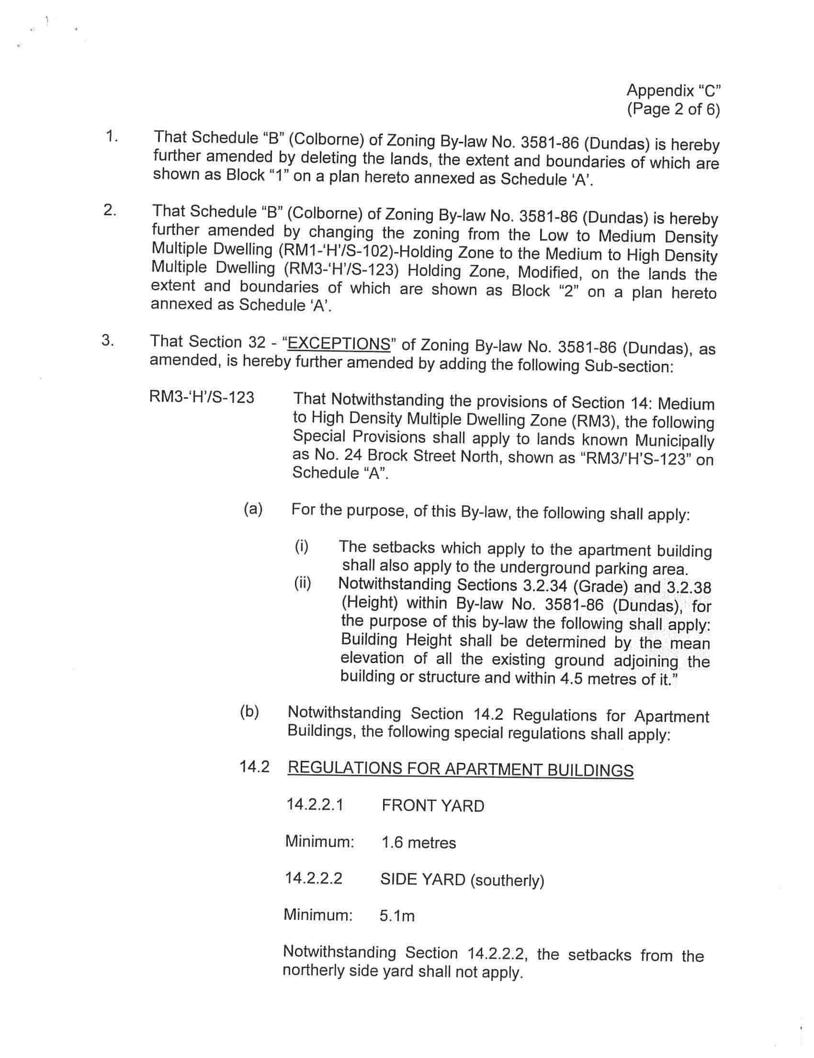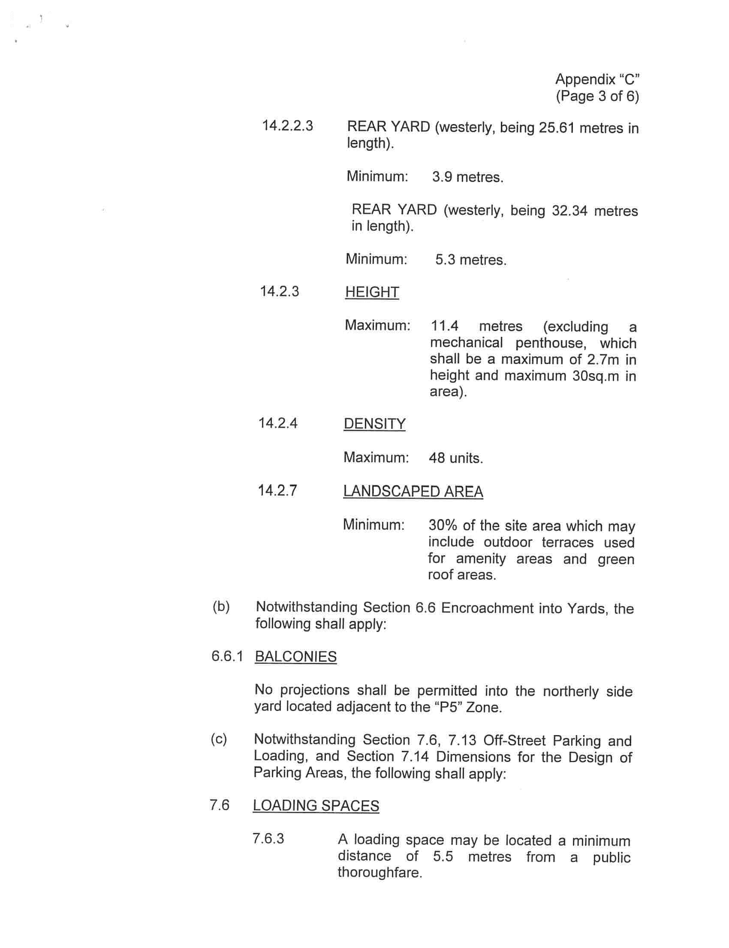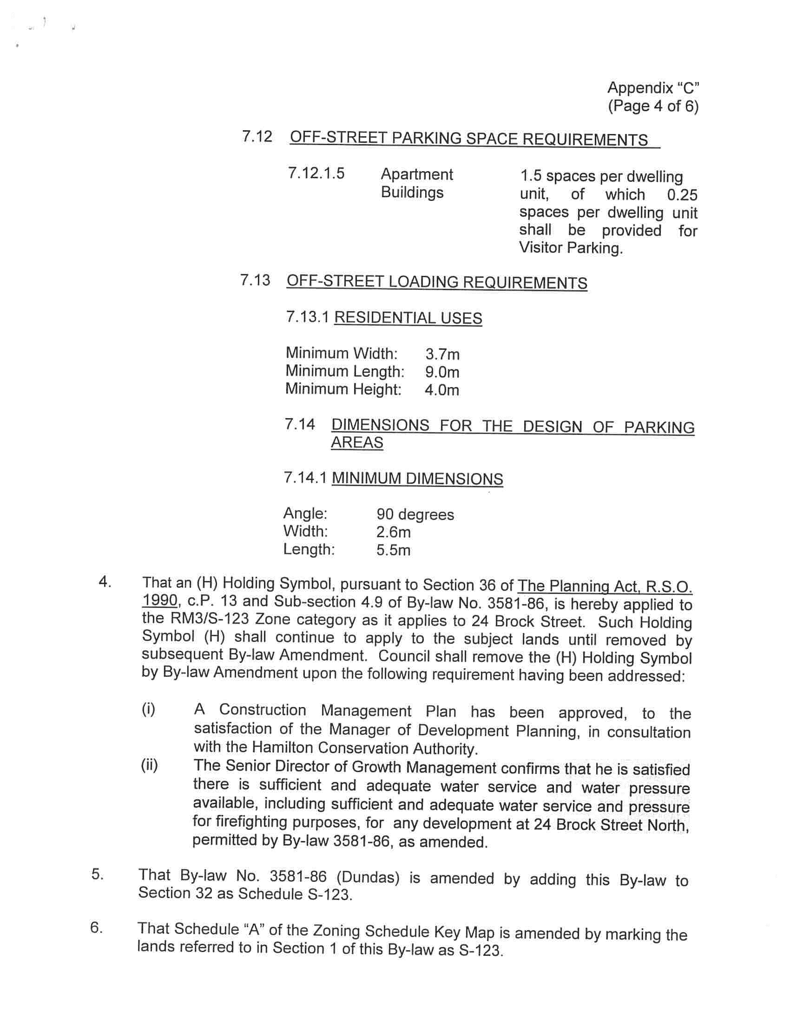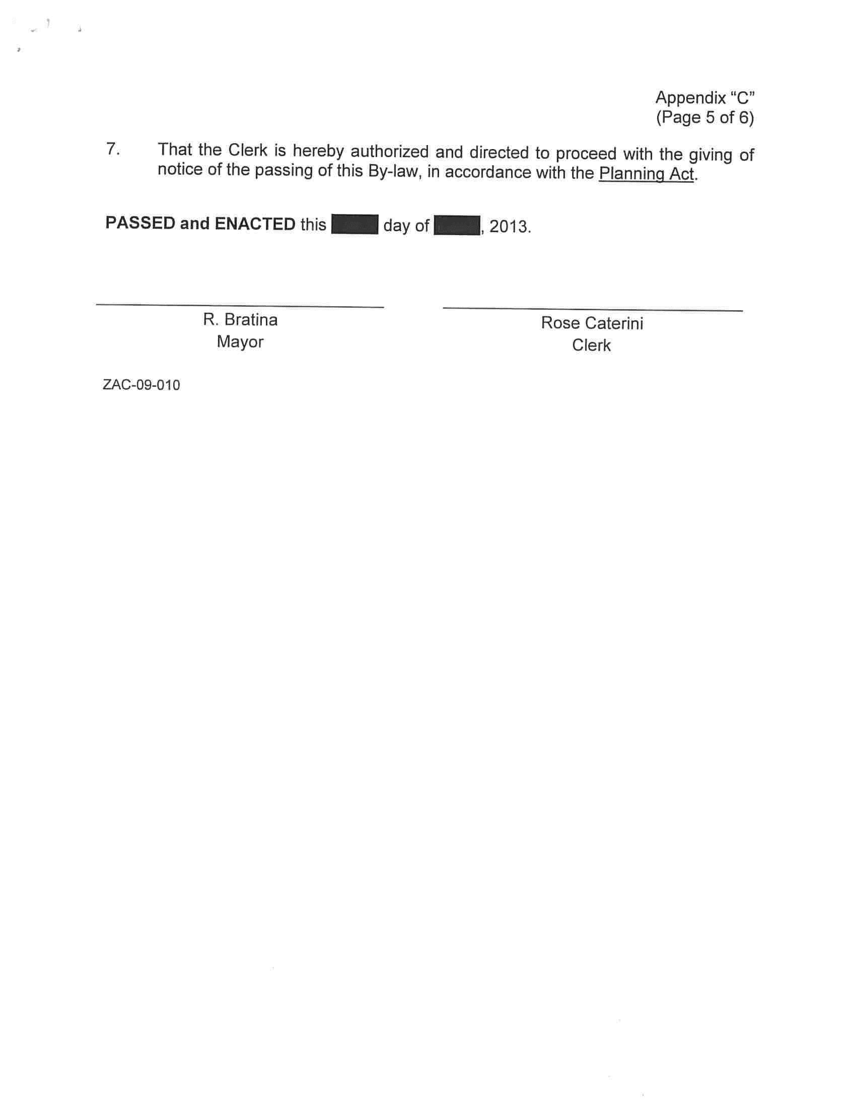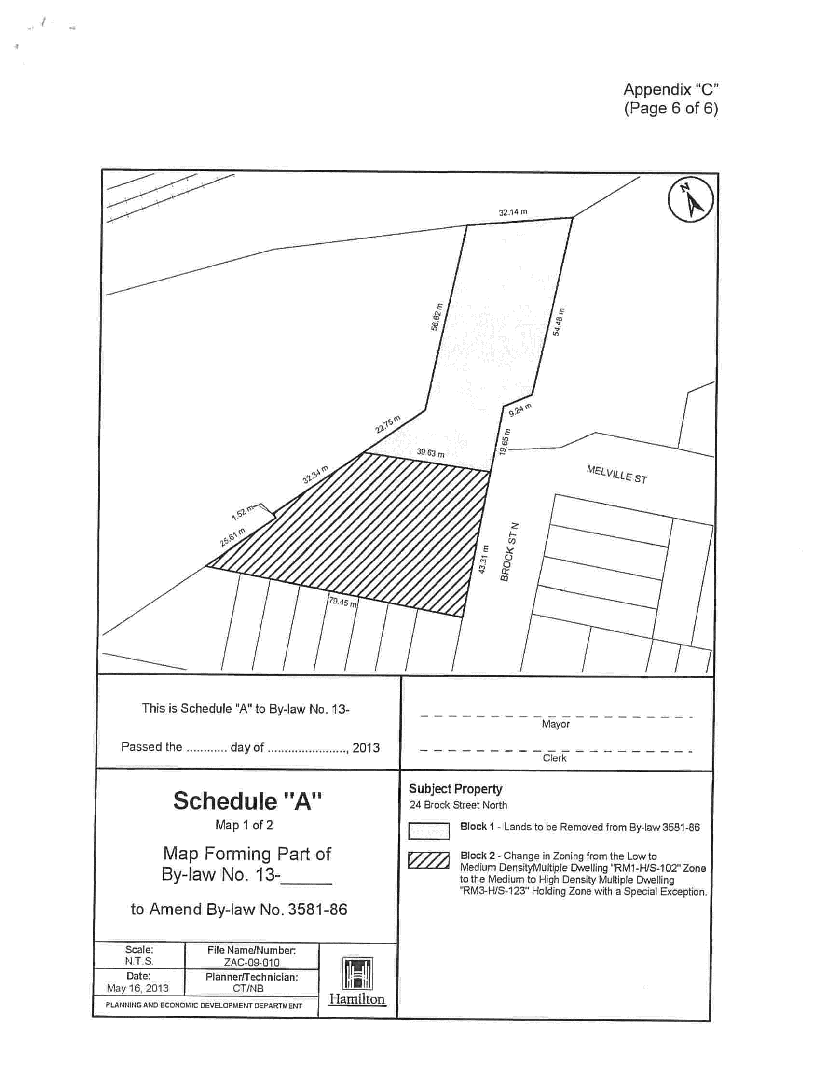
Attachment 1
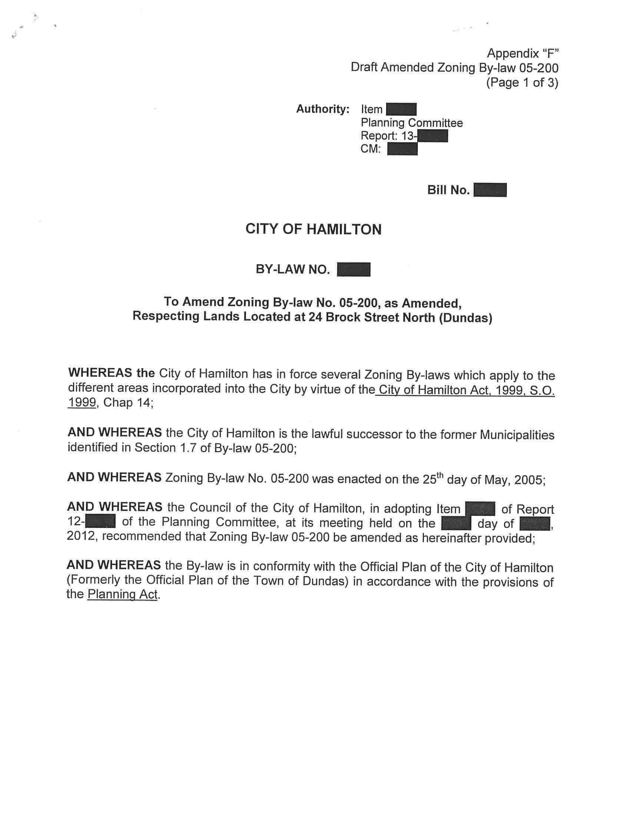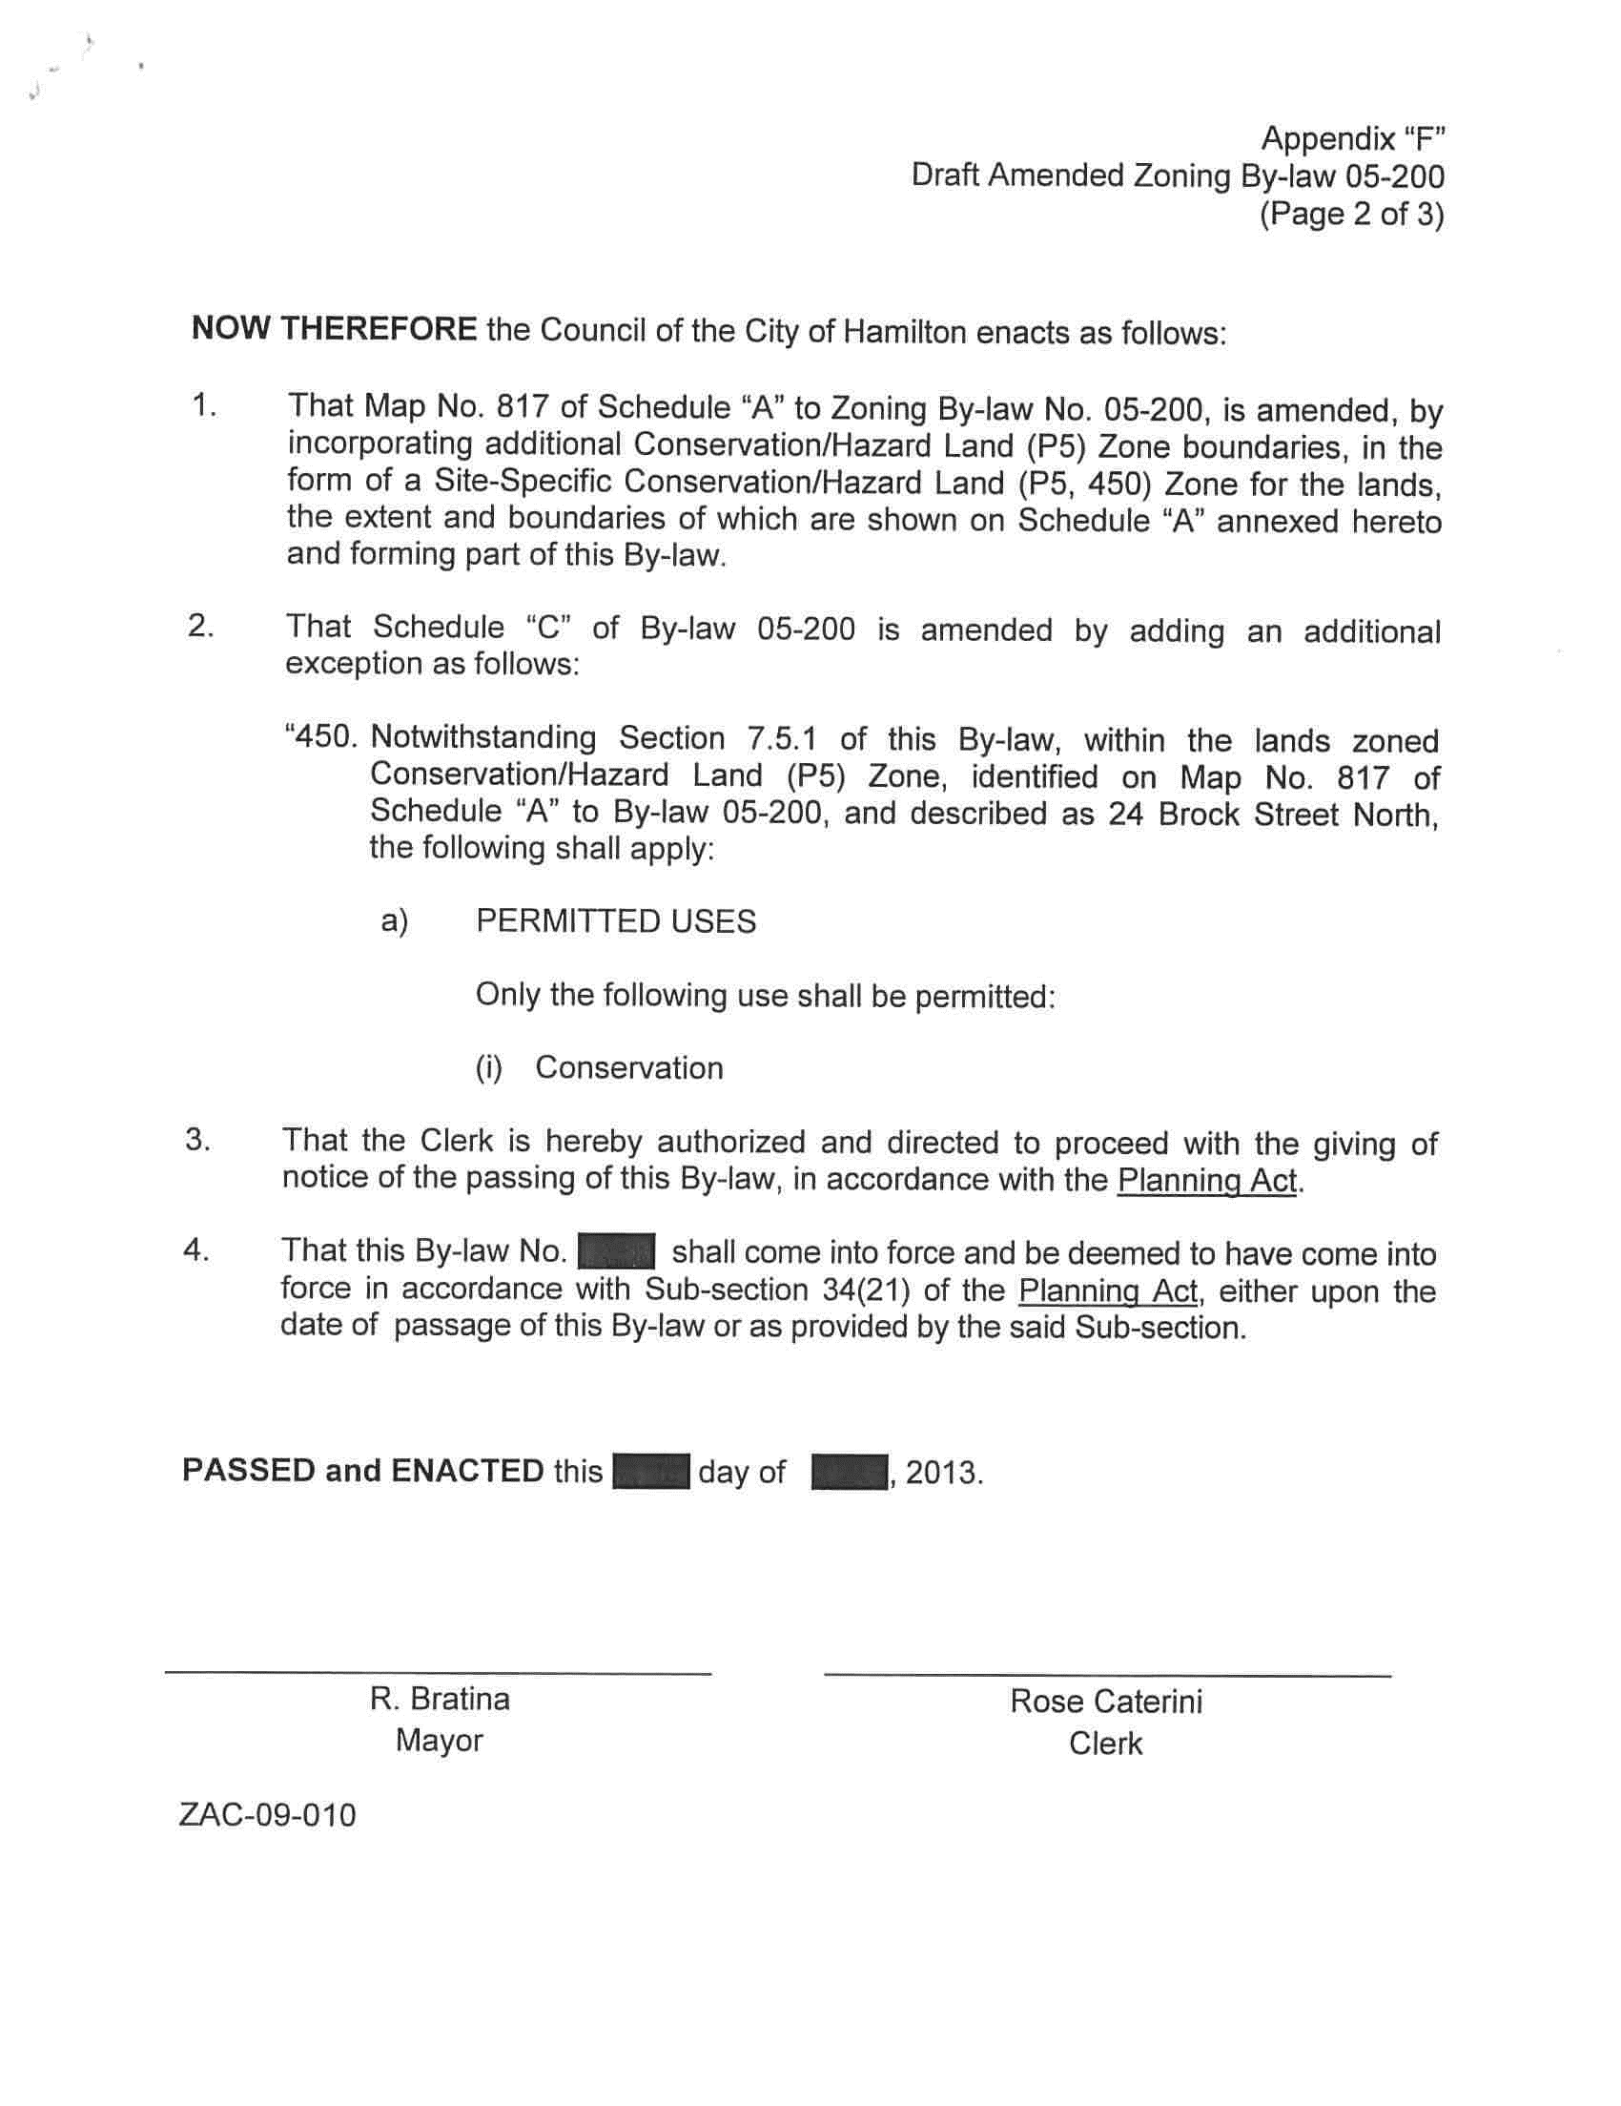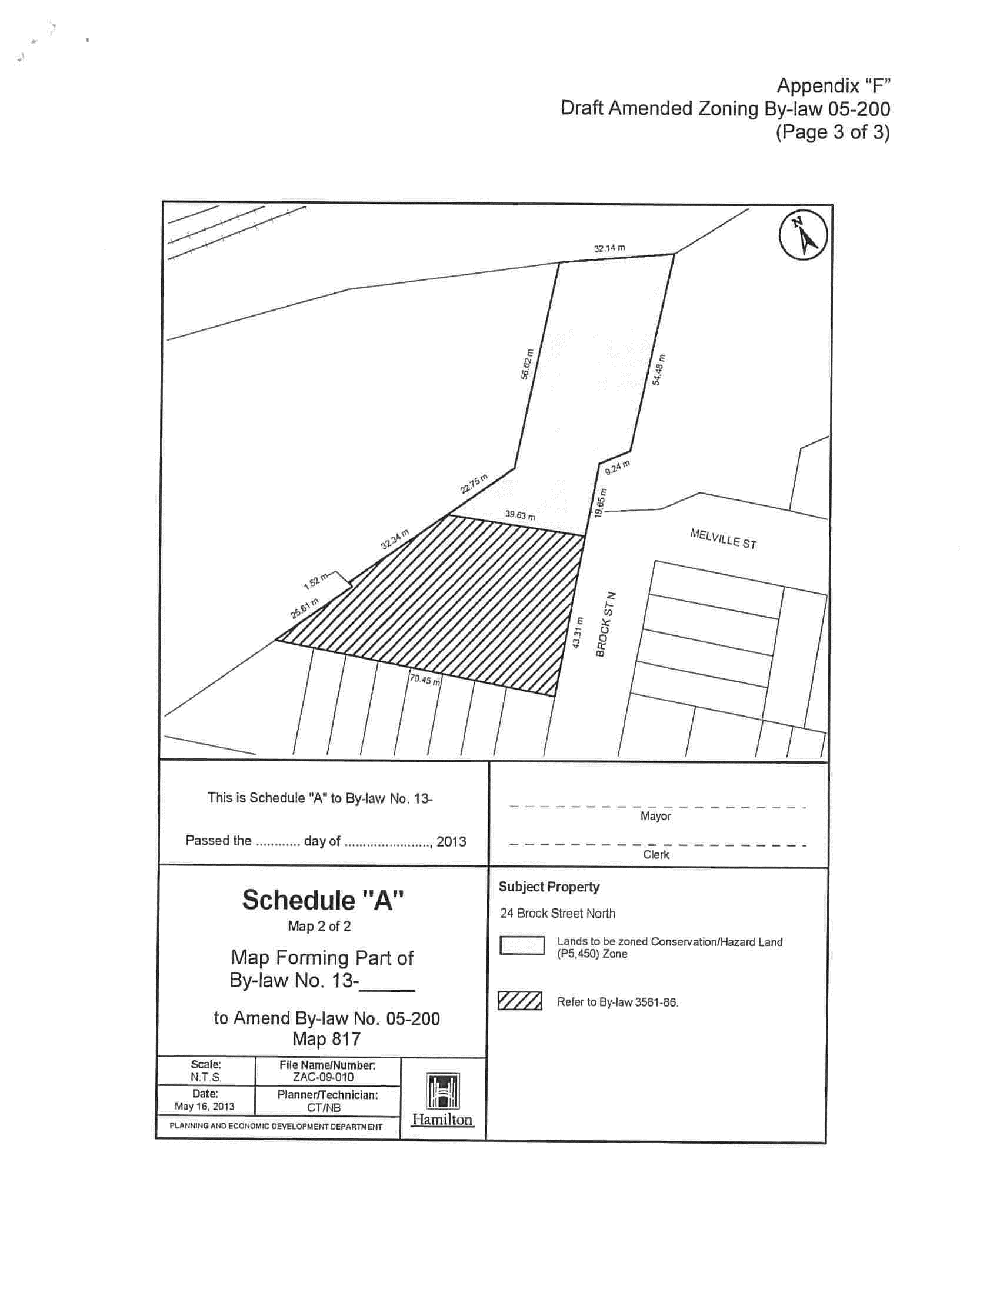
Attachment 2

