
Local Planning Appeal Tribunal
Tribunal d’appel de l’aménagement local

ISSUE DATE: | March 11, 2021 | CASE NO(S).: | PL200251

The Ontario Municipal Board (the “OMB”) is continued under the name Local Planning Appeal Tribunal (the “Tribunal”), and any reference to the Ontario Municipal Board or Board in any publication of the Tribunal is deemed to be a reference to the Tribunal.

PROCEEDING COMMENCED UNDER subsection 34(19) of the Planning Act, R.S.O. 1990, c. P.13, as amended
Appellant: | Annovator Developments
Appellant: | Orlando Corporation
Subject: | By-law No. 0121-2020
Municipality: | City of Mississauga
LPAT Case No.: | PL200251
LPAT File No.: | PL200251
LPAT Case Name: | Annovator Developments v. Mississauga (City)

Heard: | March 3, 2021 via video hearing

APPEARANCES:
Parties | Counsel
Orlando Corporation | L. F. Longo
City of Mississauga | M. Minkowski

DECISION DELIVERED BY SUSAN de AVELLAR SCHILLER AND ORDER OF THE TRIBUNAL
- The City of Mississauga (“City”) adopted By-law No. 0121-2020 (“By-law”). Two appeals were filed: one by Annovator Developments (“Annovator”) and one by Orlando Corporation (“Orlando”).
- This is the first Case Management Conference (“CMC”) in these matters. The Tribunal reviewed the Affidavit of Sean Kenney, being the Affidavit of Service declared December 21, 2020. The Tribunal was satisfied that Notice of this CMC was given in accordance with the Tribunal’s directions. The Tribunal marked the Affidavit of Service as Exhibit 1 in these proceedings.
- The Tribunal had before it no requests for either party or participant status in these proceedings.
- The City wished to scope both the Annovator appeal and that of Orlando and bring the remaining portions of the By-law into effect. The City has brought a motion, to be heard at this CMC, to do just that.
- Annovator withdrew its appeal prior to the motion being heard.
- The appeal filed by Orlando was focused and specific. For certainty, the City continued its motion to scope Orlando’s appeal. Orlando consents to the formal scoping of its appeal and to the result of bringing the remaining portions of the By-law into force and effect.
- The Motion Record included an Affidavit by Christian Binette, sworn January 8, 2021. Mr. Binette is a Candidate Member of the Ontario Professional Planners Institute who executed an Acknowledgment of Expert’s Duty form.
- Having read and considered the affidavit of Mr. Binette, and having considered the Motion and Orlando’s consent to the Motion, the Tribunal grants the Motion as follows:
  - The Appeal by Orlando is scoped to the following sections of By-law No. 0121-2020 only:
(i) Paragraph 14: Table 5.2.1 – 01 to 03 Permitted Uses and Zone Regulations, Line 13.0;
(ii) Paragraph 17: Sections 5.2.3.1 (O2-1), 5.2.3.3 (O2-3), 5.2.3.4 (O2-4), 5.2.3.7 (O2-7), 5.2.3.8 (O2-8) and Paragraph 18: Sections 5.2.4.1 (O3-1), 5.2.4.2 (O3-2), 5.2.4.3 (O3-3), 5.2.4.7 (O3-7), 5.2.4.9 (O3-9) and 5.2.4.10 (O3-10) – Shared parking permitted on other lots;
(iii) Paragraph 17: Section 5.2.3.1 (O2-1), 5.2.3.3 (O2-3) and Paragraph 18: Sections 5.2.4.1 (O3-1), 5.2.4.3 (O3-3) and 5.2.4.3;
(iv) Paragraph 17: Sections 5.2.3.1 (O2-1), 5.2.3.8 (O2-8) and Paragraph 18: Sections 5.2.4.1 (O3-1), 5.2.4.7 (O3-7), 5.2.4.9 (O3-9);
(v) Paragraph 11: Section 5.1.3.7 – Uses Accessory to a Permitted Use in an 02 and 03 Zone;
(vi) Paragraph 17: Section 5.2.3 – O2 Exception Zones; and Paragraph 18: Section 5.2.4 – O3 Exception Zones;
(vii) Paragraph 17: Section 5.2.3.3.1 – O2 Exception Zones;
  - The Appeal by Orlando, as scoped above, shall only apply to the lands owned by Orlando which are identified as Orlando Corporation Property, Gateway Corporate Centre.
  - The remainder of By-law No. 0121-2020 is declared in force and effect.
- The Tribunal discussed a draft procedural order with the parties. The parties advised the Tribunal that meetings and discussions were underway, and expected to continue, to narrow or settle the issues. The Tribunal is satisfied that if there is no narrowing or settlement that a four-day hearing is appropriate.
- The Tribunal set these matters down for a video hearing to commence at 10 a.m. on Tuesday, November 2, 2021. Log in details for the video hearing will be sent under separate cover to the parties.
- In order to provide sufficient and appropriate time for the parties to engage in their discussions, the Tribunal directed the parties to advise the Tribunal not later than Friday, July 30, 2021 whether:
  - Narrowing of the issues has not been successful and the full four days of hearing are required;
  - There has been a narrowing of issues, such that all four days would not be required; or
  - There has been a full settlement and only the first day of the hearing will be required.
- The Tribunal will take such actions as it considers appropriate once the requisite advice is received.
- As a result of the discussion at the CMC, noted above, the parties have submitted a further draft Procedural Order. The Procedural Order to govern these proceedings is found at Attachment 1 appended to this decision.
ORDER
- The Tribunal orders that:
  - The Appeal by Orlando Corporation is formally scoped to the following sections of By-law No. 0121-2020 only:
(i) Paragraph 14: Table 5.2.1 – 01 to 03 Permitted Uses and Zone Regulations, Line 13.0;
(ii) Paragraph 17: Sections 5.2.3.1 (O2-1), 5.2.3.3 (O2-3), 5.2.3.4 (O2-4), 5.2.3.7 (O2-7), 5.2.3.8 (O2-8) and Paragraph 18: Sections 5.2.4.1 (O3-1), 5.2.4.2 (O3-2), 5.2.4.3 (O3-3), 5.2.4.7 (O3-7), 5.2.4.9 (O3-9) and 5.2.4.10 (O3-10) – Shared parking permitted on other lots;
(iii) Paragraph 17: Section 5.2.3.1 (O2-1), 5.2.3.3 (O2-3) and Paragraph 18: Sections 5.2.4.1 (O3-1), 5.2.4.3 (O3-3) and 5.2.4.3;
(iv) Paragraph 17: Sections 5.2.3.1 (O2-1), 5.2.3.8 (O2-8) and Paragraph 18: Sections 5.2.4.1 (O3-1), 5.2.4.7 (O3-7), 5.2.4.9 (O3-9);
(v) Paragraph 11: Section 5.1.3.7 – Uses Accessory to a Permitted Use in an 02 and 03 Zone;
(vi) Paragraph 17: Section 5.2.3 – O2 Exception Zones; and Paragraph 18: Section 5.2.4 – O3 Exception Zones;
(vii) Paragraph 17: Section 5.2.3.3.1 – O2 Exception Zones;
  - The Appeal by Orlando Corporation, as scoped above, shall only apply to the lands owned by Orlando Corporation which are identified in the following map as Orlando Corporation Property, Gateway Corporate Centre:
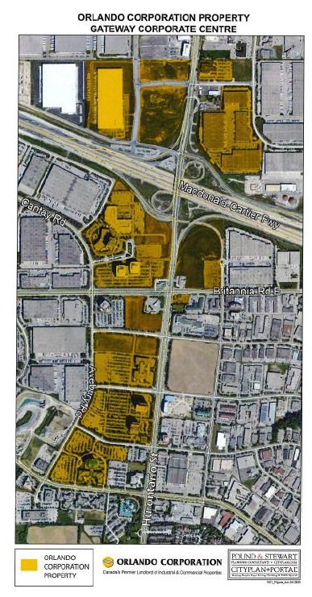
- The Tribunal declares that the remaining portions of By-law No. 0121-2020 are in force and effect.
- The Tribunal orders that the Procedural Order in these matters is as found at Attachment 1.

“Susan de Avellar Schiller”

SUSAN de AVELLAR SCHILLER
VICE-CHAIR

If there is an attachment referred to in this document,
please visit www.olt.gov.on.ca to view the attachment in PDF format.

Local Planning Appeal Tribunal
A constituent tribunal of Ontario Land Tribunals
Website: www.olt.gov.on.ca Telephone: 416-212-6349 Toll Free: 1-866-448-2248

