Ontario Land Tribunal
Tribunal ontarien de l’aménagement
du territoire

ISSUE DATE: | December 10, 2021 | CASE NO(S).: | PL200311

PROCEEDING COMMENCED UNDER subsection 34(19) of the Planning Act, R.S.O. 1990, c. P.13, as amended
Appellant: | Toronto Standard Condominium Corp. #2376
Subject: | By-law No. BL 243-2020
Municipality: | City of Toronto
OLT Case No.: | PL200311
OLT File No.: | PL200311
OLT Case Name: | Toronto Standard Condominium Corp. #2376 v. Toronto (City)
PROCEEDING COMMENCED UNDER subsection 34(19) of the Planning Act, R.S.O. 1990, c. P.13, as amended
Appellant: | Toronto Standard Condominium Corp. #2376
Subject: | By-law No. BL 244-2020
Municipality: | City of Toronto
OLT Case No.: | PL200311
OLT File No.: | PL200312
Heard: | November 22, 2021 by video hearing (“VH”)

APPEARANCES:
Parties | Counsel
Frala Dick Holdings Inc. and | Eileen Costello
544 King Street West Inc. (“Applicant”)
City of Toronto (“City”) | Mark Piel
Toronto Standard Condominium Corp. | David Donnelly
#2376 (“Appellant”)

MEMORANDUM OF ORAL DECISION DELIVERED BY WILLIAM R. MIDDLETON ON NOVEMBER 22, 2021 AND ORDER OF THE TRIBUNAL

INTRODUCTION

- Pursuant to the Procedural Order issued dated April 14, 2021, this matter was set down for a hearing to commence for 10 days starting at 10 a.m. on Monday, November 22, 2021 (“Hearing”) to adjudicate the appeals of the Appellant pertaining to the City of Toronto’s (the “City”) enactment of amendments to Zoning By-laws Nos. 438-86 and 569-2013 (“ZBAs”) sought by the Applicant in relation to a mixed use development at the Applicant’s property located at the property municipally known as 540-544 King Street West and 1-7 Morrison Street in the City (“Subject Site”).

- Shortly before the Hearing, the Parties advised that they had reached a settlement of this appeal and filed the requisite materials with the Tribunal for this settlement hearing which was conducted on November 22, 2021 by VH. In particular, Mr. Piel on behalf of the City advised that the City had no issues for the hearing of this matter, pursuant to City Council’s resolution regarding Item CC37.1 dated November 9 and 10, 2021. Subsequent to the VH, Mr. Piel advised the Tribunal that the City consented to the form and content of the two ZBAs now appended as Attachments 1 and 2 to this Decision (“Attachments”).

- In support of the settlement, the Applicant’s counsel delivered on November 18, 2021 a Settlement Hearing Document Book comprising 6 tabs and 116 pages. The Applicant’s counsel also filed a lengthy affidavit of Mr. Louis Tinker sworn November 18, 2021 with Exhibits A to K appended thereto comprising 275 pages. Counsel for the City had no objections to any of those materials and the Appellant’s counsel advised that he consented to them.

- Mr. Tinker is a Registered Professional Planner with over 20 years of land use planning experience with both the public and private sector. He was qualified, without objection, to provide expert opinion evidence to the Tribunal on land use planning matters and concerning the settlement reached by the Parties with respect to the final form of the Attachments.

- Mr. Tinker testified that:

- The Subject Site is located on King Street West, approximately mid-way between Spadina Avenue and Bathurst Street and forms part of a City block bound by King Street West, Portland Street, Adelaide Street West and Brant Street. The surrounding block contains a number of existing, approved and proposed mixed-use buildings that reflect a taller, mid-rise scale;

- From a transit perspective, the Subject Site has excellent access to transit services and is located approximately 1.35 kilometres (approximately a 15-minute walk) west of the St. Andrew subway stations on Yonge-University subway line. The Subject Site is also close to a proposed subway station on the proposed Ontario Line, which will be located at the at the intersection of King Street West and Bathurst Street;

- On March 6, 2018, on behalf of the Applicant, Bousfields Inc. submitted applications to amend the applicable City’s Zoning By-laws Nos. 438-86 and 569-2013 to permit the redevelopment of the Subject Site for a mixed-use building, with a height of 12- and 13-storeys, containing office, residential and retail uses with a total gross floor area of approximately 27,625 square metres. The proposed development included 77 residential dwelling units, approximately 15,483 square meters of office space and 3,205 square metres of street related retail uses. (“Original Proposal”). As part of the Original Proposal, the existing heritage building at 544 King Street West was proposed to be demolished;

- The applications were deemed complete by the City on April 4, 2018. Subsequently, on April 30, 2018, a community consultation meeting was held to present the Original Proposal to the community and to obtain feedback;

- At its meeting held July 23, 24, 25, 26, 27 and 30, 2018, Council directed City staff to continue to review the applications and resolve any outstanding issues. The Applicant continued to work with City staff and the community to resolve issues with the Original Proposal;

- Following extensive discussions with the City and community stakeholders, a resubmission was filed on August 15, 2019 to revise the Original Proposal to a 12- and 15-storey mixed-use building (with an overall height of approximately 50 metres, including mechanical penthouse), containing office, residential and retail uses, with a total gross floor area of 25,685 square metres and an overall density of 8.81 FSI (“Revised Proposal”). These revisions were made to address the comments made by the community, the Toronto District School Board, and the City, and are described further below;

- In a Final Report dated October 18, 2019, City staff recommended that Council approve the applications based on the Revised Proposal. In City staff’s view, the Revised Proposal represented a development concept that is consistent with the Provincial Policy Statement (“PPS”), conforms to the Growth Plan for the Greater Golden Horseshoe (“Growth Plan”), and conforms with the City’s Official Plan (“OP”), the King-Spadina Secondary Plan, the Downtown Plan, and the King-Spadina Urban Design Guidelines;

- At its meeting held December 17 and 18, 2019, Council adopted the staff recommendation to approve the Revised Proposal. On February 26, 2020, Council passed the Zoning By-laws Nos. 243-2020 and 244-2020 to give effect to the Revised Proposal. However, on July 23, 2020, the ZBAs were appealed by a single appellant, being Toronto Standard Condominium Corporation No. 2376, or Fashion House (the “Appeal”);

- Following the first Case Management Conference in this proceeding held on November 6, 2020, the Applicant and the former Party Toronto Land Corporation (“TLC”) (now a Participant only) engaged in comprehensive discussions to resolve TLC’s issues with the Revised Proposal. The resolution of these issues is reflected in Minutes of Settlement dated December 14th, 2020;

- The remaining Parties, being the Appellant, the City and the Applicant, engaged in Tribunal-assisted mediation over 2 days on July 12 and 14, 2021. Further discussions between the Applicant and the Appellant followed and counsel to the Appellant wrote to advise all Parties indicating that its issues with the Revised Proposal had been resolved, that it withdrew any objections, and that it consented to the Tribunal’s issuance of an Order approving revisions to the ZBAs;

- The Revised ZBAs, along with supporting materials, were provided to City Planning and City Legal staff for review. A Confidential Request for Directions Report, dated October 28, 2021, was provided to City Council for its consideration at its meeting of November 9 and 10, 2021. Counsel for the City has now advised the Tribunal and the Parties that the City does not have any issues for the Hearing;

- The Settlement Proposal and Revised ZBAs appropriately implement the Revised Proposal and will enable the redevelopment of the Subject Site for well-designed mixed-use building, which is compatible with the existing and planned area context. The redevelopment is consistent with the PPS, conforms to the Growth Plan and the in-force City of Toronto OP;

- The Settlement Proposal is consistent with the PPS 2020 and in particular: the policies that promote healthy, liveable and safe communities (Policy 1.1.1); the policies that apply to development within settlement areas (Policies 1.1.3.2, 1.1.3.3, 1.1.3.4 and 1.1.3.5); the policies that promote economic development and competitiveness (Policy 1.3.1); the policies that planning authorities provide for a range and mix of housing options and densities (Policy 1.4.3); the policy that promotes a land use pattern, density and mix of uses that minimize vehicle trips and support transit and active transportation (Policy 1.6.7.4); the policies that support long-term economic prosperity (Policy 1.7.1); the policies that support energy conservation and efficiency, improved air quality, reduced greenhouse emissions, and preparing for the impacts of a changing climate through land use and development patterns (Policy 1.8.1); and the policies that apply to cultural heritage (Policies 2.6.1 and 2.6.4);

- The Settlement Proposal conforms and does not conflict with the applicable policies of the Growth Plan, in particular: policies related to managing growth (Policies 2.2.1(2)(c), 2.2.1(3)(c) and 2.2.1(4)); policies for achieving the minimum intensification targets within delineated built-up areas (Policy 2.2.2(3)); policies that apply to urban growth centres (Policies 2.2.3(1) and 2.2.3(2)); policies that apply to Lands adjacent to or near to existing and planned frequent transit (Policy 2.2.4(10)); policies with respect to housing (Policies 2.2.6(1) and 2.2.6(2)); policies that apply to transportation system within the GGH (Policy 3.2.2(2)); policies that apply to public transit (Policies 3.2.3(1) and 3.2.3(2)) and policies that apply to cultural heritage resources (Policies 4.2.7(1) and 4.2.7(2);

- The Settlement Proposal conforms with the City OP, in particular: the policies related to growth management (Policies 2.1(3), 2.2(2) 2.2.1(1), 2.2.1(4), 2.2.1(5), 2.2.1(6)); policies related to the integration of transportation and land use planning (Policies 2.4(4), 2.4(7) and 2.4(8)); built form policies (Policies 3.1.2(1), 3.1.2(2), 3.1.2(3), 3.1.2(4), 3.1.2(5), 3.1.2(6)); policies related to heritage conservation (Policies 3.1.5(2), 3.1.5(5), 3.1.5(21), 3.1.5(23), 3.1.5(24), 3.1.5(26), 3.1.5(32), 3.1.5(43)); housing policies (Policies 3.2.1(1) and 3.2.1(2)), and land use policies that apply to Regeneration Areas (Policy 4.7(2)). The Settlement Proposal conforms with the specifically those policies that apply to lands in the Downtown, Regeneration Areas, built form and cultural heritage conservation;

- The Settlement Proposal conforms with applicable policies of the in-force King-Spadina Secondary Plan and has appropriate regard for the relevant guidelines of the King-Spadina Urban Design Guidelines;

- The proposed residential, retail and offices land uses are consistent with the PPS and conforms with the Growth Plan and OP. The proposed uses are also permitted under the existing as-of-right zoning. From a built form and urban design perspective, the Settlement Proposal’s height and massing are contextually appropriate and will represent a high-quality architectural addition to the area. The 12-storey building (50 metres) will fit harmoniously with the existing and planned built form context and will be compatible with the height and massing of existing and approved developments in the West Precinct of the King-Spadina area. Moreover, the significant reduction in the height of the base building, in addition to the proposed stepbacks above the base sculpts the massing and reduces the impact on adjacent properties.

- The Tribunal accepts the opinions and conclusions reached by Mr. Tinker as described in paragraph [5] above and is of the view that the Settlement, the Applicant’s proposed development on the Subject Site and the Revised ZBAs are consistent with the PPS, conform with the Growth Plan and the City’s OP and respect principles of good planning all in accordance with subsection 1.1 and sections 2 and 3 of the Planning Act, R.S.O. 1990, c. P. 13 as amended.

ORDERS

- The Tribunal orders that:

  - The Appeals filed by Toronto Standard Condominium Corporation No. 2376 of the Council of the City of Toronto’s passage of Zoning By-laws Nos. 243-2020 and 243-2020 are allowed in part; and

  - City of Toronto Zoning By-law No. 438-86, as amended, and Zoning By-law No. 569-2013, as amended, are amended as set out in the Revised Zoning By-law Amendments which are appended hereto as Attachments 1 and 2 to this Order. In all other respects, the Tribunal orders the Appeal is dismissed.

“William R. Middleton”

WILLIAM R. MIDDLETON
MEMBER

Ontario Land Tribunal
Website: www.olt.gov.on.ca Telephone: 416-212-6349 Toll Free: 1-866-448-2248

The Conservation Review Board, the Environmental Review Tribunal, the Local Planning Appeal Tribunal and the Mining and Lands Tribunal are amalgamated and continued as the Ontario Land Tribunal (“Tribunal”). Any reference to the preceding tribunals or the former Ontario Municipal Board is deemed to be a reference to the Tribunal.
PL200311 – Attachment 1
CITY OF TORONTO
BY-LAW 243-2020
To amend former City of Toronto Zoning By-law 438-86, as amended, with respect to the lands municipally known as 540-544 King Street West and 1-7 Morrison Street.
Whereas authority is given to Council by Section 34 of the Planning Act, R.S.O. 1990, c. P.13, as amended, to pass this By-law; and
Whereas Council of the City of Toronto has provided adequate information to the public and has held at least one public meeting in accordance with the Planning Act; and
Whereas the Official Plan for the City of Toronto contains provisions relating to the authorization of increases in height and/or density of development; and
Whereas pursuant to Section 37 of the Planning Act, a by-law under Section 34 of the Planning Act, may authorize increases in the height or density of development beyond those otherwise permitted by the by-law for the provision of such facilities, services or matter as are set out in the by-law; and
Whereas the owner of the aforesaid lands has elected to provide the facilities, services and matters hereinafter set out; and
Whereas the Council of the City of Toronto has required the owner of the aforesaid lands to enter into one or more agreements for the provision of certain facilities, services and matters in return for the increases in height and density permitted by this By-law;
The Council of the City of Toronto enacts:

- Pursuant to Section 37 of the Planning Act, the height and density of development permitted by this By-law are permitted subject to compliance with the conditions set out in this By-law and in return for the provision by the owner of the lot of the facilities, services and matters set out in Schedule A attached to this By-law the provisions of which shall be secured by an agreement or agreements pursuant to Section 37(3) of the Planning Act.

- Upon execution and registration of an agreement or agreements between the City and the owner of the lot on title to the lot pursuant to Section 37 of the Planning Act securing the provision of the facilities, services and matters set out in Schedule A attached to this By-law, the lot is subject to the provisions of this By-law, provided that in the event the said agreement(s) requires the provision of a facility, service or matter as a precondition to the issuance of a building permit, such building may not be erected or used until the owner of the lot has satisfied the said requirements.

- Wherever in this By-law a provision is stated to be conditional upon the execution and registration of an agreement(s) entered into with the City pursuant to Section 37 of the Planning Act, then once such agreement has been executed and registered, such conditional provisions shall continue to be effective notwithstanding any subsequent release or discharge of all or any part of such agreement.

- Except as otherwise provided herein, the provisions of By-law 438-86 shall continue to apply on the lot.

- None of the provisions of Section 2(1) with respect to the definitions of grade, height, lot, residential gross floor area, non-residential gross-floor area, sales office, stacked bicycle parking space and Sections 4(2), 4(5), 4(8) 4(9), 4(13)(a), (c), (d), 4(14), 7(3) Part I, 7(3) Part II 1, 3, 4, 5, 7, 12(1)88, 12(2)132, 12(2)204, 12(2) 246(a)(e)(f), 12(2)380 of Zoning By-law 438-86, as amended, being "A By-law to regulate the use of land and the erection, use, bulk, height, spacing and other matters relating to buildings and structures and to prohibit certain uses of lands and the erection and use of certain buildings and structures in various areas of the City of Toronto", shall apply to prevent the erection and use of a mixed-use building, containing dwelling units and non-residential uses on the lot, provided that:

  - The lot on which the building is to be located comprises at least those lands within the heavy lines on Map 1, attached to and forming part of this By-law;

  - The total aggregate residential gross floor area and non-residential gross floor area of any building or structure erected on the lot shall not exceed 26,200 square metres, provided:

- The residential gross floor area does not exceed 7,200 square metres; and

- The non-residential gross floor area does not exceed 19,000 square metres;

  - A minimum of 10 percent of the dwelling units must contain three or more bedrooms and 20 percent of the dwelling units must contain two or more bedrooms;

  - No portion of any building or structure on the lot shall have a height greater than the height in metres specified on specified by the number following the "HT" symbol as shown on Map 2 attached to By-law 243-2020 except for:

- Wind screens, parapets, terrace or balcony guardrails, balustrades, railings and dividers, pergolas, trellises and signage, planters, eaves, privacy screens, stair enclosures, skylights, mechanical equipment and screens, architectural screens, access hatches, roof assemblies, roof drainage, window washing equipment, chimneys, vents, lightning rods, light fixtures, pavers, elements of a green roof, structures located on the roof used for outside or open air recreation which may project by a maximum of 2.0 metres; and

- Elevator overrun which may project by a maximum of 4 metres;

  - No portion of any building or structure erected and used above grade on the lot shall be located otherwise than wholly within the areas delineated by heavy lines shown on Map 2 attached to By-law 243-2020 except for:

- Cornices, eaves, light fixtures, parapets, art and landscaping features, trellises, window sills, mullions, ventilation shafts, mechanical equipment and screens, architectural screens, ornamental elements, balustrades, railings, fences and privacy screens, wheelchair ramps, site servicing features, window washing equipment, and underground garage ramp and associated structures, which may project by a maximum of 0.5 metres;

- Balconies and terraces which may project by a maximum of 1.5 metres; and

- Awning and canopies which may project by a maximum of 2.0 metres;

  - Notwithstanding section 5(e)(ii) balconies proposed within the hatched area indicated on Map 2 attached to By-law 243-2020 shall only be permitted above the second storey of the building and may project by a maximum of 1.5 metres. No portion of a balcony within the hatched area indicated on Map 2 attached to By-law 243-2020 may be located less than 4.0 metres from the eastern lot line;

  - A stepback is required along King Street West as shown on Map 3 attached to By-law 243-2020;

  - Residential amenity space shall be provided and maintained above grade on the lot in accordance with the following:

- A minimum of 1.5 square metres of indoor residential amenity space for each dwelling unit; and

- A minimum of 1.0 square metres of outdoor residential amenity space for each dwelling unit;

  - A minimum number of parking spaces shall be provided and maintained on the lot in accordance with the following:

- A minimum of 14 parking spaces for residents;
- No parking spaces are required for residential visitors;
- No parking spaces are required for non-residential uses; and
- A minimum of 32 parking spaces in a commercial parking garage;

  - The minimum rates for bicycle parking spaces shall be provided and maintained on the lot in accordance with the following:

- A minimum of 0.9 bicycle parking spaces per dwelling unit;
- A minimum of 0.1 bicycle parking spaces per dwelling unit for visitors;
- A minimum of 31 bicycle parking spaces shall be provided for non-residential uses; and

  - One loading space – Type "G" and two loading spaces – Type "C" shall be provided and maintained on the lot.

- None of the provisions of By-law 438-86, as amended, shall apply to prevent a sales office on the lot, and a sales office shall be exempt from the requirements of By-law 438-86, as amended.

- For the purposes of this By-law, all italicized words and expression have the same meanings as defined in By-law 438-86, as amended, with the exception of the following:

        - bicycle parking space means an area that is equipped for the purpose of parking and securing bicycles;

      - bicycle parking space - visitor and bicycle parking space - occupant may be located within a secured room; and
      - stacked bicycle parking space means a horizontal bicycle parking space that is positioned above or below another bicycle parking space and equipped with a mechanical device providing floor level access to both bicycle parking spaces and has a minimum vertical clearance of 2.5 metres, a minimum width of 0.6 metres and a minimum length of 1.8 metres;

        - Grade means the Canadian Geodetic Elevation of 88.53 metres;

        - Height means the vertical distance between grade and the highest point of the building or structure;

        - Residential gross floor area means the aggregate of the areas of each floor, measured between the exterior faces of the exterior walls of the building or structure at the level of each floor, but excluding:

- Parking, loading and bicycle parking spaces below grade;
- Required loading spaces on the ground level and required bicycle parking spaces at or above grade;
- Common areas, hallways, storage rooms, washrooms, electrical, utility, mechanical and ventilation rooms located above or below grade;
- Shower and change facilities that are required by this By-law for required bicycle parking spaces;
- Amenity space;
- A maximum of 520 square meters of mechanical space located within the building;
- Elevator shafts;
- Garbage shafts;
- Mechanical penthouse; and
- Exit stairwells in the building;

        - Non-residential gross floor area means the aggregate of the areas of each floor, measured between the exterior faces of the exterior walls of the building or structure at the level of each floor, but excluding;

- Parking, loading and bicycle parking spaces below grade;
- Commercial parking garage located below grade;
- Required loading spaces on the ground level and required bicycle parking spaces at or above grade;
- Common areas, hallways, storage rooms, washrooms, electrical, utility, mechanical and ventilation rooms located above or below grade;
- Shower and change facilities that are required by this By-law for required bicycle parking spaces;
- Amenity space;
- A maximum of 520 square meters of mechanical space located within the building;
- Elevator shafts;
- Garbage shafts;
- Mechanical penthouse; and
- Exit stairwells in the building;

        - Sales office means a building, structure, facility or trailer on the lot used for the purpose of the sale and/or initial leasing of dwelling units or non-residential gross floor area to be erected on the lot.

- Despite any existing or future severance, partition or division of the lot, the provisions of this By-law shall apply to the whole lot as if no severance, partition or division occurred.

- Within the lands shown on Map 1 attached to this By-law, no person shall use any land or erect or use any building or structure unless the following municipal services are provided to the lot line and the following provisions are complied with:

        - all new public roads have been constructed to a minimum of base curb and base asphalt and are connected to an existing public highway; and

        - all water mains and sanitary sewers, and appropriate appurtenances, have been installed and are operational.

SCHEDULE A
Section 37 Provisions

The facilities, services and matters set out below are required to be provided to the City at the owner's expense in return for the increase in height and density of the proposed development on the lands as shown in Diagram 1 in this By-law and secured in an agreement or agreements under Section 37(3) of the Planning Act in accordance with this By-law whereby the owner agrees as follows:

    - Prior to the issuance of the first above-grade building permit, the owner shall make a cash contribution in the amount of $200,000.00 towards the Toronto Community Housing revolving capital fund for repairs to Toronto Community Housing properties in Ward 10, to the satisfaction of the Chief Planner and Executive Director, City Planning Division, in consultation with the Ward Councillor.

    - Prior to the issuance of the first above-grade building permit, the owner shall make a cash contribution in the amount of $200,000.00 for the provision of affordable housing in Ward 10 within the vicinity of the site to the satisfaction of the Chief Planner and Executive Director, City Planning Division, in consultation with the Ward Councillor.

    - Prior to the issuance of the first above-grade building permit, the owner shall make a cash contribution in the amount of $600,000.00 for above base streetscape improvements on the west side of Brant Street between King Street West and Adelaide Street West, including a portion which will be allocated to the revitalization of the playground of the Toronto District School Board property at 20 Brant Street, subject to public access outside of regular school hours, all to the satisfaction of the Chief Planner and Executive Director, City Planning Division, in consultation with the Ward Councillor.

    - All cash contributions referred (1) to (3) above shall be upwardly indexed in accordance with the Statistics Canada Residential Building or Non-Residential Building Construction Price Index, as the case may be, for the Toronto Census Metropolitan Area, reported by Statistics Canada in the Building Construction Price Indexes Publication 327-0058, or its successor, calculated from the date of the Section 37 Agreement to the date the payment is made to the City.

    - In the event that the cash contribution referred to in (1) to (3) above have not been used for the intended purposes upon the third annual anniversary of the By-laws coming into full force and effect, the cash contribution may be redirected for another purpose, at the discretion of the Chief Planner and Executive Director, City Planning Division, in consultation with the Ward Councillor, provided that the purpose is identified in the Toronto Official Plan and will benefit the community in Ward 10.

The following matters are to be secured in the Section 37 Agreement as a legal convenience to support the development:

    - Prior to final site plan approval, the owner shall provide an Interpretation Plan for the heritage property at 544 King Street West, to the satisfaction of the Senior Manager, Heritage Preservation Services and thereafter shall implement such Plan to the satisfaction of the Senior Manager, Heritage Preservation Services;

    - Prior to final site plan approval, the owner shall provide a Heritage Lighting Plan that describes how the heritage property at 544 King Street West will be sensitively illuminated to enhance its heritage character as viewed from the public realm to the satisfaction of the Senior Manager, Heritage Preservation Services;

    - Prior to final site plan approval, the owner shall submit a Signage Plan to the satisfaction of the Senior Manager, Heritage Preservation Services;

    - Prior to the issuance of the first building permit, the owner shall provide a letter of credit, including provision for upwards indexing, in accordance with paragraph (4) of this Schedule A, in a form and amount and from a bank satisfactory to the Senior Manager, Heritage Preservation Services to secure all work included in the approved Re-construction Plan and approved Interpretation Plan;

    - Prior to the issuance of first building permit, the owner shall provide full documentation of the existing heritage property at 544 King Street West, including two (2) printed sets of archival quality 8” x 10” colour photographs with borders in a glossy or semi-gloss finish and one (1) digital set on a CD in tiff format and 600 dpi resolution keyed to a location map, elevations and measured drawings, and copies of all existing interior floor plans and original drawings as may be available, to the satisfaction of the Senior Manager, Heritage Preservation Services;

    - Prior to the release of the letter of credit to be provided in accordance with paragraph (9) above, the owner shall provide a letter of substantial completion prepared and signed by a qualified heritage consultant confirming that the required restoration work and the required interpretive work has been completed in accordance with the Re-construction Plan and Interpretation Plan and that an appropriate standard of conservation has been maintained, all to the satisfaction of the Senior Manager, Heritage Preservation Services;

    - Prior to the issuance of the first permit for the demolition, shoring and excavation work, the owner shall submit, and thereafter implement, a construction management plan to address such matters as noise, dust, street closures, parking and laneway uses and access. Such plan shall be to the satisfaction of the General Manager, Transportation Services and the Chief Planner and Executive Director, City Planning Division, in consultation with the Ward Councillor; and

    - The owner agrees to work with the Toronto Lands Corporation to implement and maintain a living green wall for the height of the ground floor of the east-facing façade of the portion of the building located at 1-7 Morrison Street, immediately adjacent to the Toronto District School Property at 20 Brant Street, utilizing vegetation which will remain green throughout all four seasons of the year. The green wall will be maintained by the owner of 540-544 King Street West and will be detailed in the Site Plan control drawings.

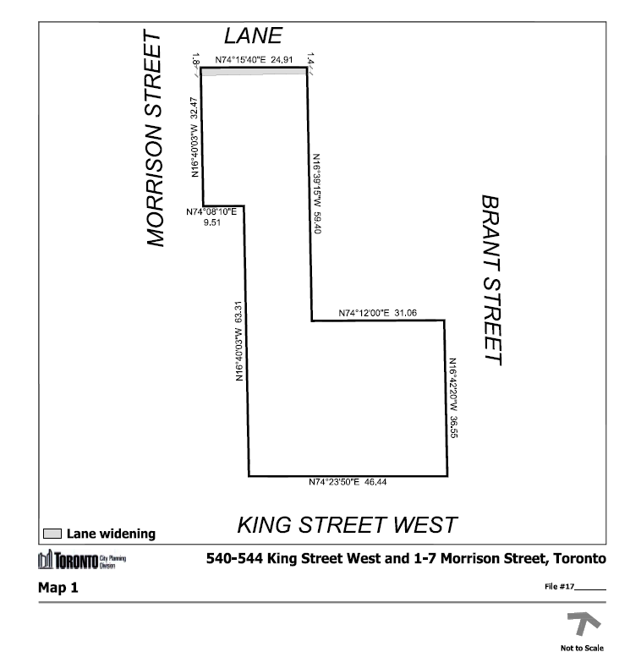

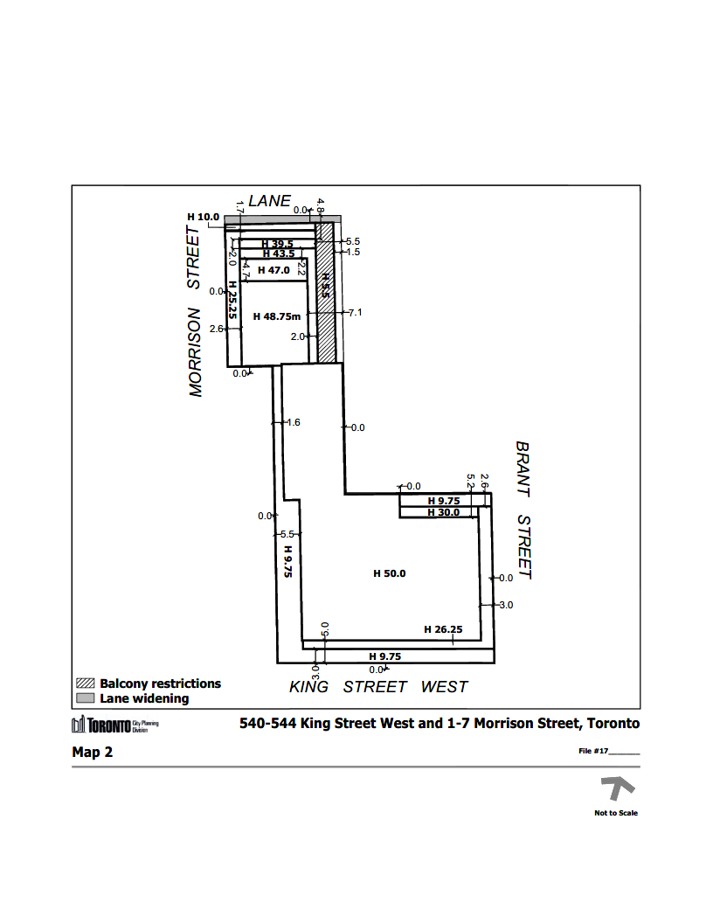
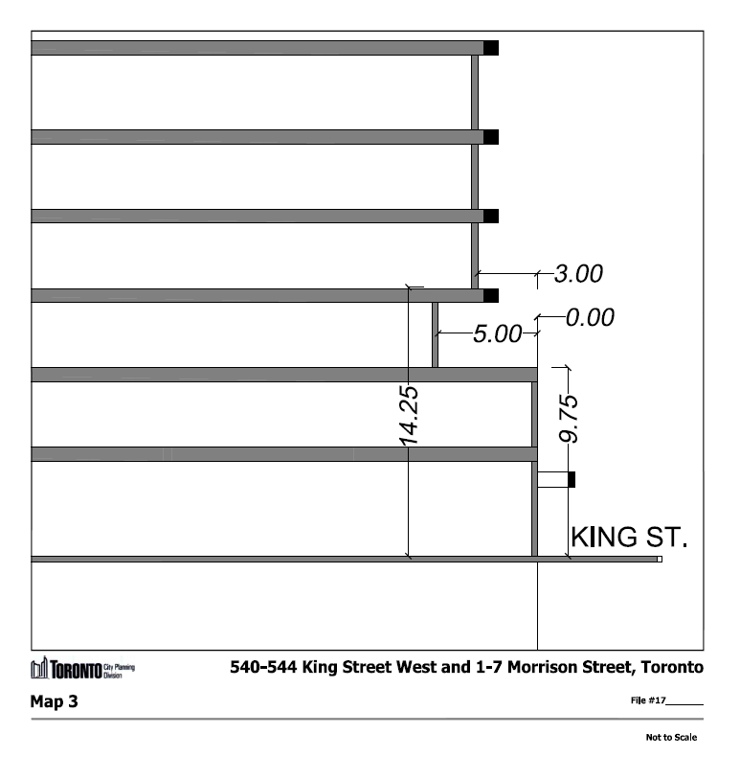
PL200311 – Attachment 2
CITY OF TORONTO
BY-LAW 244-2020

To amend Zoning By-law 569-2013, as amended, with respect to the lands municipally known in the year 2019 as 540-544 King Street West and 1-7 Morrison Street.

Whereas Council of the City of Toronto has the authority to pursuant to Section 34 of the Planning Act, R.S.O. 1990, c. P. 13, as amended, to pass this By-law; and

Whereas Council of the City of Toronto has provided adequate information to the public and has held at least one public meeting in accordance with the Planning Act; and

Whereas the Official Plan for the City of Toronto contains provisions relating to the authorization of increases in height and density of development; and

Whereas pursuant to Section 37 of the Planning Act, a by-law under Section 34 of the Planning Act, may authorize increases in the height and density of development beyond those otherwise permitted by the by-law and that will be permitted in return for the provision of such facilities, services or matters as are set out in the by-law; and

Whereas subsection 37(3) of the Planning Act provides that where an owner of land elects to provide facilities, services and matters in return for an increase in the height or density of development, the municipality may require the owner to enter into one or more agreements with the municipality dealing with the facilities, services and matters; and

Whereas the owner of the aforesaid lands has elected to provide the facilities, services and matters hereinafter set out; and

Whereas the increase in height and density permitted beyond that otherwise permitted on the aforesaid lands by By-law 569-2013 as amended, is permitted in return for the provision of the facilities, services and matters set out in this By-law which is secured by one or more agreements between the owner of the land and the City of Toronto;

The Council of the City of Toronto enacts:

- The lands subject to this By-law are outlined by heavy black lines on Diagram 1 attached to this By-law.

- The words highlighted in bold type in this By-law have the meaning provided in Zoning By-law 569-2013, Chapter 800 Definitions.

- Zoning By-law 569-2013, as amended, is further amended by amending the zone label on the Zoning By-law Map in Section 990.10 respecting the lands outlined by heavy black lines to CRE (x27), as shown on Diagram 2 attached to this By-law.

- Zoning By-law 569-2013, as amended, is further amended by adding Article 900.12.10 Exception Number 27 so that it reads:
Exception CRE 27

The lands, or a portion thereof as noted below, are subject to the following Site Specific Provisions, Prevailing By-laws and Prevailing Sections:

Site Specific Provisions:

- On 540-544 King Street West and 1-7 Morrison Street, if the requirements of Section 6 and Schedule A of By-law 244-2020 are complied with, then a building or structure many be constructed in compliance with regulations (B) to (U) below;

- Despite regulation 50.10.20.10(1), public parking is a permitted use;

- The maximum gross floor area on the lot must not exceed 26,200 square metres, provided:

- the residential gross floor area does not exceed 7,200 square metres; and

- the non-residential gross floor area does not exceed 19,000 square metres;

- In addition to the exclusions listed in Clause 50.5.40.40, the gross floor area of a building is also reduced by:

- the area in the building used for public parking located below finished ground level;

- a maximum of 520 square metres of mechanical space located within the building; and

- amenity space;

- A minimum of 10 percent of the dwelling units must contain three or more bedrooms and 20 percent of the dwelling units must contain two or more bedrooms;

- Despite regulation 50.5.40.10(1), the height of a building or structure is the distance between the Canadian Geodetic Datum of 88.53 metres and the elevation of the highest point of the building or structure;

- Despite regulation 50.10.40.10(1), no portion of any building or structure on the lot may have a height greater than the height in metres specified by the number following the "HT" symbol as shown on Diagram 3 attached to By-law 244-2020;

- Despite Clause 50.5.40.10 and regulation (G) above, the following elements of a building may exceed the maximum permitted height as follows:

- Wind screens, parapets, terrace or balcony guardrails, ornamental elements, pavers, balustrades, railings and dividers, pergolas, trellises, planters, eaves, privacy screens, stair enclosures, skylights, mechanical equipment, mechanical and architectural screens, access hatches, roof assemblies, roof drainage, window washing equipment, chimneys, vents, lightning rods, light fixtures, pavers, elements of a green roof, structures located on the roof used for outside or open air recreation, which may project above the height limits shown on Diagram 3 and Diagram 4 attached to By-law 244-2020 by no more than 2.0 metres; and

- Elevator overrun which may project above the height limits shown on Diagram 3 attached to By-law 244-2020 by no more than 4 metres;

- Despite clause 50.5.40.70 and regulations 50.10.40.70(1), (3) and (5), and 50.10.40.80(1) and (3), the required minimum building setbacks and minimum distance between main walls must be provided as shown Diagram 3 and Diagram 4 of By-law 244-2020;

- Despite regulation 50.5.40.60(1), clause 50.10.40.60 and regulation (I) above, the following elements of a building may encroach into the required building setback or separation distance:

- Cornices, eaves, light fixtures, parapets, art and landscaping features, trellises, window sills, vertical window screens, ornamental elements, ventilation shafts, mechanical equipment, balustrade, railings, wheelchair ramps, site servicing features, window washing equipment, mullion cap extensions, screening, stair enclosures, fences underground garage ramp and associated structures, up to a maximum of 0.5 metres;

- Balconies and terraces, up to a maximum of 1.5 metres; and

- Awning and canopies, up to a maximum of 2.0 metres;

- Notwithstanding Regulation (J)(ii) of By-law 244-2020 balconies proposed within the hatched area indicated on Diagram 3 of By-law 244-2020 shall only be permitted above the second storey of the building and may encroach into the required building setback up to a maximum of 1.5 metres. No portion of a balcony within the hatched area indicated on Diagram 3 of By-law 244-2020 may be located less than 4.0 metres from the eastern lot line.

- Regulation 600.10.10 with respect to building setbacks does not apply;

- Regulation 50.10.40.30(1) with respect to building depth does not apply;

- Despite regulation 50.10.40.50(1), amenity space must be provided as follows:

- A minimum of 1.5 square metres per dwelling unit of indoor amenity space; and

- A minimum of 1.0 square metres per dwelling unit of outdoor amenity space;

- Despite regulation 200.5.10(1), parking spaces must be provided as follows:

- A minimum of 14 parking spaces for the dwelling units;

- No parking spaces are required for the visitors of the dwelling units;

- No parking spaces are required for the non-residential uses; and

- A minimum of 32 parking spaces in a public parking garage;

- Despite regulation 220.5.10.1(3) and (5), at least one Type "G" loading space and two Type "C" loading spaces must be provided and maintained;

- Despite regulation 50.10.90.10(1), a loading space is permitted in a side yard abutting a street;

- Despite regulation 50.10.90.40(1), vehicle access to a loading space is permitted from a street which is a major street;

- Despite regulation 230.5.1.10(10), both long-term and short-term bicycle parking spaces may be provided in a stacked bicycle parking space;

- Despite regulation 230.5.1.10(9), long-term bicycle parking spaces may be provided in the P1 and P2 level of the building; and

- Despite regulation 230.40.1.20(2), a short-term bicycle parking space may be located more than 30 metres from a pedestrian entrance.

Prevailing By-laws and Prevailing Sections:

- 12(2)270 of former City of Toronto By-law 438-86

- Despite any existing or future severance, partition or division of the lot shown in Diagram 2 of this by-law, the provisions of this By-law apply to the whole lot as it no severance, partition or division occurred.

- Section 37 Provisions

  - Pursuant to Section 37 of the Planning Act, and subject to compliance with this By-law, the increase in height and density of the development is permitted beyond that otherwise permitted on the lands shown on Diagram 1 in return for the provision by the owner, at the owner's expense, of the facilities, services and matters set out in Schedule A hereof and which are secured by one or more agreements pursuant to Section 37(3) of the Planning Act that are in a form and registered on title to the lands, to the satisfaction of the City Solicitor.

  - Where Schedule A of this By-law requires the owner to provide certain facilities, services or matters prior to the issuance of a building permit, the issuance of such permit shall be dependent on satisfaction of the same.

  - The owner shall not use, or permit the use of, a building or structure erected with an increase in height or density pursuant to this By-law unless all provisions of Schedule A are satisfied.

SCHEDULE A
Section 37 Provisions

The facilities, services and matters set out below are required to be provided to the City at the owner's expense in return for the increase in height and density of the proposed development on the lands as shown in Diagram 1 in this By-law and secured in an agreement or agreements under Section 37(3) of the Planning Act in accordance with this By-law whereby the owner agrees as follows:

- Prior to the issuance of the first above-grade building permit, the owner shall make a cash contribution in the amount of $200,000.00 towards the Toronto Community Housing revolving capital fund for repairs to Toronto Community Housing properties in Ward 10, to the satisfaction of the Chief Planner and Executive Director, City Planning Division, in consultation with the Ward Councillor.

- Prior to the issuance of the first above-grade building permit, the owner shall make a cash contribution in the amount of $200,000.00 for the provision of affordable housing in Ward 10 within the vicinity of the site to the satisfaction of the Chief Planner and Executive Director, City Planning Division, in consultation with the Ward Councillor.

- Prior to the issuance of the first above-grade building permit, the owner shall make a cash contribution in the amount of $600,000.00 for above base streetscape improvements on the west side of Brant Street between King Street West and Adelaide Street West, including a portion which will be allocated to the revitalization of the playground of the Toronto District School Board property at 20 Brant Street, subject to public access outside of regular school hours, all to the satisfaction of the Chief Planner and Executive Director, City Planning Division, in consultation with the Ward Councillor.

- All cash contributions referred (1) to (3) above shall be upwardly indexed in accordance with the Statistics Canada Residential Building or Non-Residential Building Construction Price Index, as the case may be, for the Toronto Census Metropolitan Area, reported by Statistics Canada in the Building Construction Price Indexes Publication 327-0058, or its successor, calculated from the date of the Section 37 Agreement to the date the payment is made to the City.

- In the event that the cash contribution referred to in (1) to (3) above have not been used for the intended purposes upon the third annual anniversary of the By-laws coming into full force and effect, the cash contribution may be redirected for another purpose, at the discretion of the Chief Planner and Executive Director, City Planning Division, in consultation with the Ward Councillor, provided that the purpose is identified in the Toronto Official Plan and will benefit the community in Ward 10.

The following matters are to be secured in the Section 37 Agreement as a legal convenience to support the development:

- Prior to final site plan approval, the owner shall provide an Interpretation Plan for the heritage property at 544 King Street West, to the satisfaction of the Senior Manager, Heritage Preservation Services and thereafter shall implement such Plan to the satisfaction of the Senior Manager, Heritage Preservation Services;

- Prior to final site plan approval, the owner shall provide a Heritage Lighting Plan that describes how the heritage property at 544 King Street West will be sensitively illuminated to enhance its heritage character as viewed from the public realm to the satisfaction of the Senior Manager, Heritage Preservation Services;

- Prior to final site plan approval, the owner shall submit a Signage Plan to the satisfaction of the Senior Manager, Heritage Preservation Services;

- Prior to the issuance of the first building permit, the owner shall provide a letter of credit, including provision for upwards indexing, in accordance with paragraph (4) of this Schedule A, in a form and amount and from a bank satisfactory to the Senior Manager, Heritage Preservation Services to secure all work included in the approved Re-construction Plan and approved Interpretation Plan;

- Prior to the issuance of first building permit, the owner shall provide full documentation of the existing heritage property at 544 King Street West, including two (2) printed sets of archival quality 8” x 10” colour photographs with borders in a glossy or semi-gloss finish and one (1) digital set on a CD in tiff format and 600 dpi resolution keyed to a location map, elevations and measured drawings, and copies of all existing interior floor plans and original drawings as may be available, to the satisfaction of the Senior Manager, Heritage Preservation Services;

- Prior to the release of the letter of credit to be provided in accordance with paragraph (9) above, the owner shall provide a letter of substantial completion prepared and signed by a qualified heritage consultant confirming that the required restoration work and the required interpretive work has been completed in accordance with the Re-construction Plan and Interpretation Plan and that an appropriate standard of conservation has been maintained, all to the satisfaction of the Senior Manager, Heritage Preservation Services;

- Prior to the issuance of the first permit for the demolition, shoring and excavation work, the owner shall submit, and thereafter implement, a construction management plan to address such matters as noise, dust, street closures, parking and laneway uses and access. Such plan shall be to the satisfaction of the General Manager, Transportation Services and the Chief Planner and Executive Director, City Planning Division, in consultation with the Ward Councillor; and

- The owner agrees to work with the Toronto Lands Corporation to implement and maintain a living green wall for the height of the ground floor of the east-facing façade of the portion of the building located at 1-7 Morrison Street, immediately adjacent to the Toronto District School Property at 20 Brant Street, utilizing vegetation which will remain green throughout all four seasons of the year. The green wall will be maintained by the owner of 540-544 King Street West and will be detailed in the Site Plan control drawings.

