Ontario Land Tribunal
Tribunal ontarien de l’aménagement
du territoire

ISSUE DATE: | October 14, 2021 | CASE NO(S).: | PL200411

PROCEEDING COMMENCED UNDER subsection 22(7) of the Planning Act, R.S.O. 1990, c. P.13, as amended
Applicant and Appellant: | 2726984 Ontario Ltd.
Subject: | Request to amend the Official Plan - Failure of City of Mississauga to adopt the requested amendment
Existing Designation: | Residential Low Density 1
Proposed Designated: | Residential Medium Density
Purpose: | To permit four (4) standard condominium, 4-storey townhomes
Property Address/Description: | 2207 Dixie Road
Municipality: | City of Mississauga
Approval Authority File No.: | OZ 20/002
OLT Case No.: | PL200411
OLT File No.: | PL200411
OLT Case Name: | 2726984 Ontario Ltd v. Mississauga (City)
PROCEEDING COMMENCED UNDER subsection 34(11) of the Planning Act, R.S.O. 1990, c. P.13, as amended
Applicant and Appellant: | 2726984 Ontario Ltd.
Subject: | Application to amend Zoning By-law No. 0225-2007 - Refusal or neglect of City of Mississauga to make a decision
Existing Zoning: | Residential R3
Proposed Zoning: | RM4-XX with site specific modifications
Purpose: | To permit four (4) standard condominium, 4-storey townhomes
Property Address/Description: | 2207 Dixie Road
Municipality: | City of Mississauga
Municipality File No.: | OZ 20/002
OLT Case No.: | PL200411
OLT File No.: | PL200412
Heard: | August 6, 2021 by video hearing

APPEARANCES:
Parties | Counsel
2726984 Ontario Ltd. | Mary Flynn-Guglietti
City of Mississauga | Michal Minkowski
Regional Municipality of Peel | Rachel Godley

MEMORANDUM OF ORAL DECISION DELIVERED BY JATINDER BHULLAR ON AUGUST 6, 2021 AND ORDER OF THE TRIBUNAL

INTRODUCTION

- The Tribunal having been informed that parties have reached a settlement and requesting a settlement hearing conducted this settlement hearing.

- 2726984 Ontario Ltd. (the "Applicant") filed applications with the City of Mississauga (the "City") to amend the Official Plan (“OP”) and the Zoning By-law (“ZBL”) to permit the redevelopment of the lands at 2207 Dixie Road (the “Subject Lands”) with four standard condominium townhomes. The City deemed the applications complete on February 13, 2020. On September 16, 2020, the Applicant filed appeals pursuant to s. 22(7) and s. 34(11) of the Planning Act (the "Act") against the City’s failure to make a decision on the applications within the prescribed timeframes of the Act.

- The Subject Lands are located at the northeast corner of Dixie Road and Venta Avenue in the Sherway West area of the Lakeview Neighbourhood Character Area. The lot comprises an area of 720 m² (0.17 acres) with frontage of approximately 25 metres (“m”) on Dixie Road and 30 m on Venta Avenue. The Subject Lands are designated Residential Low Density I and are proposed to be redesignated to Residential Medium Density in the City’s OP, as amended.

- The Lands are currently occupied by a vacant dwelling which has been unoccupied since 2017, when the lot was severed, resulting in this site being the severed lands. The subject property is zoned “R3-75”, which permits detached dwellings. An amendment to the City ZBL No. 0225-2007 is required to permit the proposed townhouse development by rezoning the subject property from “R3-75” to “Townhouses - RM4-XX” with site-specific modifications.

EVIDENCE AND ANALYSIS

- Jim Levac was called by the Applicant/Appellant to provide expert opinion in the area of land use planning. The Tribunal received the sworn Affidavit of Mr. Levac and it was marked as Exhibit 2.

- Mr. Levac reviewed applicable subsections of s. 2 of the Act. He opined that the proposed development has sufficient regard for s. 2 of the Act and in particular s. 2 (f), (i) and (p).

- Mr. Levac reviewed the Provincial Policy Statement 2020 (“PPS 2020”). He that the proposed Official Plan Amendment (“OPA”) and Zoning By-law Amendment (“ZBA”) are consistent with the PPS 2020. He specifically reviewed sections 1.1.1, 1.1.3.1, 1.1.3.2, 1.1.3.3 and 1.1.3.4, which call for efficient use of public infrastructure, transit supportive mix of land uses, intensification and redevelopment.

- Mr. Levac reviewed the Growth Plan for the Greater Golden Horseshoe 2020 (the “Growth Plan”). He opined that the proposal conforms with the Growth Plan. He reviewed in detail sections 1.2.1, 2.2.1 and 2.2.2.3. He stated these considerations call for developing complete communities designed to support healthy and active living, directing growth to settlement areas, and intensification in delineated built-up areas.

- Mr. Levac reviewed the Region of Peel’s OP and in particular section 5.3.1 which calls for compact, transit supportive intensification in areas that efficiently utilize lands, services and infrastructure among others. He opined that the proposal development conforms with the Region of Peel Official Plan in the context of applicable policies.

- Mr. Levac reviewed the City’s OP and in particular sections 5.3 and 5.4 which encourage compact, mixed use development that is transit supportive and in appropriate locations, and that will protect and conserve the character of stable residential neighbourhoods. He reviewed policies 16.1.1.1 and 16.1.2.1 which state that four storeys are allowed unless otherwise directed. In this regard, Mr. Levac stated that the Lakeview Local Area Plan restricts such to three storeys. He opined that the requested amendment to the City OP and the ZBL otherwise conforms with the general intent and purpose of the City OP and the ZBL respectively. He also submitted that the requested amendments have been supported by City staff and City Council.

- The Tribunal, having considered the uncontroverted expert planning opinion evidence in the sworn Affidavit of Mr. Levac, his uncontroverted expert opinion evidence at this hearing and all other material on file, finds that the OPA and ZBA have had regard for matters in s. 2 of the Act, are consistent with the PPS 2020, conforms with the Growth Plan, conforms to the Region of Peel and, in the case of the ZBA, conforms with the City’s OP.

- The Tribunal further finds that the OPA represent good land use planning.

ORDER

- The Tribunal Orders that the appeals are allowed. The Official Plan for the City of Mississauga is amended as set out in Attachment 1 to this Order.

- By-law No. 0225-2007, as amended, is hereby amended as set out in Attachment 2 to this Order. The Tribunal authorizes the Municipal Clerk of the City of Mississauga to assign a number to this By-law for record keeping purposes.

“Jatinder Bhullar”

Jatinder bhullar
MEMBER

Ontario Land Tribunal
Website: www.olt.gov.on.ca Telephone: 416-212-6349 Toll Free: 1-866-448-2248

The Conservation Review Board, the Environmental Review Tribunal, the Local Planning Appeal Tribunal and the Mining and Lands Tribunal are amalgamated and continued as the Ontario Land Tribunal (“Tribunal”). Any reference to the preceding tribunals or the former Ontario Municipal Board is deemed to be a reference to the Tribunal.
PL200411 – Attachment 1
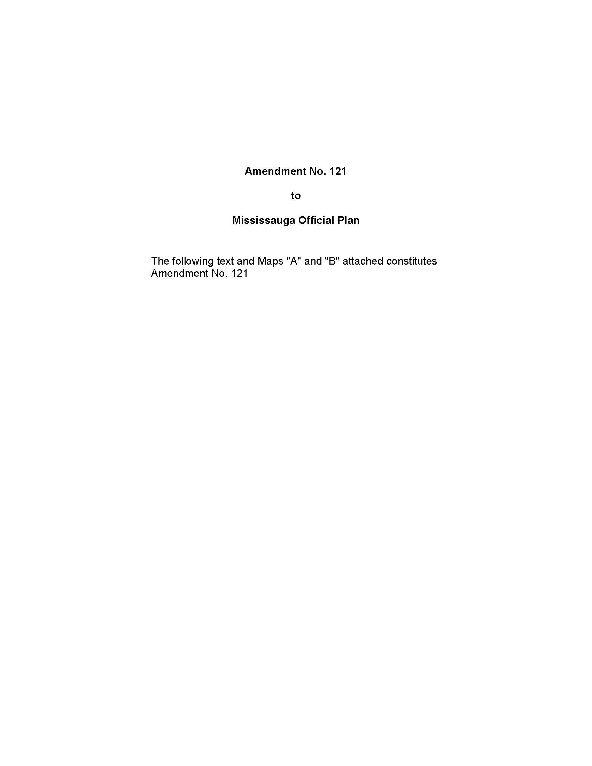
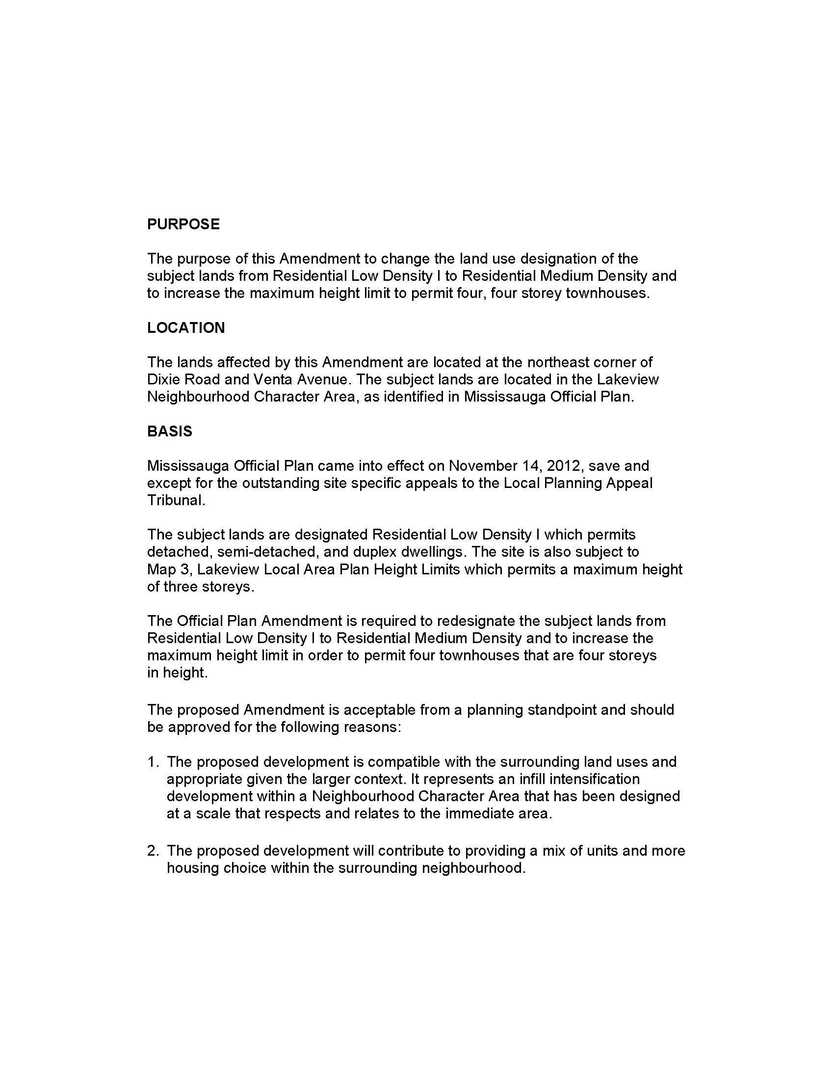
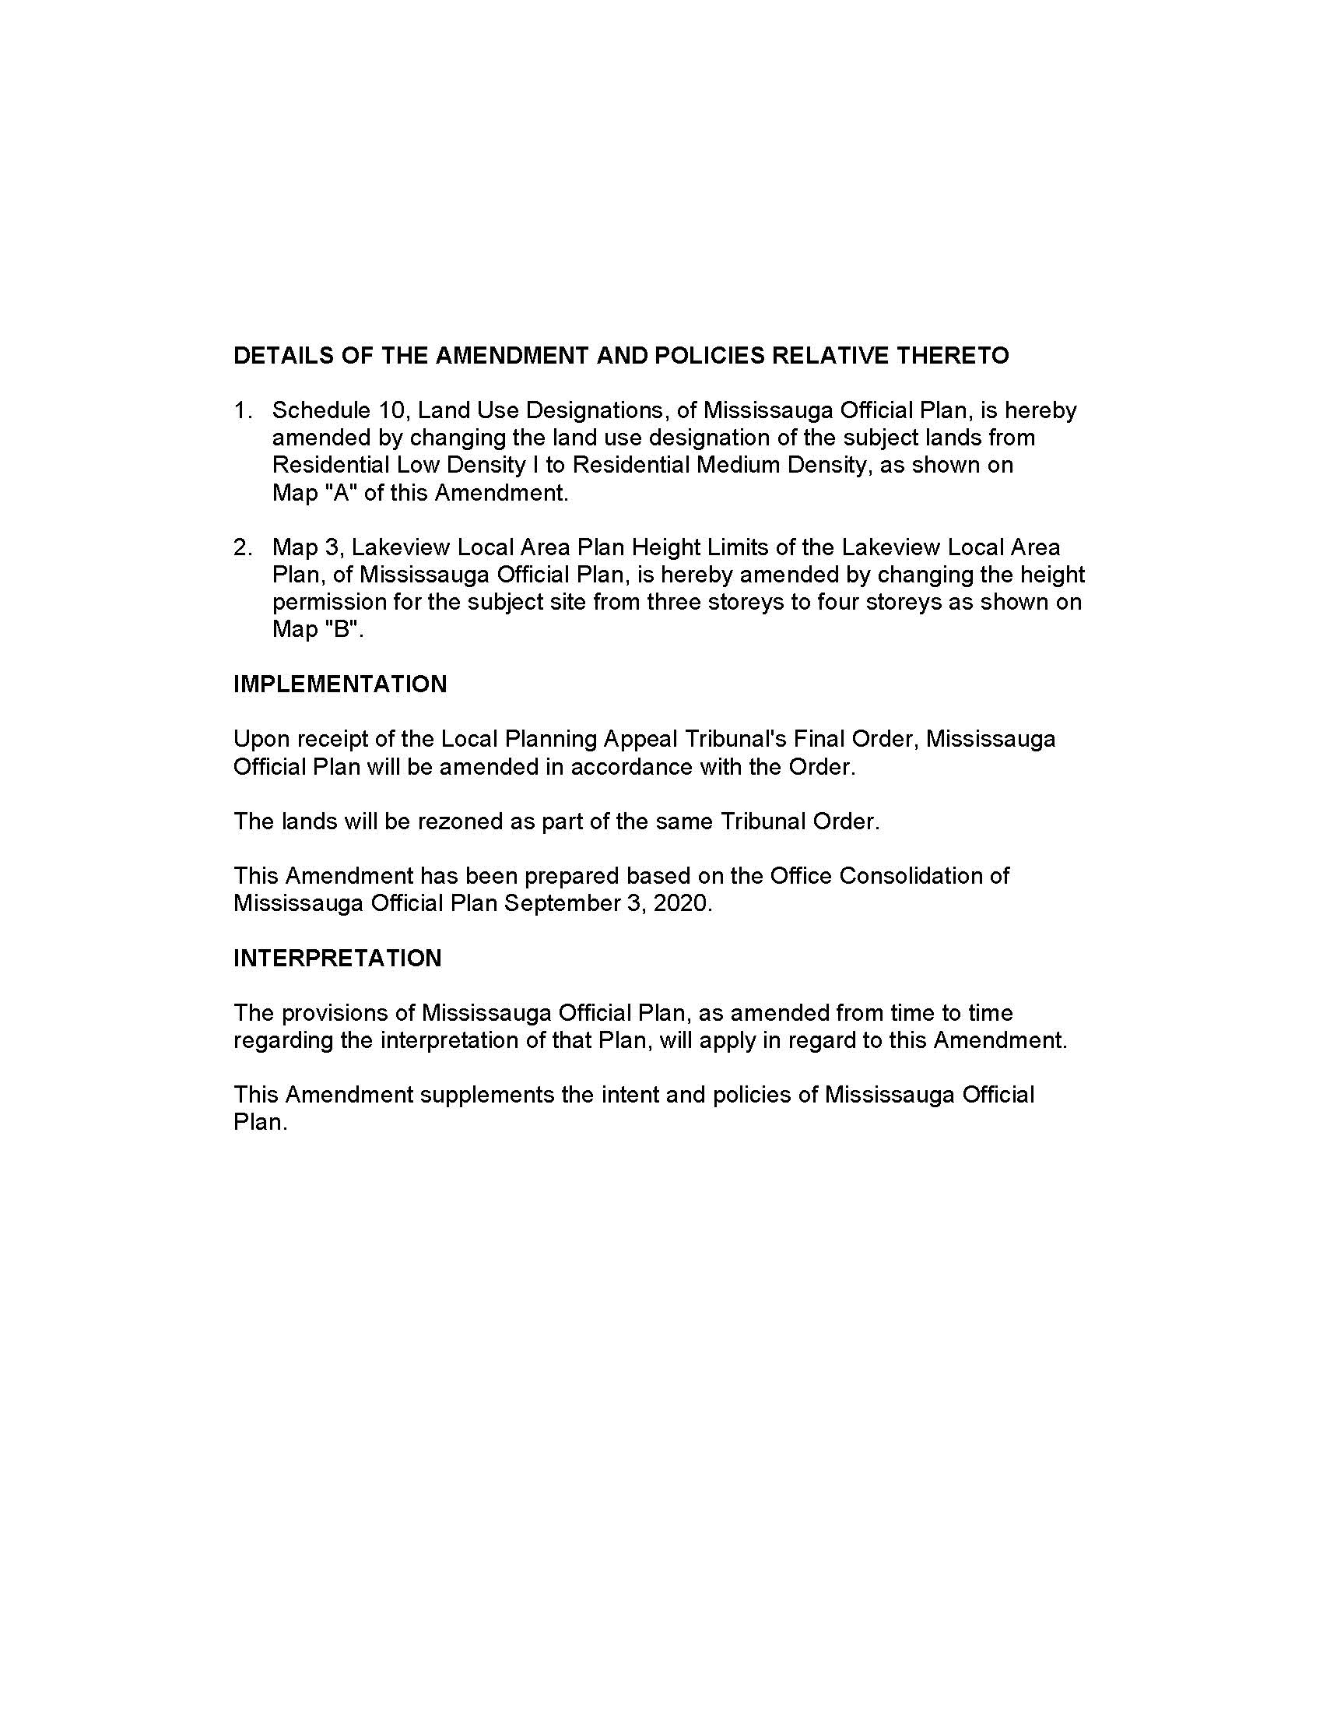
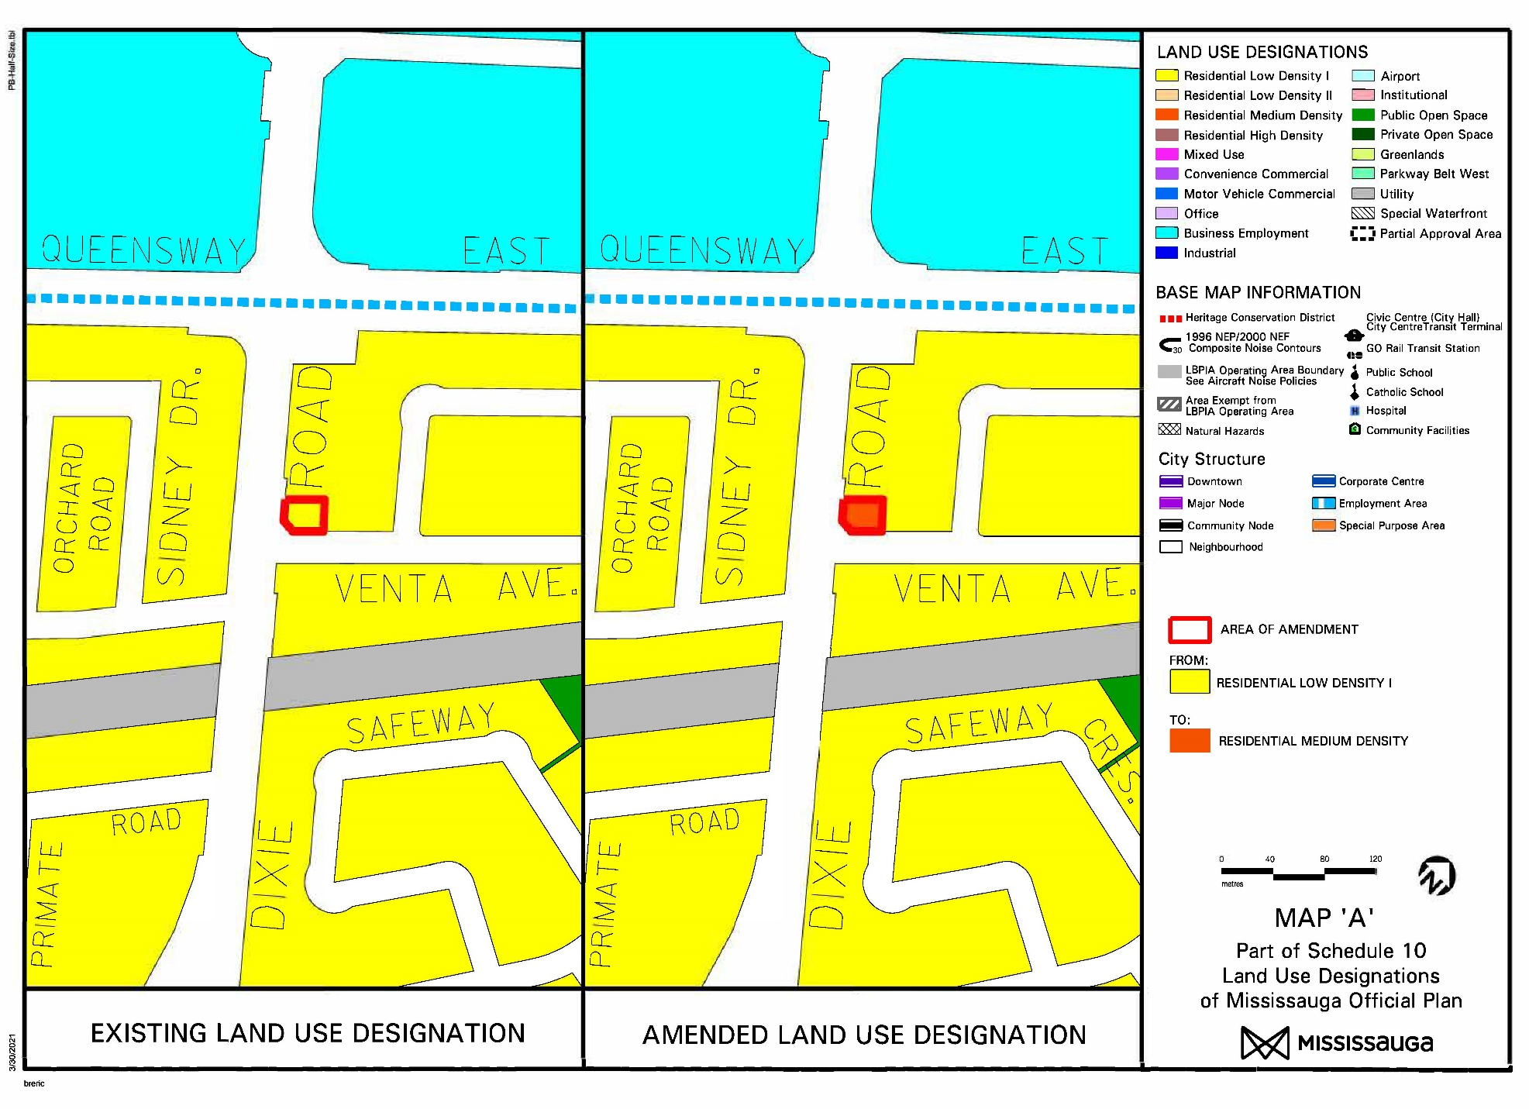
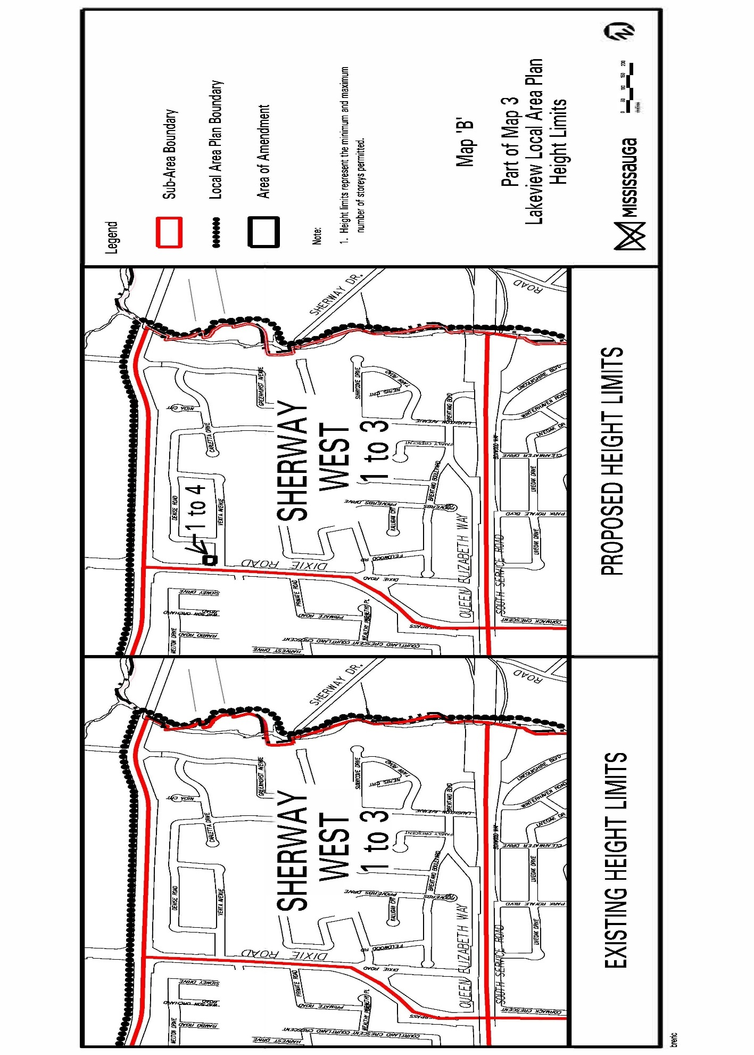
PL200411 – Attachment 2
