Ontario Land Tribunal
Tribunal ontarien de l’aménagement
du territoire

ISSUE DATE: | February 08, 2022 | CASE NO(S).: | PL200458

PROCEEDING COMMENCED UNDER subsection 22(7) of the Planning Act, R.S.O. 1990, c. P.13, as amended
Applicant and Appellant: | LJM Developments (Stoney Creek) Inc.
Subject: | Request to amend the Official Plan - Refusal of request by the City of Hamilton
Existing Designation: | Medium Density Residential 3
Proposed Designated: | High Density Residential
Purpose: | To permit a residential development for an 11-storey, 148-unit multiple dwelling with a maximum net residential density of 551 units
Property Address/Description: | 325 Highway No. 8
Municipality: | City of Hamilton
Approval Authority File No.: | UHOPA-20-005
OLT Case No.: | PL200458
OLT File No.: | PL200458
OLT Case Name: | LJM Developments (Stoney Creek) Inc. v. Hamilton (City)
PROCEEDING COMMENCED UNDER subsection 34(11) of the Planning Act, R.S.O. 1990, c. P.13, as amended
Applicant and Appellant: | LJM Developments (Stoney Creek) Inc.
Subject: | Application amend Zoning By-law No. 3692-92 - Refusal of Application the City of Hamilton
Existing Zoning: | Multiple Residential (RM4-8) – Zone
Proposed Zoning: | Site-specific – to be determined
Purpose: | To permit a residential development for an 11-storey, 148-unit multiple dwelling with on-site ground level amenity areas and outdoor terraces
Property Address/Description: | 325 Highway No. 8
Municipality: | City of Hamilton
Municipality File No.: | ZAC-20-010
OLT Case No.: | PL200458
OLT File No.: | PL200459
Heard: | November 29, 2021 by video hearing (“VH”)

APPEARANCES:
Parties | Counsel
LJM Developments (Stoney Creek) Inc. | Russell Cheeseman
(“Applicant/Appellant”)
City of Hamilton (“City”) | Patrick MacDonald

DECISION DELIVERED BY K.r. andrews AND ORDER OF THE TRIBUNAL

INTRODUCTION

- These are appeals by the Applicant/Appellant from a refusal by the City to adopt a proposed Official Plan Amendment (“OPA”) and a Zoning By-law Amendment (“ZBA”) to permit the construction of a high-density multi-unit residential dwelling at 325 Highway No. 8 in the City (the “Subject Lands”).

Site Description

- The Subject Lands are legally described as Part of Lot 20 Concession 2 Saltfleet, Designated as Part 1 on Plan 62R9594, City of Hamilton. The property has an approximate lot frontage of 50 metres (“m”), lot depth of 57 m, and a lot area of 2,685 square metres. Currently, the property features a temporary structure used as the Kings Park Condominium Sales Centre.

- The block consisting of the Subject Lands is bound by Ellington Avenue to the east, Highway No. 8 to the south and private condominium roads to the north and west. There is a medium density residential neighbourhood consisting of townhouses to the north, retirement centre and nursing home to the east, park and a church to the south, and a 7-storey (plus mechanical penthouse) condominium building to the west.

- The property is identified as “Secondary Corridor” on Schedule E – Urban Structure and designated “Neighbourhoods” on Schedule E-1 – Urban Land Use Designations in the Urban Hamilton Official Plan (“UHOP”) and designated “Medium Density Residential 3” and located within “Site Specific Policy Area A” in the Western Development Area Secondary Plan (“WDASP”) – Land Use Plan. Highway No. 8 is designated a Major Arterial road on Schedule C – Functional Road Classification in the UHOP.

Applications

- The applications are for:

- an OPA to change the designation from “Medium Density Residential 3” to a “High Density” designation and to replace the existing Site Specific Policy Area A in the WDASP to permit an 11-storey 148 unit multiple dwelling with a maximum net residential density of 551 units per hectare; and
- a ZBA to further modify the Multiple Residential “RM4-8” Zone to permit an 11-storey 148-unit multiple dwelling with 22 surface visitor parking spaces and 123 underground parking spaces in a two-level underground parkade.

- It is noteworthy that a previous OPA and ZBA were sought by the Applicant/Appellant in 2016. Following revisions to the applications, Council subsequently approved:

- OPA No. 72 (By-law No. 17-052) to change the land use designation of the Subject Lands from “Low Density Residential 3c” to “Medium Density Residential 3” and to establish a site specific policy to permit a multiple dwelling with a maximum of 93 units (344 units per net residential hectare) and a maximum height of six storeys; and
- By-law No. 17-053 to rezone the Subject Lands from the General Commercial “GC-13” Zone, Modified, to the Residential Multiple “RM4-8” Zone, Modified, and to introduce site specific performance standards in order to permit the development of a 6-storey multiple dwelling-unit building containing 93 units and 129 parking spaces (all spaces underground, except three parking spaces at grade).

- In 2017, the Subject Lands received corresponding Site Plan approval for a 6-storey building consisting of 93 dwelling units and a density of 344 units per net residential hectare. That Site Plan Approval lapsed as of November 1, 2019.

- The Applicant/Appellant explained that the former plan has been abandoned because it is no longer economically viable.

EVIDENCE AND ANALYSIS

Witnesses

- The following witnesses were called by the Applicant/Appellant and qualified on consent as experts in their respective fields (as indicated):

- John Ariens – land use planning;
- Tim O’Brien – urban design;
- Roland Rom Coltoff – architecture;
- Michael Masschaele – acoustical engineering;
- Mario Patitucci – landscape architecture;
- Stew Elkins – transportation planning.

- Tim Vrooman was the only witness called by the City, and he was qualified on consent as an expert in land use planning.

Agreed Statement of Facts and main issues

- The parties submitted an agreed statement of facts (“ASF”) confirming the following:

- Concerns about noise mitigation pertain only to the formerly proposed outdoor amenity area “noise mitigation wall”, and all other noise concerns have been addressed through the Acoustic Study submitted by the Applicant/Appellant. The Tribunal notes that, since the Applicant/Appellant’s proposal has been revised to eliminate the “noise mitigation wall” altogether, the Tribunal finds that noise concerns are no longer an issue.
- The concern regarding the cumulative impact of proposed zoning modifications and the impact upon the existing character of the area pertains primarily to reduced setbacks to the street and building height. The Tribunal notes that this remains a principal issue of this matter.
- The use of a holding provision is only related to sanitary servicing and it can be addressed at a future Site Plan stage. The parties agree that a holding provision is appropriate in this regard. The Tribunal notes that the parties have settled and jointly submitted the form and contents of such a holding provision.
- Shadow impact is not a concern, given that the Sun Shadow Study demonstrates minimal or no measurable difference between the proposed 11-storey plan and the as-of-right 6-storey plan. The Tribunal finds, therefore, that this is no longer an issue.
- Any increase in traffic density is not a concern, given that the Traffic Impact Study demonstrates that the existing roads and intersection will not be adversely affected by the proposed plan. The Tribunal finds, therefore, that this is no longer an issue.
- Plans for the City’s LRT system is in flux, but Highway No. 8 is nevertheless a main transit line and the Subject Lands are well served with existing transit.

- Given the above ASF, combined with the fact that the Applicant/Appellant’s experts’ evidence and opinions regarding urban design, architecture, acoustical engineering, landscape architecture and transportation planning was unshaken during testimony (and ultimately untested by the City through its own experts), the Tribunal accepts the evidence provided by Messrs. O’Brien, Rom Coltoff, Masschaele, Patitucci, and Elkins in support of the applications. As the parties both conceded through their respective summations, this case primarily turns on issues of a local land use planning nature.

- The primary questions for the Tribunal to answer involve whether the Applicant/Appellant’s plan goes too far in terms of height and density, and whether the revised layout and setbacks are otherwise appropriate, as it relates the proposed 11-storey building compared to the already approved 6-storey building. This question is highly contextualized and, given the difference in opinions between Messrs. Arien and Vrooman, it will turn on a preference of one expert’s opinion over the other’s.

- For the reasons that follow, the Tribunal allows the appeals, generally preferring the opinion and evidence of the Applicant/Appellant’s expert in land use planning, Mr. Ariens. In general, the Tribunal accepts Mr. Ariens’ evidence and opinion insofar as it demonstrates that the proposal is an appropriate form of redevelopment along a major arterial road, it is situated at a signalized intersection with crosswalks where two major roads (King Street / Ellington Avenue and Highway No. 8) intersect, creating a key focal point, it achieves a compatible interface with the abutting land uses, including the 7-storey (plus mechanical penthouse) condominium building to the west, and it otherwise represents good land use planning and is in the public interest.

- By comparison, Mr. Vrooman’s evidence was often shaken. As will be described in greater detail below, he initially claimed that the proposal was not consistent with the Provincial Policy Statement (“PPS”) and not in conformity with the Growth Plan for the Greater Golden Horseshoe (“Growth Plan”), but he eventually conceded these points during cross-examination. When it relates to the appropriateness of the proposed height, setbacks and building form in general, and fit within the neighbourhood character and compatibility, his opinion lacked sufficient context insofar as he argued a strict application of urban design principles regarding a 45 degree angular plane barrier limiting height and enforcing greater setbacks. This overly formulistic approach included argument over a 1.5 m elevation starting point to measure the said 45 degree angular plane. More generally, his testimony lacked demonstrative evidence of adverse impacts that the development might cause to the surrounding area.

Provincial Policy Statement, 2020

- The PPS outlines the policies for managing and directing land use to achieve effective and efficient development and land use patterns. Despite the parties being largely in agreement that this case does not turn on issues of higher order provincial policy, the Tribunal is obliged to assess the proposal in this regarding due to Mr. Vrooman’s initial contention that the proposed development lacked consistency with the PPS.

- In his witness statement, Mr. Vrooman opined that the proposed development is not consistent with the PPS “in terms of providing an appropriate range of residential density, nor encouraging a sense of place by promoting well designed built form”. Through examination in chief, he provided nothing to support this general assertion. On cross-examination, Mr. Vrooman further admitted that if the originally proposed noise wall is eliminated, then the proposal would otherwise be consistent with the PPS. As a result, given that the Applicant/Appellant’s revised proposal eliminates the noise wall, the Tribunal rejects Mr. Vrooman’s initial opinion regarding polices of the PPS and accepts the otherwise uncontroverted evidence and opinion of Mr. Ariens, as set out below.

- The below paragraphs outline the PPS policies that were identified as being relevant to the current matter, followed by Mr. Ariens’ comments and opinion regarding same.

Policy 1.1 Managing and Directing Land Use to Achieve Efficient and Resilient Development and Land Use Patterns
Policy 1.1.1 Healthy, liveable and safe communities are sustained by:

b) accommodating an appropriate affordable and market-based range and mix of residential types (including single-detached, additional residential units, multi-unit housing, affordable housing and housing for older persons), employment (including industrial and commercial), institutional (including places of worship, cemeteries and long-term care homes), recreation, park and open space, and other uses to meet long-term needs;

Policy 1.4.3 Planning authorities shall provide for an appropriate range and mix of housing options and densities to meet projected market-based and affordable housing needs of current and future residents of the regional market area by: […]

- Mr. Ariens testified that the matter before the Tribunal is seeking planning permission to redevelop the lands and add another 55 apartment units through five additional floors of building height. He opined that this redevelopment and increase in units will provide additional market-based housing for current and future residents and will contribute to the range of housing types available in this area of the City.

Policy 1.4.3 […] b) permitting and facilitating:

- all housing options required to meet the social, health, economic and well-being requirements of current and future residents, including special needs requirements and needs arising from demographic changes and employment opportunities; and
- all types of residential intensification, including additional residential units, and redevelopment in accordance with policy 1.1.3.3;…

- Mr. Ariens opined that additional dwelling units represent a form of intensification, which will provide additional housing to meet the needs of current and future residents, including local residents who wish to move to less-maintenance condominium-style accommodations without leaving the immediate area.

Policy 1.4.3 […] c) directing the development of new housing towards locations where appropriate levels of infrastructure and public service facilities are or will be available to support current and projected needs;…

- Mr. Ariens opined that appropriate levels of infrastructure and public service facilities are available to accommodate the additional units, with many within walking distance of the Subject Lands.

Policy 1.4.3 […] d) promoting densities for new housing which efficiently use land, resources, infrastructure and public service facilities, and support the use of active transportation and transit in areas where it exists or is to be developed;…

- Mr. Ariens opined that the additional density proposed will more efficiently use the Subject Lands and associated resources, infrastructure and public service facilities. He noted that the lands are well-serviced by existing transit and bicycle parking is proposed to encourage active transportation.

Policy 1.4.3 […] e) requiring transit-supportive development and prioritizing intensification, including potential air rights development, in proximity to transit, including corridors and stations; and…

- Mr. Ariens opined that the additional density proposed is more transit supportive and is directly located upon a major east-west transit corridor, and this form of intensification is prioritized by the policy.

Policy 1.4.3 […] f) establishing development standards for residential intensification, redevelopment and new residential development which minimize the cost of housing and facilitate compact form, while maintaining appropriate levels of public health and safety.

- Mr. Ariens testified that the implementing Zoning By-law will establish appropriate development standards for the proposed development, which, in his opinion, will result in minimizing the cost of housing and facilitate a more compact built form on the Subject Lands. No public health or safety issues were identified.

Policy 1.7.1 […] e) encouraging a sense of place, by promoting well-designed built form…

- In summary, Mr. Ariens testified that the proposed development, regarding increased height and density in particular, is consistent with the identified sections of the PPS. The Tribunal accepts his evidence and opinion, and finds same.

A Place to Grow: Growth Plan for the Greater Golden Horseshoe

- The policies within the Growth Plan provide direction on where growth should be distributed and how it should occur regarding development, population growth and employment.

- Similar to his treatment of the PPS described above, Mr. Vrooman opined in his witness statement that the proposed development does not conform to the Growth Plan, this time for failing to “[achieve] complete communities by providing for a vibrant public realm”. Again, through examination in chief, he provided nothing to support this general assertion. However, again on cross-examination, Mr. Vrooman admitted that if the originally proposed noise wall was eliminated, then the proposal would conform to the Growth Plan. As a result, given that the Applicant/Appellant’s revised proposal eliminates the noise wall, the Tribunal rejects Mr. Vrooman’s initial opinion and accepts the otherwise uncontroverted evidence and opinion of Mr. Ariens, as set out below.

- The below paragraphs outline the Growth Plan policies that were identified as being relevant to the current matter, followed by Mr. Ariens’ comments and opinion regarding same.

Policy 2.2 Policies for Where and How to Grow

Policy 2.2.1 Managing Growth
4. Applying the policies of this Plan will support the achievement of complete communities that:
a) Feature a diverse mix of land uses, including residential and employment uses, and convenient access to local stores, services, and public service facilities;

- Mr. Ariens opined that the additional housing units will contribute to the diverse mix of land uses required by the Growth Plan and the Subject Lands have close and convenient access to local stores, services and public service facilities.

Policy 2.2.1.4 […] b) improve social equity and overall quality of life, including human health, for people of all ages, abilities, and incomes;…

- Mr. Ariens opined that the additional housing units will improve social equity by introducing a higher density building on the periphery of a mature neighbourhood. He further opined that the proposed development introduces a form of housing that is less common in the neighbourhood. He further opined that the quality of life for adjacent properties will not be adversely impacted as a result of the proposed development, other than minor privacy and overlook concerns which are already established in the area.

Policy 2.2.1.4 […] c) provide a diverse range and mix of housing options, including additional residential units and affordable housing, to accommodate people at all stages of life, and to accommodate the needs of all household sizes and incomes;…

- Mr. Ariens opined that the proposed development contributes to the range of housing options available in the area and, being located along a major transit corridor, the proposed building is ideal for young professionals, first time home buyers and seniors / empty nesters from the immediate neighbourhood that wish to stay in the area but “down-size”.

Policy 2.2.1.4 […] d) expand convenient access to:
i. a range of transportation options, including options for the safe, comfortable and convenient use of active transportation;

- Mr. Ariens testified that the Subject Lands feature a range of vehicular transportation options, including private automobiles, public transit, taxi and Uber services. Sidewalks are also available along both sides of Highway No. 8 and Ellington Avenue, most major intersections are signalized with pedestrian crossings, and bicycle parking is also being provided by the developer.

Policy 2.2.1.4 […] d) expand convenient access to: […]
ii. public service facilities, co-located and integrated in community hubs;

- Mr. Ariens testified that public service facilities are within a very close walk and include both public and separate schools, several Places of Worship, and the Stoney Creek Cenotaph.

Policy 2.2.1.4 […] d) expand convenient access to: […]
iii. an appropriate supply of safe, publicly-accessible open spaces, parks, trails, and other recreational facilities; and

- Mr. Ariens testified that the proposal includes on-site amenities and the King Street Parkette is located directly across the road. Memorial Park is also located 614 m to the south, Ferris Park is located 600 m to the north, and two local schools and their outdoor playgrounds are also very close to the Subject Lands.

Policy 2.2.1.4 […] d) expand convenient access to: […]
iv. healthy, local, and affordable food options, including through urban agriculture;

- Mr. Ariens testified that healthy, local and affordable food options are readily available, including most major grocery stores, delis and bakeries, and specialty food stores. The Stoney Creek area is also situated at the cusp of the Niagara Fruit Belt, known for its local fresh produce and roadside farm stands.

Policy 2.2.1.4 […] e) provide for a more compact built form and a vibrant public realm, including public open spaces;

- Mr. Ariens opined that the additional density and height being proposed will create a more compact form of development. Furthermore, the proposed building is oriented towards the street edge and particularly to the corner intersection, which minimizes the building mass impact on the surrounding residential area to the north, and supports street life while also designed to create a sense of reduced enclosure to a more desirable scale.

Policy 2.2.1.4 […] f) mitigate and adapt to the impacts of a changing climate, improve resilience and reduce greenhouse gas emissions, and contribute to environmental sustainability; and

- Mr. Ariens opined that the proposed increase in density and height of the development will help mitigate and adapt to the impacts of a changing climate by reducing the dependency on automobiles, as public transit is available, together with many stores and shops in close proximity to the Subject Lands. He testified that, within 500 m in either direction along Highway No. 8, there are three drug stores (including one with a post office), personal service shops, professional and medical offices, two banks and a credit union, bakeries and delis, and restaurants (including fast food and a bistro), all within a short walking distance. Churches, schools and neighbourhood parks are also conveniently close by.

- In summary, Mr. Ariens testified that the proposed development, regarding increased height and density in particular, conforms with the identified sections of the Growth Plan. The Tribunal accepts his evidence and opinion, and finds same.

Urban Hamilton Official Plan and Western Development Area Secondary Plan

- Mr. Vrooman provided the following account of the relevant UHOP and WDASP provisions and policies applicable to this matter.

- The Subject Lands are identified as “Secondary Corridor” on Schedule E – Urban Structure and designated “Neighbourhoods” on Schedule E-1 – Urban Land Use Designations of the UHOP and designated “Medium Density Residential 3” on Map B.7.1.1 – WDASP – Land Use Plan.

- The following UHOP policies apply:

B.2.4.1.4 Residential intensification developments shall be evaluated based on the following criteria:

- a balanced evaluation of the criteria in b) through g), as follows;
- the relationship of the proposal to existing neighbourhood character so that it maintains, and where possible, enhances and builds upon desirable established patterns and built form;
- the development’s contribution to maintaining and achieving a range of dwelling types and tenures;
- the compatible integration of the development with the surrounding area in terms of use, scale, form and character. In this regard, the City encourages the use of innovative and creative urban design techniques;
- the development’s contribution to achieving the planned urban structure as described in Section E2.0 – Urban Structure;
- infrastructure and transportation capacity; and,
- the ability of the development to comply with all applicable policies.

B.2.4.2.2 When considering an application for a residential intensification development within the Neighbourhoods designation, the following matters shall be evaluated:

- the matters listed in Policy B.2.4.1.4;
- compatibility with adjacent land uses including matters such as shadowing, overlook, noise, lighting, traffic and other nuisance effects;
- the relationship of the proposed building(s) with the height, massing, and scale of nearby residential buildings;
- the considerations of transitions in height and density to adjacent residential buildings;
- the relationship of the proposed lot(s) with the lot pattern and configuration within the neighbourhood;
- the provision of amenity space and the relationship to existing patterns of private and public amenity space;
- the ability to respect and maintain or enhance the streetscape patterns including block lengths, setbacks and building separations;
- the ability to complement the existing functions of the neighbourhood;
- the conservation of cultural heritage resources; and,
- infrastructure and transportation capacity and impacts.

B.3.3.2.3 Urban design should foster a sense of community pride and identity by:

- respecting existing character, development patterns, built form, and landscape;
- promoting quality design consistent with the locale and surrounding environment;

B.3.3.2.4 Quality spaces physically and visually connect the public and private realms. Public and private development and redevelopment should create quality spaces by:

a) organizing space in a logical manner through the design, placement, and construction of new buildings, streets, structures, and landscaping; and,..
c) recognizing that every new building or structure is part of a greater whole that contributes to the overall appearance and visual cohesiveness of the urban fabric.

B.3.6.3.11 Design of noise mitigation measures adjacent to collector roads, or major or minor arterial roads shall address streetscape quality through compliance with the following policies:

a) Noise mitigation measures shall avoid the use of noise barriers (walls and berms) wherever possible.
b) The use of noise barriers shall only be considered if it can be demonstrated to the satisfaction of the City that no other noise mitigation measures are practical or feasible and their long term maintenance and replacement has been addressed.
c) The use of noise barriers shall be prohibited adjacent to Primary, Secondary, or Potential Expansion of Secondary Corridors designated on Schedule E – Urban Structure, and adjacent to pedestrian focus streets as identified in Section E.4.3 – Pedestrian Focus Streets. (OPA 69)
d) Noise mitigation measures shall comply with Section 3.3 – Urban Design Policies, and all other design policies of this Plan unless it is determined in the detailed noise study, to the satisfaction of the City, that compliance with the design policies is not practical or feasible.

C.5.3.11 The City shall ensure that any change in density can be accommodated within the municipal water and wastewater system.

E.2.4.10 The built form along the Urban Corridors shall generally consist of low to mid rise forms, but will vary along the length of the corridors with some areas permitted to accommodate high density and high rise built form. The Primary Corridors shall have a greater proportion of the corridor length in retail and mixed use forms, while the Secondary Corridors shall generally accommodate retail and mixed use forms in small clusters along the corridors with medium density housing located between the clusters.

E.2.4.11 Urban Corridors shall be a focus for intensification through the Neighbourhoods which they traverse. However, it is anticipated that intensification will also occur within the surrounding Neighbourhoods, particularly on sites along other arterial roads that are not designated as Urban Corridors.

E.2.4.12 Secondary Corridors are currently characterized, in large measure, by single use buildings. The intent of this Plan is to evolve the Secondary Corridors to an increasing proportion of multiple storey, mixed use buildings in small cluster locations with at grade retail and service commercial uses.

E.2.4.16 New development shall respect the existing built form of adjacent neighbourhoods where appropriate by providing a gradation in building height. New development shall locate and be designed to minimize the effects of shadowing and overview on properties in adjacent neighbourhoods. (OPA 98)

E.2.4.17 Reductions in parking requirements shall be considered in order to encourage a broader range of uses and densities to support existing and planned transit routes. (OPA 98)

E.3.2.4 The existing character of established Neighbourhoods designated areas shall be maintained. Residential intensification within these areas shall enhance and be compatible with the scale and character of the existing residential neighbourhood in accordance with Section B.2.4 – Residential Intensification and other applicable policies of this Plan.

E.3.3.2 Development or redevelopment adjacent to areas of lower density shall ensure the height, massing, and arrangement of buildings and structures are compatible with existing and future uses in the surrounding area.

E.3.6.6 In high density residential areas, the permitted net residential densities, identified on Appendix G – Boundaries Map shall be:

…
b) greater than 100 units per hectare and not greater than 200 units per hectare in all other Neighbourhoods designation areas.
c) Notwithstanding the maximum density requirement in Policy E.3.6.6 b), for smaller sites fronting on arterial roads, an increase in density may be considered, without an amendment to this Plan, provided the policies of this Plan are met. (OPA 109)

E.3.6.7 Development within the high density residential category shall be evaluated on the basis of the following criteria:

a) Development should have direct access to a collector or major or minor arterial road. If direct access to such a road is not possible, the development may be permitted indirect access to a collector or major or minor arterial roads from a local road upon which only a small number of low density residential dwellings are fronting on the local road. (OPA 109)
b) High profile multiple dwellings shall not generally be permitted immediately adjacent to low profile residential uses. A separation distance shall generally be required and may be in the form of a suitable intervening land use, such as a medium density residential use. Where such separations cannot be achieved, transitional features such as effective screening and/or design features shall be incorporated into the design of the high density development to mitigate adverse impact on adjacent low profile residential uses.
…
d) Development shall:
i) provide adequate landscaping, amenity features, on-site parking, and buffering where required;
ii) be compatible with existing and future uses in the surrounding area in terms of heights, massing, and an arrangement of buildings and structures; and,
iii) provide adequate access to the property, designed to minimize conflicts between traffic and pedestrians both on-site and on surrounding streets.
e) In accordance with the policies of Section B.3.3 – Urban Design Policies, development shall contribute to an attractive public realm by minimizing the view of the following elements from the abutting public streets (excluding public alleys):
…
iv) expanses of blank walls.
…
f) The City may require studies, in accordance with Chapter F - Implementation Policies, completed to the satisfaction of the City, to demonstrate that the height, orientation, design and massing of a building or structure shall not unduly overshadow, block light, or result in the loss of privacy of adjacent residential uses.

- The following WDASP policy applies:

B.7.1.5.1 For the lands located at 325 Highway No. 8, identified as Site Specific Policy Area A on Map B.7.1-1 – Western Development Area – Land Use Plan and designated Medium Density Residential 3, the following shall apply:

a) Notwithstanding the maximum residential densities of Policy E.3.5.7 of Volume 1 and Policy B.7.1.1.4 b) of Volume 2, a multiple dwelling having a maximum of 93 dwelling units or 344 units per net residential hectare shall be permitted.

- As it relates to the above listed provisions and policy of the UHOP and WDASP, the parties, through their respective land use planning experts, submitted opposite positions as it relates to three primary areas of consideration:

- Conformity with the applicable policies in terms of neighbourhood character and compatibility, associated height, density, massing, privacy, overlook and setbacks;
- Parking; and
- In the context of conformity with the UHOP and WDASP, whether the proposed development represent good land use planning and is in the public interest.

Neighbourhood character and compatibility, height, density, massing, privacy, overlook and setbacks

- As it relates to “Neighbourhood Character and Compatibility for Residential Intensification”, Mr. Vrooman testified that the UHOP establishes a node and corridor of urban structure consisting of a series of key focal points of activity (nodes) connected by a series of corridors. His uncontroverted testimony included that the Subject Lands are located along Highway No. 8, which is a major arterial road identified as a Secondary Corridor, located within the WDASP, and that the surrounding neighbourhood character includes a variety of low-rise and mid-rise housing forms, ranging from single detached housing to street townhouses and multiple dwellings. More specifically, the interior of the neighbourhood to the north contains a variety of low-rise housing forms such as single detached dwellings and townhouse dwellings, while along Highway No. 8 there is a 3-storey retirement and nursing home to the east and a 7-storey (plus mechanical penthouse) condominium immediately to the west of the Subject Lands. A variety of retail, open space and institutional uses are also located along Highway No. 8 in the immediate vicinity.

- Mr. Vrooman further testified (uncontroverted) that the UHOP defines “compatible” as “land uses and building forms that are mutually tolerant and capable of existing together in harmony within an area”. He also acknowledged that compatibility should not be narrowly interpreted to mean "the same as" or even as "being similar to". However, Mr. Vrooman took the contested position that the development needs to be “in keeping” with the surrounding context of the area and opined that it does not.

- With respect to the appropriateness of the proposed residential dwelling type, density, and built form to support the achievement of complete communities, Mr. Vrooman opined that proposal does not meet the intensification and compatibility policies of the UHOP. While acknowledging that the UHOP focuses intensification along Urban Corridors and directs high density residential multiple dwelling forms to the periphery of neighbourhoods in proximity to major or minor arterial roads, such as the Subject Lands, he took the position that it also requires that the existing character of established neighbourhoods in the vicinity be maintained and that residential intensification within these areas must enhance and be compatible with the scale and character of the existing residential neighbourhood in terms of matters such as privacy, overlook, noise, built form, density, height, scale, massing, provision of amenity space, and infrastructure capacity.

- Mr. Vrooman went on to explain that the UHOP establishes urban design policies to direct design in both the public and private realms, including along Urban and Secondary Corridors. He testified that the City-Wide Corridor Planning Principles and Design Guidelines require all parts (including balconies) of a building above three storeys in height to be limited to a 45 degree build to plane applied at 80% of the arterial road right-of-way to achieve adequate street proportions in support of pedestrian comfort and neighbourhood character. While acknowledging that the bulk of the massing and height of the proposed building is placed at the corner furthest away from adjacent residential lands, Mr. Vrooman nevertheless testified that the massing does not strictly meet the application of the 45 degree angular plane along the road rights-of-way of Highway No. 8 and Ellington Avenue and he took the positions that this will unacceptably impact the streetscape and pedestrian realm.

- Mr. Vrooman continued to explain that the UHOP requires that the existing character of established neighbourhoods be maintained, and that residential intensification enhance and be compatible with the scale and character of the existing residential neighbourhood. He noted that the site is located immediately adjacent to low rise developments, such as the street townhouse dwellings to the north and single detached dwellings to the northeast, which are of a scale appropriate to low density typology, while he highlighted that Policy E.3.6.7 b), which indicates that high density residential development shall not generally be permitted immediately adjacent to low density residential uses without some form of intervening land use or transitional features.

- Mr. Vrooman opined that the height and mass of the proposed 11-storey building does not adequately mitigate the impact of the building on adjacent properties. He acknowledged that the proposed step backs provided for the upper floors of the building apply a 45 degree build to plane on the north elevation; however, he opined, the building encroaches above the recommended limits for the eighth storey and above and, he noted, the Angular Plane Analysis has not taken into account the approximately 1.5 m reduction in grade from the north to south property lines.

- Mr. Vrooman acknowledged that these encroachments are similar in scale to that of the previously approved 6-storey development; however, he opined, overlook and privacy encroachment are still of concern without adequate mitigation. He noted that the previously approved Site Plan (Application No. DA-17-059) provided mitigating design solutions (i.e. frosted balcony railing and partially frosted fenestration) to address these concerns. In absence of these mitigating features, he opined, the privacy and overlook issues on the immediately adjacent properties are unacceptable. He also opined that there are also issues arising from the residential balconies located on the second and third storeys, potentially creating further overlook and privacy encroachment onto the adjacent properties.

- While acknowledging that a higher density residential development contributes to several planning objectives, Mr. Vrooman nevertheless opined that the proposed scale of the development is not in keeping with the existing character of the neighbourhood or the surrounding cluster of development along the Secondary Corridor with respect to UHOP Policy B.2.4.2.2. He opined that, while the previous approvals for a 6-storey development was considered appropriate, the proposed increase in height to 11-storeys and density of 551 units per hectare represents an overdevelopment of this site. Given the size of the site, at 0.268 hectares, Mr. Vrooman further opined that the Subject Lands cannot accommodate the proposed number of units and still meet the setback requirements, landscape buffers, and parking requirements to integrate with the area.

- Mr. Ariens essentially took the opposite position as it relates to conformity with the policies in terms of neighbourhood character and compatibility, associated height, density, massing, privacy, overlook and setbacks.

- With regard to UHOP Policy 2.4.1.4 and 2.4.2.2, Mr. Ariens opined that the proposal is an appropriate form of redevelopment along a major arterial road, which also achieves a compatible interface with the abutting land uses, being the medium density townhouses to the north and the 7-storey (plus mechanical penthouse) condominium to the west. He further opined that the proposed increase in height and density is in conformity with the identified policies of the UHOP.

- For UHOP Policy 2.4.10 and 2.4.11 (Scale), Mr. Ariens opined that this policy direction recognizes that while the built form along Urban Corridors is “generally” to consist of low to mid-rise forms, flexibility is recognized and built into the policy so that some areas can accommodate higher density and high rise built form, noting that intensification is to be focused along Urban Corridors. He took the position that the Subject Lands are located at a key signalized focal point suitable to create a gateway or high-density focus, such as the proposed development.

- With regard to UHOP Policy 2.4.12 (Design), Mr. Ariens testified that the subject section of Highway No. 8 is designated as a Secondary Corridor in the UHOP. A single use residential building is appropriate for the Subject Lands, given the inability to create convenient lay-by parking for commercial uses, which is similar to the previously approved 6-storey building for these lands, as well as the existing building to the west. Mr. Ariens opined that lay-by parking is a pre-requisite for mixed use buildings to be successful, which is not possible in the current circumstances and which makes a higher density single use residential building more appropriate.

- Regarding UHOP Policy E.2.4.16 and Policy E.3.2.4 (Scale and Design), Mr. Ariens opined that the proposed increase in height and density is in conformity with the UHOP insofar as it requires a compatible integration with the surrounding area.

- Mr. Ariens opined that compatible integration with the surrounding area is achieved with the main mass and height of the building being focussed along Highway No. 8 and particularly to the southeast corner of the Subject Lands. He testified that an appropriate interface with the residential townhouses to the north has been achieved through a step-back design, which moves the upper floors further away from the adjacent residential development, and vegetative screening to the north. He opined that this minimizes privacy and overlook concerns.

- Mr. Ariens testified that privacy and overlook concerns are specifically addressed through strategic design methods as follows:

- The placement of balconies directly facing north on the closest wall of the building is only for two units on the second floor and three third floor units.
- There is only one dwelling unit on the ground floor in this wing and its windows face east and not to the north.
- Floors 4, 5 and 6 are setback further from the north lot line and only a terrace is proposed for the two units facing north on the fourth floor.
- The two units facing north of Floors 5 and 6 do not have a balcony or terrace.
- Floors 7 and 8 are setback even further, and only Floor 7 has a terrace for the two units facing north. The two units facing north on Floor 8 do not have a balcony or terrace.
- Floors 9, 10 and 11 are setback further again, and only a terrace is provided for the three units on Floor 9, facing north.
- The three units on each of Floors 10 and 11 facing north do not have a balcony or terrace and are setback almost 30 m from the northerly property line.
- Of the 25 units facing north on this wing, only a total of five balconies are proposed on Floors 2 and 3. The terraces have been set back even further than the edge of the wall and can be setback more if required during the Site Plan stage of the planning process. The Applicant/Appellant can also use opaque screening for upper floor terrace panels to further minimize privacy and overlook concerns, which again can be addressed through the Site Plan approval process.
- 13 of the 25 units along the northeast wing do not have either a balcony or a terrace facing north.
- Floors 7 to 11 proposed by the application contain 52 units, but only four units have terrace access facing north on this north-easterly wing. Terrace enclosures are also setback further from the wall edge and can be further setback or include opaque materials, which again can be addressed through the site plan approval process.

- In summary, as a result of the above measures, Mr. Ariens opined that the increased height does not contribute to markedly increased overlook or privacy issues compared to the already approved 6-storey development.

- Mr. Ariens noted that the side yard of the existing 2-storey townhouse fronting upon Ellington Avenue, which shares almost half of the north lot line of the Subject Lands, has its garage wall facing the Subject Lands without any openings and the 2-storey portion of the dwelling also has no windows or openings facing south. Mr. Ariens’ evidence showed that the rear yard amenity area for this and other townhouses to the north all are oriented in a westerly direction which, in his opinion, mitigate overlook and privacy concerns further.

- Mr. Ariens further noted that the balance of the north lot line of the Subject Lands is shared with one more townhouse in a row of four units. Three of the four units in this row directly abut the 7-storey (plus mechanical penthouse) condominium building to the west, while the most easterly unit abuts the Subject Lands. Mr. Ariens acknowledged that these 2-storey townhouses have their rear yard amenity area and one sliding door facing south on the ground floor, with one window on the second floor also facing south. However, in Mr. Ariens’ opinion, these townhouse units will not experience any additional adverse privacy or overlook issues resulting from the proposed development, compared to an as-of-right 6-storey building as a result of the above described interface being created by the strategic reduction and placement of balconies, setbacks of upper floors, landscape screenings along the common lot line. Furthermore, there would be no net increase in overlook or privacy concerns given what already exists in relation to the existing 7-storey building to the west of the Subject Lands.

- In response to a contention by the City that the starting point of the 45 degree angular plane used to measure step backs and assess privacy and overlook concerns is 1.5 m too high, Mr. Ariens noted that his analysis used the same elevation starting point which was used and accepted by the City to perform the same analyses to approve the 6-storey proposal. He took the position that an elevation change of 1.5 m is too small to be material to his analysis in any event.

- Regarding UHOP Policies 3.2.3.2, 3.3.2.4 and 3.6.3.11, Mr. Ariens opined that the proposed increase in height and density of the development is in conformity with the identified urban design policies of the UHOP, which require a compatible integration with the surrounding area. He also noted that these policies have been addressed by the removal of the formerly proposed noise wall.

- Mr. Ariens further testified that these policies deal primarily with general urban design requirements regarding quality design that respects the character of an area and creates quality spaces and landscaped areas. Mr. Ariens opined that the proposal consists of a high-quality design to be located at a key focal point intersection and that the architectural elevations demonstrate the design elements and positive design components illustrated in the Urban Design Brief prepared by Mr. O’Brien. Mr. Ariens testified that he concurs with the conclusions of Mr. O’Brien (the only witness qualified to provide expert testimony in the field of Urban Design) insofar as the development will be a very attractive, well-designed building in character with the surrounding area.

- Mr. Ariens also noted that the development will be subject to a detailed review as part of the municipal Site Plan approval process and specific compliance with all urban design policies and guidelines will be implemented at that time. As a result, it is premature to be dealing with finite urban design issues in the present case.

- In considering UHOP and WDASP policy issues associated with neighbourhood character and compatibility, height, density, massing, privacy, overlook and setbacks, the Tribunal prefers the opinions of Mr. Ariens and finds that a higher density residential development, involving greater height, mass and density, contributes to several planning objectives, while the details of the proposed development plan are sufficiently sensitive to concerns and policy objectives related to character and compatibility, privacy, overlook and setbacks. The Tribunal does not agree that the development fails to sufficiently keep with the existing or planned character of the surrounding neighbourhood or the cluster of development along a Secondary Corridor. The design elements of the proposal, including setbacks of upper floors and strategic locations of balconies, terraces and windows, adequately addresses concerns related to character and compatibility, privacy and overlook.

- The Tribunal also finds Mr. Ariens’ analysis more compelling because his analysis was more contextualized, considering the actual proposed built form within the actual context of the Subject Lands and surrounding area. By comparison, Mr. Vrooman took an overly mathematical approach to his assessment of neighbourhood character, compatibility and setbacks, with too much focus on piercing of angular planes by the upper floors.

- While the measurement of an angular plane may be a useful method to begin an analysis regarding the integration of a building within its context, the Tribunal does not accept that it should be applied so strictly. In the present case, the evidence shows that the Applicant/Appellant’s design did generally follow a 45 degree angular plane from the northern lot line, only piecing it midway through various floors. In general, it respected the concept of avoiding abrupt changes in building heights. The Tribunal therefore finds the proposal adequately addresses issues respecting character and compatibility, privacy and overlook. The Tribunal further finds that, even if the elevation starting point of measuring the 45 degree angular plane is off by 1.5 m, it makes no practical difference to a contextual analysis since it does not materially affect character and compatibility, privacy or overlook in the present circumstances.

Parking

- The current by-law applicable to the Subject Lands (to permit the previously planned 6-storey building) requires 1.04 parking spaces plus 0.35 visitor parking spaces per dwelling unit.

- Without the passing of the ZBA to permit the 6-storey building, the unmodified Multiple Residential “RM4” Zone for the Subject Lands would require:

- 1.25 parking spaces and 0.35 visitor parking spaces for each bachelor or one-bedroom apartment dwelling unit.
- 1.5 parking spaces and 0.35 visitor parking spaces for each two-bedroom apartment dwelling unit.
- 1.75 parking spaces and 0.35 visitor parking spaces for each apartment dwelling unit having three or more bedrooms.

- The present applications propose to further reduce the minimum parking requirements to 0.98 spaces per dwelling unit (0.83 residential spaces plus 0.15 visitor spaces per unit, totalling 123 residential spaces plus 22 visitor spaces for 148 dwelling units). Mr. Vrooman opined that this further reduction in parking requirements cannot be supported. He testified that there is no provision for on-street parking along either frontage of the site and therefore all parking requirements must be satisfied onsite. He acknowledged that, while the site is located along a Secondary Corridor, which provides opportunities for future transit-oriented development and may be served by higher order transit service, it is not located within an existing or planned transit-oriented development area where further reduced parking requirements could be considered. The Tribunal notes, however, that the City provided no evidence, in the form of a report or otherwise, to support the contention that the proposed number of parking spaces would not actually meet the demand of the proposed development.

- In his testimony, Mr. Ariens highlighted UHOP Policy 2.4.17, which states “[r]eductions in parking requirements shall be considered in order to encourage a broader range of uses and densities to support existing and planned transit routes”, and opined that this means parking requirements need to be balanced with actual parking demand to efficiently use land and resources for parking. He stated that neither a surplus of unused spaces nor a shortage of parking spaces are desirable outcomes, and noted that provincial direction dealing with climate change is leading to a reduction on automobile dependence and a greater reliance on public transit and active transportation options.

- In support of his opinion, Mr. Ariens referenced the following conclusion from the Parking Demand Analysis conducted by Paradigm Transportation Solutions in their Transportation and Parking Report:

A review of actual parking demand that is likely to be generated by the proposed development has been considered to assess, independent and separate from a review of Zoning By-law requirements. The actual demands established are based upon parking demand technical resources and information collected by Paradigm and others at comparable land uses. Observed parking demand at two suburban multi-family housing suggests a parking demand of 1.00 spaces per unit (0.83 residential spaces and 0.17 visitor spaces). This results in a proposed parking demand of 149 spaces for the Subject Lands. The parking demand outlined in the ITE Parking Generation (5th Edition) suggest an average parking rate of 0.98 spaces per unit, equating to 145 parking spaces.

- The Tribunal prefers the Applicant/Appellant’s approach in assessing the adequacy of parking spaces of the proposed development, given that it is based on a needs basis. The Tribunal agrees that it is equally detrimental to develop a surplus of parking spaces as it is to develop inadequate spaces from a land use perspective. The Applicant/Appellant’s evidence is therefore particularly helpful in assessing the actual parking needs of the development. Given that the Parking Demand Analysis conducted by Paradigm Transportation Solutions indicates a need of 1.0 spaces per unit, and the proposal provides 0.98 spaces per unit, the Tribunal is satisfied that the proposal adequately addresses the parking needs of the plan.

Does the proposed development represent good land use planning and is in the public interest?

- Mr. Vrooman opined that the proposal for intensification and redevelopment with higher densities and high-rise built form located beside low density residential forms do not meet several criteria as set out in the UHOP. Furthermore, he opined that the proposed amendment to the UHOP cannot be supported as it is contrary to the overall vision, planning principles and policies for the area. He concluded, as a result, that the proposed development does not represent good land use planning and is not in the public interest.

- Mr. Ariens came to the opposite conclusion. He opined that the proposed OPA and ZBA will strike the appropriate balance between neighbourhood character, streetscape, urban design, intensification and compatibility. He characterized the plan as a high-quality development proposed at a key and pivotal intersection of the City, integrating well with the 7-storey (plus mechanical penthouse) building to the west. He opined that the building design minimizes adverse impact upon the neighbourhood to the north by carefully designed step backs and the removal of most balconies and terraces.

- The Tribunal accepts Mr. Ariens’ opinion in this regard and finds same for the reasons set out above as it relates to the project’s compatibility with surrounding neighbourhoods and integration of character through strategic design methods used to reduce the impact on privacy and overlook concerns.

Conclusion

- The Tribunal finds in favour of the Applicant/Appellant and will approve the requested OPA and ZBA, subject to the holding provision jointly submitted to the Tribunal.

ORDER

- THE TRIBUNAL ORDERS that:

- the appeal pursuant to s. 22(7) of the Planning Act is allowed and the Official Plan for the City of Hamilton is amended as set out in Attachment 1 to this Order; and
- the appeal pursuant to s. 34(11) of the Planning Act is allowed, in part, and By-law No. 3692-92 is hereby amended as set out in Attachment 2 to this Order. The Tribunal authorizes the Municipal Clerk of the City of Hamilton to assign a number to this by-law for record keeping purposes.

“K.R. Andrews”

K.r. andrews
MEMBER

Ontario Land Tribunal
Website: www.olt.gov.on.ca Telephone: 416-212-6349 Toll Free: 1-866-448-2248

The Conservation Review Board, the Environmental Review Tribunal, the Local Planning Appeal Tribunal and the Mining and Lands Tribunal are amalgamated and continued as the Ontario Land Tribunal (“Tribunal”). Any reference to the preceding tribunals or the former Ontario Municipal Board is deemed to be a reference to the Tribunal.
PL200458 – Attachment 1
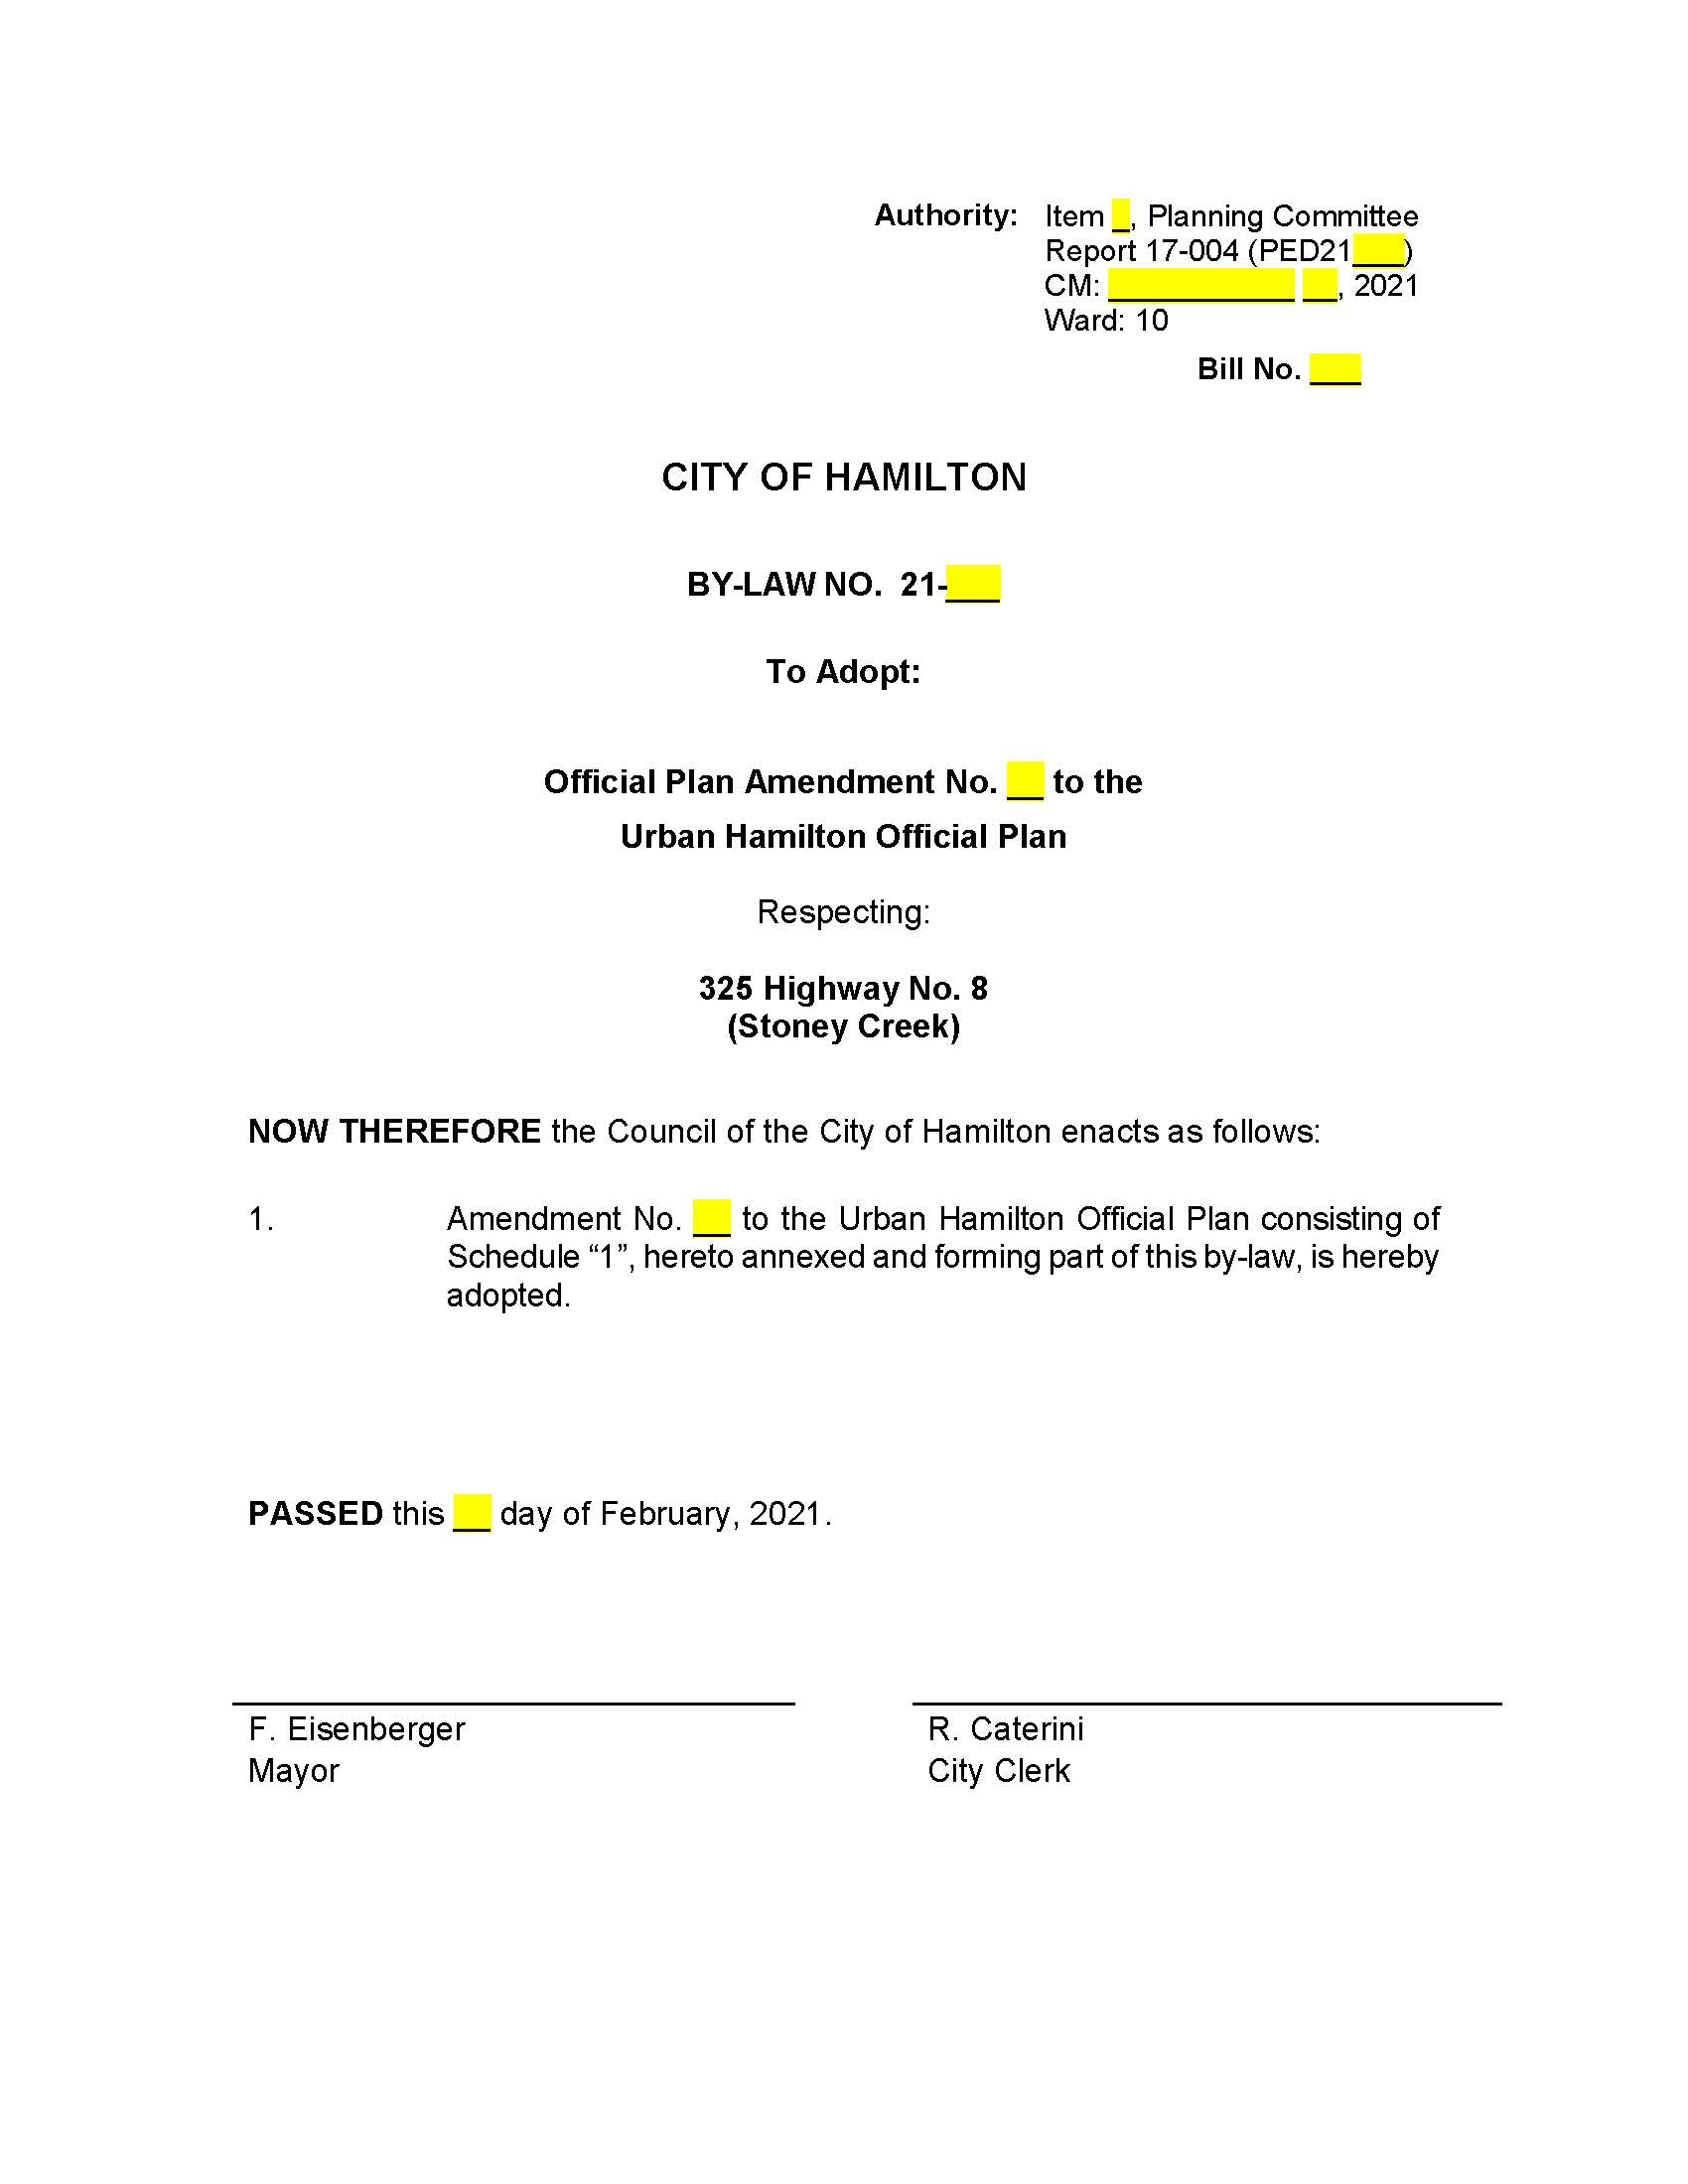
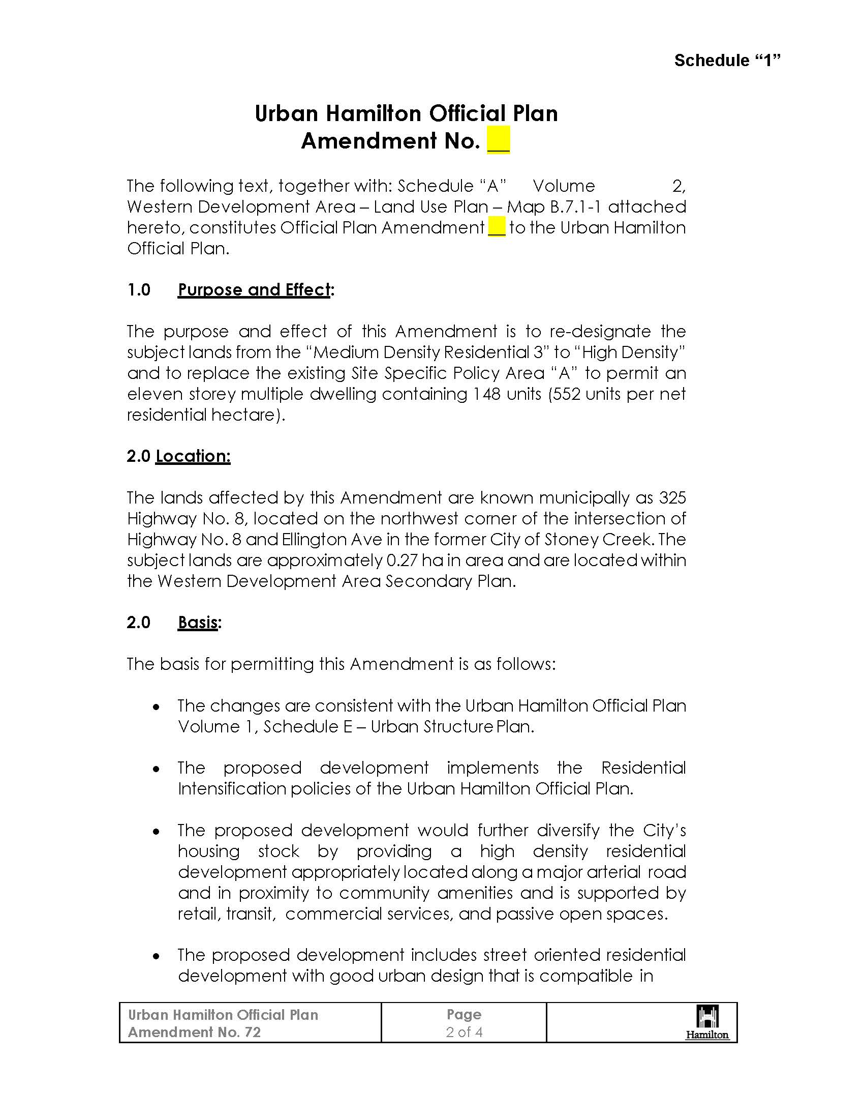
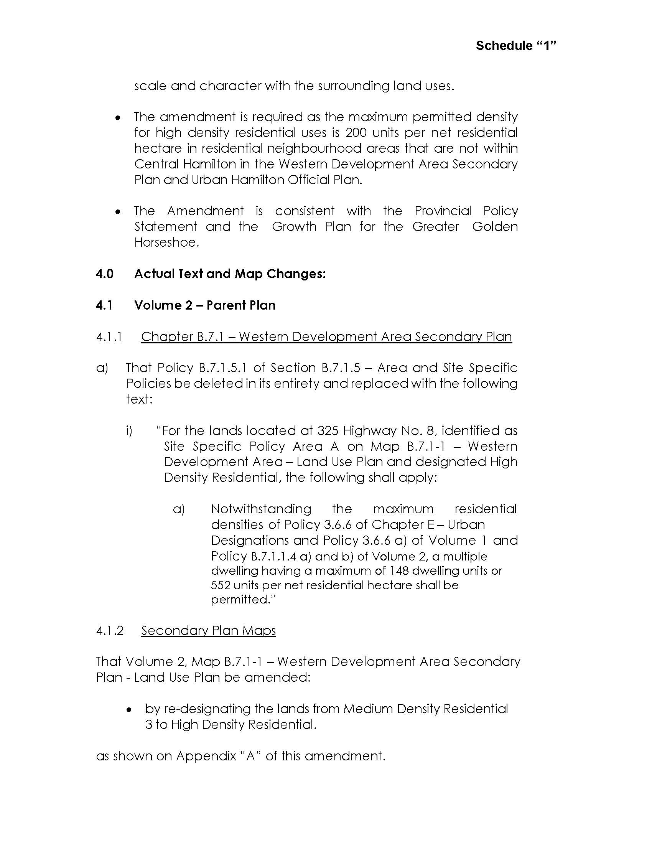
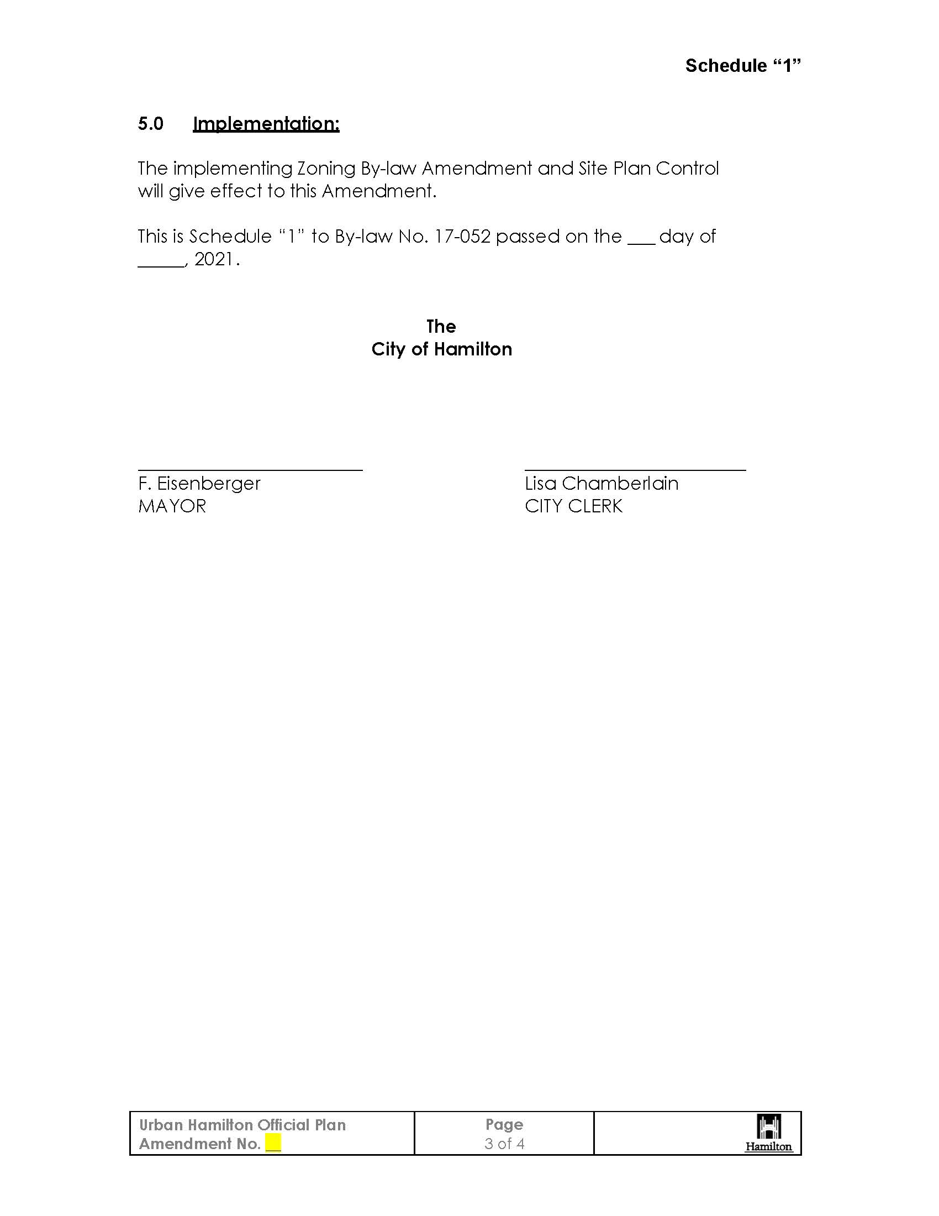
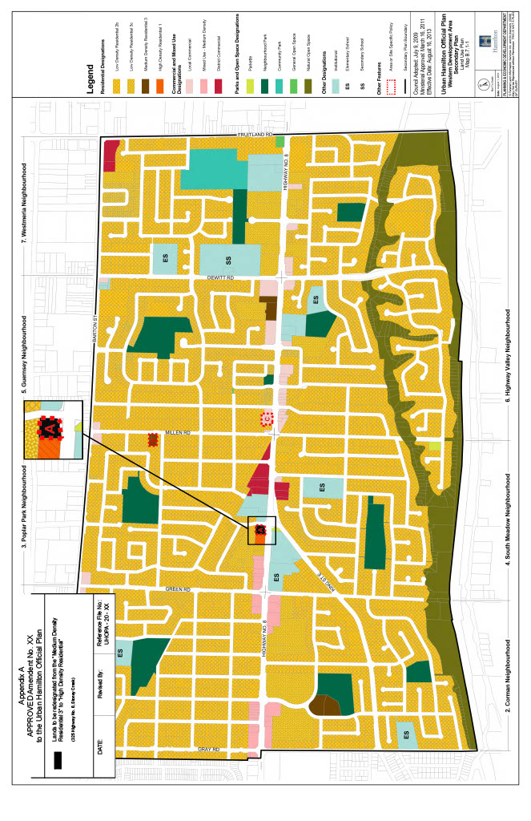
PL200458 – Attachment 2
