Ontario Land Tribunal
Tribunal ontarien de l’aménagement
du territoire

ISSUE DATE: | January 14, 2022 | CASE NO(S).: | PL210071

PROCEEDING COMMENCED UNDER subsection 22(7) of the Planning Act, R.S.O. 1990, c. P.13, as amended
Applicant and Appellant: | Cento Homes & Renovations Inc.
Subject: | Request to amend the Official Plan - Refusal of request by City of Hamilton
Existing Designation: | Institutional
Proposed Designated: | Medium Density Residential 3
Purpose: | To permit six townhouse dwellings
Property Address/Description: | 19 Dawson Avenue
Municipality: | City of Hamilton
Approval Authority File No.: | UHOPA-20-007
OLT Case No.: | PL210071
OLT File No.: | PL210071
OLT Case Name: | Cento Homes & Renovations Inc. v. Hamilton (City)
PROCEEDING COMMENCED UNDER subsection 34(11) of the Planning Act, R.S.O. 1990, c. P.13, as amended
Applicant and Appellant: | Cento Homes & Renovations Inc.
Subject: | Application to amend Zoning By-law No. 3692-92 - Refusal of Application by City of Hamilton
Existing Zoning: | Small Scale Institutional
Proposed Zoning: | Site Specific (To be determined)
Purpose: | To permit six townhouse dwellings
Property Address/Description: | 19 Dawson Avenue
Municipality: | City of Hamilton
Municipality File No.: | ZAC-20-012
OLT Case No.: | PL210071
OLT File No.: | PL210072

Heard: | November 8-10, 2021 by Video Hearing
APPEARANCES:
Parties | Counsel
Cento Homes & Renovations Inc. | Jennifer Meader
 | Meredith Baker
City of Hamilton | Aisling Flarity

DECISION DELIVERED BY JATINDER BHULLAR AND ORDER OF THE TRIBUNAL

INTRODUCTION

- This was a hearing conducted over two days. Cento Homes & Renovations Inc. (the “Applicant/Appellant”) owns a property located in the City of Hamilton (“City”), municipally known as 19 Dawson Avenue, Stoney Creek (the “subject property”). The Applicant/Appellant applied for approval of an Official Plan Amendment (“OPA”) and Zoning By-law Amendment (“ZBA”) to permit six street townhouse dwellings. The applications were refused.

- The Applicant/Appellant plans to develop the subject property by building five townhomes facing Dawson Avenue. On the opposite side along Dawson Avenue, Amica Development has townhouses with backyards overlooking Dawson Avenue. In general, on either side and behind the subject property, there exist detached dwellings mainly one or one-and-half-storeys in height.

- The requested OPA will designate the subject property from “Small Scale Institutional” to “Medium Density Residential 3”.

- The requested ZBA will amend Zoning By-law No. 3692-92 (“ZBL”) to permit development of the lands with residential townhouse dwellings based on Site Specific Exemption RM2-46, which includes a number of site specific regulations in order to implement the proposed development. This includes establishing a maximum building height of 11 metres and two-and-a-half storeys and establishing specific lot areas, frontages and setbacks.

- For reasons that follow, the Tribunal allows the Appeals and appropriately issues the included Tribunal Order in this Decision.

WITNESSES AND EXHIBITS

- The Applicant/Appellant called Andrea Sinclair, an urban designer and a registered professional planner, qualified by the Tribunal to provide expert opinion evidence in the area of urban design and land use planning. The Applicant/Appellant also called City’s land use planner, Shannon Mckie, under Tribunal issued subpoena. Ms. Mckie was qualified by the Tribunal to provide expert opinion evidence in the area of land use planning.

- The City called Allan Ramsay, a registered professional planner, qualified by the Tribunal to provide expert opinion evidence in the area of land use planning.

- The Tribunal received and marked the following ten exhibits for the record:

- Exhibit 1. Joint Document Book
- Exhibit 2. Visual Evidence of Applicant/Appellant
- Exhibit 3. Photographs of the City: Submitted by the City
- Exhibit 4. Visual Exhibits of the City
- Exhibit 5. Witness Statement of Andrea Sinclair
- Exhibit 5a. Reply Witness Statement: Andrea Sinclair
- Exhibit 6. Will Say: Statement of Shannon Mckie submitted by
the Applicant/Appellant
- Exhibit 7. Witness Statement of Allan Ramsay
- Exhibit 7a. Reply Witness Statement of Allan Ramsay
- Exhibit 8. Proposed OPA: Agreed statement of facts
- Exhibit 9. Proposed ZBA
- Exhibit 10. Excerpted Amica Approved ZBA

- The evidence presented by all witnesses were focussed on aspects of land use planning as in the Exhibits as well as the Municipal record on file. The parties have also previously agreed upon an issues list which formed part of the Procedural Order, which governed this Hearing.

EVIDENCE AND ANALYSIS

- Ms. Sinclair provided non-opinion based factual information about the subject property and its surroundings. She stated that the subject property consists of a 0.069 hectares (686.65 square metres) lot, which has ± 36.58 metres (120 feet) of frontage on Dawson Avenue and ± 19.05 metres (62.5 feet) of frontage on Passmore Street. She added that the subject property currently contains a vacant, two storey brick building, which was previously used as a Masonic Hall. The primary entrance to the existing building is accessed via Dawson Avenue. There is no parking on-site.

- Ms. Sinclair described the subject property context as follows:

North: Single detached dwellings on the north side of Passmore Street.

East: Townhomes on the opposite side of Dawson Avenue. The townhomes are part of a larger retirement development (Amica).

South: Single detached dwellings along Dawson Avenue. The Subject Property abuts the side lot line of one single detached dwelling.

West: Single detached dwellings located on Passmore Street. The Subject Property abuts lot line of one single detached dwelling.

- Ms. Sinclair provided details regarding the approvals requested from the City. She stated that the Applicant/Appellant sought a change in designation from existing “Small Scale Institutional” to “Medium Density Residential 3” in the City’s Official Plan (the “OP”) and sought to amend Zoning By-law No. 3692-92 to permit development of the lands with residential townhouse dwellings. Whereas originally the Applicant/Appellant planned to build six three storey tall townhomes, she stated that it was modified in dialog with City staff to five townhomes at two-and-a-half storey height each.

- In the testimony presented at the Hearing, Ms. Mckie supported the expressed testimony, the policy analysis and conclusions reached by Ms. Sinclair. She testified that the approval of the OPA and ZBA is appropriate as it reflected a final proposal that the Applicant/Appellant evolved to, in due consideration, with the planning inputs provided by the City planning staff.

The Planning Act (“Act”)

- The matters of provincial interest is identified for consideration as follows in the Issues List (“IL”);

- Does approval of the applications have regard to matters of provincial interest in section 2 of the Planning Act including the matters set out in sections 2(h), 2(n), 2(p) and 2(r) therein?

- Ms. Sinclair testified that in addressing s.2(h), the proposed development represents an orderly development of safe and healthy communities. She stated that with respect to the s. 2(n), the proposed development is a residential development in a residential area. She opined that this subsection relates to situations where conflicts may arise in terms of broader public interest and the proposed use. In reviewing s. 2(p), Ms. Sinclair testified that the proposed development is appropriate in terms of scale. She added that the current building represents an underutilization of the subject property and that the proposed development is compatible with the existing low density residential developments in the area. In reviewing the policy in subsection 2(r), Ms. Sinclair opined that the proposed built form for the townhomes and the associated site development encourage a sense of place and positively addresses the public streetscape. Ms. Sinclair also reviewed other sections and opined that the proposal and the requested OPA and ZBA have regard for the provincial interest as required under s. 2 of the Act.

- Mr. Ramsay testified that the proposal does not represent orderly development but rather over development. Mr. Ramsay also opined that the proposed development creates conflict with immediately adjacent properties. Mr. Ramsay acknowledged that the proposed development is an appropriate area for modest growth but not appropriate for the proposed extent of the growth. He testified there could be different configurations for lesser development. Mr. Ramsay stated that the proposed development will not provide for a sense of place and specially with reduced front and rear yard setbacks, which will not fit harmoniously with the adjacent neighbourhood properties.

- While evaluating the evidence of Ms. Sinclair and Mr. Ramsay, the Tribunal finds that Mr. Ramsay’s views of streetscape and sense of place ignore aspects of a mid-rise development as well as townhouses across the road from the subject property and other properties. The Tribunal finds that Ms. Sinclair used the appropriate lens in assessing the provincial interest within the reasonably appropriate scope of the neighbourhood as compared to Mr. Ramsay. The Tribunal relying on the evidence and comparative assessment of the opposing opinions finds that the proposed development addresses issue 1 appropriately and positively, and further , the proposed development has regard for the provincial interest as required under s. 2 of the Act.

Provincial Policy Statement 2020 (the “PPS”)

- The key PPS policies for consideration, in the contested evidence, were as follows:

Issue 2. Are the proposed Official Plan and Zoning By-law Amendments consistent with the Provincial Policy Statement, 2020? In particular, but not limited to the following policy sections:

  - Policy Sections 1.1.1, 1.1.3.2, 1.1.3.3 and 1.1.3.4 (Settlement Areas); and
  - Policy Section 4.6 (Implementation and Interpretation).

- In reviewing these policies, Ms. Sinclair opined that the proposed development provides for efficient use of infrastructure, allows for a range of uses, and provides for additional variety in housing choices. She added that the proposal will provide for compact built forms and is aligned in density and form with the surrounding developments including Amica. She testified that the proposed development would also use existing municipal services like water and sewer allowing for efficient use of the same.

- Ms. Sinclair concluded and opined that when all the applicable policies and those identified in Issue 2 are considered, the proposed development is consistent with the PPS.

- Mr. Ramsay testified that the proposed ZBA was not consistent with the Settlement Area policies of the PPS related to over development and the lack of consideration for existing building stock. He added that the proposal is not appropriate for an area considered as low-density.

- Based on the totality of evidence presented by Ms. Sinclair, the Tribunal finds that she has provided a wholesome analysis as required in consideration of the PPS as a whole. Ms. Sinclair’s evidence withstood cross-examination as well as contest offered by Mr. Ramsay’s evidence and the Tribunal thus finds that the proposed development is consistent with the PPS.

A Place to Grow: Growth Plan for the Greater Golden Horseshoe: 2020 Consolidation (the “Growth Plan”)

- The issue raised for consideration is as follows;

Issue 3: Are the proposed Official Plan and Zoning By-law Amendments in conformity with the A Place to Grow: Growth Plan for the Greater Golden Horseshoe, 2019? In particular, but not limited to the following policy sections:

  - Policy Section 1.2.1 (Guiding Principles);
  - Policy Section 2.2.1 (Managing Growth); and
  - Policy Section 5.2.5.8 (Implementation and Interpretation).

- Ms. Sinclair stated that, and Mr. Ramsay concurred that there was no contest of opinions between the two experts regarding the conformity of the proposed development with the Growth Plan.
- Ms. Sinclair highlighted key aspects of the proposed development and stated that it is situated within the area of built up boundaries, it contributes towards a target of 50% growth in built up areas, and it also conforms to housing policies in s. 2 of the Growth Plan.

- Ms. Sinclair concluded that the proposal conforms with the Growth Plan.

Urban Hamilton Official Plan, September 2013 (“UHOP”)

- The UHOP consideration was driven in part by Issues 4, 6, 9, 10 and 12 as follows;

Issue 4: Is the proposed Zoning By-law Amendment in conformity with the Urban Hamilton Official Plan (Volume 1)? In particular, but not limited to the following policy sections:

- Policy B.2.4.1.4 and Policy 2.4.2.1 (Residential Intensification)
- Policy B.3.3.1 (Urban Design Goals), Policy B.3.3.2.3 and B.3.3.2.6 (Principles), B.3.3.3 (Built Form)
- Policy E.1.0 (Goals)
- Policy E.2.1 (Urban Structure Principles)
- Policy E.2.6 (Neighbourhoods), E.2.6.7 (Scale)
- Policy E.3.0 (Neighbourhood Designation), E.3.1.4 - E.3.1.5 (Policy Goals)
- Policy E.3.2.4, E.3.2.7 and E.3.2.13 (Scale and Design)
- Policy E.3.3.2 (Residential Uses-General Policies)
- Policy E.3.5.9 (Medium Density-Design)

Issue 6: Does the Official Plan and Zoning By-law Amendments authorize an appropriate level of density and intensification for the subject lands?

Issue 10: Does the proposed Zoning By-law Amendment sufficiently regulate matters of built form including lot size, height, density, massing, scale, setbacks, lot coverage and landscaping having regard for the site, adjacent property and the character of the surrounding lands?

Issue 12: Does the proposed development maintain and enhance the established character of the area?

- In reference to Policies B.2.4.1.4 and B.2.4.2.1, Ms. Sinclair opined that the proposed development is in the “Neighbourhoods” urban structure element and this is where intensification is encouraged by the UHOP policies. Ms. Sinclair stated that residential intensification is further required to have consideration for a number of evaluation criteria. Among these criteria, Ms. Sinclair enumerated that the following are conformed with;

b) the relationship of the proposal to existing neighbourhood character so that it maintains, and where possible, enhances and builds upon desirable established patterns and built form;

d) the compatible integration of the development with the surrounding area in terms of use, scale, form and character. In this regard, the City encourages the use of innovative and creative urban design techniques;

- These two criteria were the focus of opposing planning opinions by Ms. Sinclair and Mr. Ramsay. The points raised led to evidence on neighbourhood character, established patterns and compatible integration with surrounding areas in terms of use, scale, form and character.

- Ms. Sinclair testified that the neighbourhood contains a variety of land uses. She added that the predominant form of housing is low-rise, ground oriented dwellings oriented towards public streets. She opined that the proposed development conforms to this general character in the form of low rise townhomes, individual driveways and orientation towards Dawson Avenue. She also described that on the opposite side of the street, the townhomes located in the Amica development already exist. She stated that these Amica townhomes have their front enclosed internally within the private property away from the Dawson Avenue.

- Ms. Sinclair specifically cited that the proposed development is for a maximum height of two-and-a-half storeys, which is compatible with surrounding houses which range from one to two storeys. She stated that the OP as well the applicable ZBL allow the proposed height in houses. She further added that density and level of intensification are within the policy limits and are also appropriate based on the immediate as well as extended neighbourhood context.

- Mr. Ramsay disagreed with Ms. Sinclair and stated that the neighbourhood character is defined by generally lower height from one or one-and-a-half storey bungalows or similar homes. He added that additionally the immediate neighbourhood is characterized by generous landscaped front yards with houses set well back from the streets like Dawson Avenue.

- Mr. Ramsay further focused his testimony upon the amendments sought by the Applicant/Appellant. Through his witness statement (Exhibit 7, Appendix 4), Mr. Ramsay shared a variety of statistical data tables to show by considering front yard setbacks, rear yard setbacks, minimum corner lot area, minimum end lot area, minimum interior lot area, minimum side yards, size of lot versus built up area, the side yard setback, sample lot depths and zoning regulation analysis. Whereas most of these tables (Exhibit 7, Appendix 4) when considered individually showed that the proposed development parameters were in the lower end of preferrable range when considered one at a time for the properties enumerated by Mr. Ramsay. However, Mr. Ramsay admitted that he has not done a balanced view of each of the properties to compare for a like for like total proposal comparison.

- During cross-examination, Mr. Ramsay further admitted that true analysis would have required a balanced, albeit very complex and very difficult exercise to carry out when comparing the proposed development as a whole against other alike developments enumerated in his statistical tables. Under cross-examination, Mr. Ramsay further acknowledged that his analysis in Table 8 (Exhibit 7, pages 50 and 51) also did not account for permitted other parameters that could have been allowed for.

- The Tribunal finds that Mr. Ramsay’s analysis, which was heavily based on his statistical presentation, is fundamentally flawed as any development requires a balanced review of all parameters of development to establish if it represents good planning or not and if its conformity is in a form complimentary to the planning documents when considered as a whole. Mr. Ramsay has not shown that the proposal does not comply with density parameters or intensification policies whereas Ms. Sinclair has positively established the same.

- The matter of Issue 9 was addressed by Mr. Ramsay as a significant concern. The issue is identified as follows;

Issue 9: Does the proposed development create adverse impacts related to privacy and overlook?

- Mr. Ramsay testified that there will be adverse impacts upon people using Dawson Avenue. He stated that with the proposed front balconies and reduced front yard setbacks versus properties of many nearby neighbours, people would feel uncomfortable due to overlook and feel their privacy being impacted.

- Ms. Sinclair testified that the newer urban designs encourage livening up the streets where the dwellings and other uses are encouraged to provide presence to the street. Ms. Sinclair further added that such presence leads to a sense of neighbourhood and safety.

- During questioning, Mr. Ramsay admitted that he was not qualified to provide assessment regarding possible psychological impacts and the degree to such would come into play. Mr. Ramsay, when asked how a private property could impact a public road in terms of overlook, he admitted that he can not qualify that. Mr. Ramsay during questioning also confirmed that there are no sidewalks on either side of Dawson Avenue fronting the subject property or the properties of adjacent neighbours.

- The Tribunal having reviewed the testimonies of Ms. Sinclair and Mr. Ramsay finds that there would be no negative impacts vis-a-vis privacy and overlook.

- Ms. Sinclair as an urban planner opined that the front of the townhomes with recessed garages and road facing balconies with setback compliant front yards, represents conformity with the neighbourhood in terms of use, scale, form and character. Ms. Sinclair considered urban design aspects in the UHOP through the lens of applicable policies in sections within Policy B.3.3 as well as in Policies E.1 through E.3. She highlighted considerations for medium density development, landscaping, the townhomes with eyes on the street and there being no planned front surface parking lots proposed.

- Issue number 5 further demands consideration with respect to the Old Towne Secondary Plan (“the “OTSP”) among other in the UHOP. This issue is as follows;

Issue 5: Is the proposed Zoning By-law Amendment in conformity with the Old Town Secondary Plan of the Urban Hamilton Official Plan (Volume 2)? In particular, but not limited to the following policy section:

- Policy B.7.2.1.3 (General Policies); and
- Policy B.7.2.2.3 (Medium Density Residential 3 Designation).

Issue 7: Does the proposed development provide for an appropriate streetscape?

- Ms. Sinclair opined that the proposed development would help maintain the viability of the Stoney Creek by creating more efficient and greater use of an underutilized site. Mr. Ramsay contested that the proposal takes away an institutional designated site and depletes this particular use with respect to the secondary plan preferred uses. Ms. Sinclair stated that the site has stayed vacant and unused even though in the past the building was used to host some community activities as arranged with the private institutional owner. Ms. Sinclair opined that in regard to policy 7.2.2.3 in OTSP, there is compliant front yards for landscaping, parking is in garages with driveways and the density is within the maximum permitted of 99 units per residential hectare. Ms. Sinclair concluded that the proposed development conforms with the OTSP as contained in the UHOP.

- An issue raised by the City related to adequate provisioning of amenity area in the proposed development. This issue was defined as follows;

Issue 8: Does the proposed development provide for an appropriate amount of amenity area?

- Mr. Ramsay opined that a proposed swale to be used for stormwater routing and discharge in the rear yards will cause a reduction in the possible amenity area provisioned for each dwelling. Ms. Sinclair stated that such areas are not excluded from the establishment or determination of amenity area conformance. Mr. Ramsay during cross-examination concurred that indeed such areas are not excluded from amenity area designation. As a result, the assertion by Ms. Sinclair that the proposal provides for required amenity areas was affirmed.

- As such the Tribunal finds that the Applicant/Appellant has positively and suitably addressed the issue and that the proposal provides for appropriate amenity area for each of the dwelling units.

- Having considered the evidence of all the UHOP and ZBL centric issues, the Tribunal finds that the Applicant/Appellant has positively addressed all of the City’s issues and further provided confirmation of the proposed development’s conformity with the UHOP. The Tribunal thus based on the analysis above and the totality of evidence before it finds that the proposed development conforms with the UHOP.

Possible Future Consents

- The matter of possible future consents that may be needed to implement the development, was raised by the City as Issue 12 as follows;

Issue 11: Does the proposed development, which is to be implemented through future consent applications, have sufficient regard for Section 51(24) of the Planning Act?

- The Applicant/Appellant submitted that s. 51(24) matter is not before the Tribunal in these appeals. Mr. Ramsay submitted that since the OPA and ZBA would set up a framework for such future activities that sufficient regard needs to be had for s. 51(24) provisions.

- The Tribunal noting that no consent application is before it and neither are there any consents defined or delimited in the appeal before this panel, the matters of s. 51(24) are more appropriately addressed as and when such applications are files by the Applicant/Appellant for consideration and approvals by the City.

Good Land Use Planning

- This aspect was raised by the City as the following issue;

Issue 13: Does the proposed development represent good land use planning and is it in the public interest?

- Ms. Sinclair opined that the Applicant/Appellant has duly considered the provincial interest, the PPS, and the Growth Plan and shown conformity with the UHOP. She added that the proposed development is welcome intensification which takes an unused non-descript windowless building and updates the site with modern urban design based development that adds to a mix of housing choices. She stated that the public interest is served as the proposed development will add to housing supply while making efficient use of existing municipal services.

- Mr. Ramsay countered that it is overdevelopment that does not fit with immediate context or the neighbourhood.

- The Tribunal having determined that the Applicant/Appellant proposal has positively and satisfactorily addressed issues 1 through issue 12 finds that the opinions expressed, and assertions made by Ms. Sinclair are appropriate. Thus, in consideration of all the evidence before it the Tribunal concludes that the proposed development represents good land use planning and is in the public interest.

- In conclusion regarding the requested OPA, the Tribunal determines that the requested OPA has regard for the provincial interest, is consistent with the PPS, conforms with the Growth Plan and represents good planning and is in the public interest.

- In conclusion regarding the requested ZBA, the Tribunal determines that the ZBA has regard for the provincial interest, is consistent with the PPS, conforms with the Growth Plan and the UHOP, and represents an appropriate use of the subject property and represents good land use planning.

ORDER

- The Tribunal allows the appeal in part and the Urban Hamilton Official Plan of the City of Hamilton is amended as set out in attached Schedule “A” to this Order.

- The Tribunal allows the appeal in part, and Zoning By-law No. 3692-92 (Stoney Creek) of the City of Hamilton is amended as set out in attached Schedule “B” to this Order.

- The site plan application submitted to the City of Hamilton for approval shall be in general conformity with the conceptual site plan and elevation drawings which are attached as Schedules “C” and “D” to this Order.

“Jatinder Bhullar”

jatinder bhullar
MEMBER

Ontario Land Tribunal
Website: olt.gov.on.ca Telephone: 416-212-6349 Toll Free: 1-866-448-2248

The Conservation Review Board, the Environmental Review Tribunal, the Local Planning Appeal Tribunal and the Mining and Lands Tribunal are amalgamated and continued as the Ontario Land Tribunal (“Tribunal”). Any reference to the preceding tribunals or the former Ontario Municipal Board is deemed to be a reference to the Tribunal.
SCHEDULE A

DRAFT Urban Hamilton Official Plan Amendment No. XX

The following text, together with Appendix “A” – Volume 2, Map B.7.2.1 – Old Town Secondary Plan – Land Use Plan attached hereto, constitutes Official Plan Amendment No. xxx to the Urban Hamilton Official Plan.

1.0 Purpose and Effect:

The purpose and effect of this Amendment is to redesignate lands and establish a Site Specific Policy within the Old Town Secondary Plan to permit the development of five street townhouses.

2.0 Location:

The lands affected by this Amendment are known municipally as 19 Dawson Ave, in the former City of Stoney Creek.

3.0 Basis:

The basis for permitting this Amendment is as follows:

- The proposed development supports the residential intensification policies of the Urban Hamilton Official Plan and assists in the creation of an active and vibrant pedestrian realm;

- The proposed development is compatible with the existing and planned development in the area; and,

- The Amendment is consistent with the Provincial Policy Statement, 2020 and conforms to the Growth Plan for the Greater Golden Horseshoe, 2020, as Amended.

  - Actual Changes:

  - Volume 2 – Secondary Plans

Text

    - Chapter B.7 – Stoney Creek Secondary Plans – Section B.7.2 – Old Town Secondary Plan

a. That Volume 2, Chapter B.7 – Stoney Creek Secondary Plans, Section B.7.2 – Old Town Secondary Plan be amended by adding a new Site Specific Policy, as follows:

“Site Specific Policy – Area “X”

B.7.2.8.X For the lands located at 19 Dawson Avenue, Stoney Creek, designated Medium Density Residential 3, and identified as Site Specific Policy – Area “X” on Map B.7.2-1 – Old Town Secondary Plan – Land Use Plan, the following policies shall apply:

Maps
- Notwithstanding Policy E.3.5.2 and E.3.5.3 of Volume 1 and Policy B.7.2.2.3 b) of Volume 2, only street townhouses shall be permitted;

- Notwithstanding Policy E.3.5.7 of Volume 1, and Policy
B.7.2.2.3 a) of Volume 2, the density range shall be from 30 to 73 units per net residential hectare; and,

- Notwithstanding Policy E.3.5.8 of Volume 1, building height shall not exceed two and a half storeys.”

4.2.2 Map

a. That Volume 2, Map B.7.2-1 – Old Town Secondary Plan – Land Use Plan be amended by:

- Redesignating the subject lands from “Institutional” to “Medium Density Residential 3”; and,

- identifying the subject lands as Site Specific Policy – Area “X” as shown on Schedule “A” to this Amendment.

5.0 Implementation:

An implementing Zoning By-Law Amendment and Site Plan will give effect to the intended uses on the subject lands.

This Official Plan Amendment is Schedule “1” to By-law No. passed on the ______ of __________________, 2022

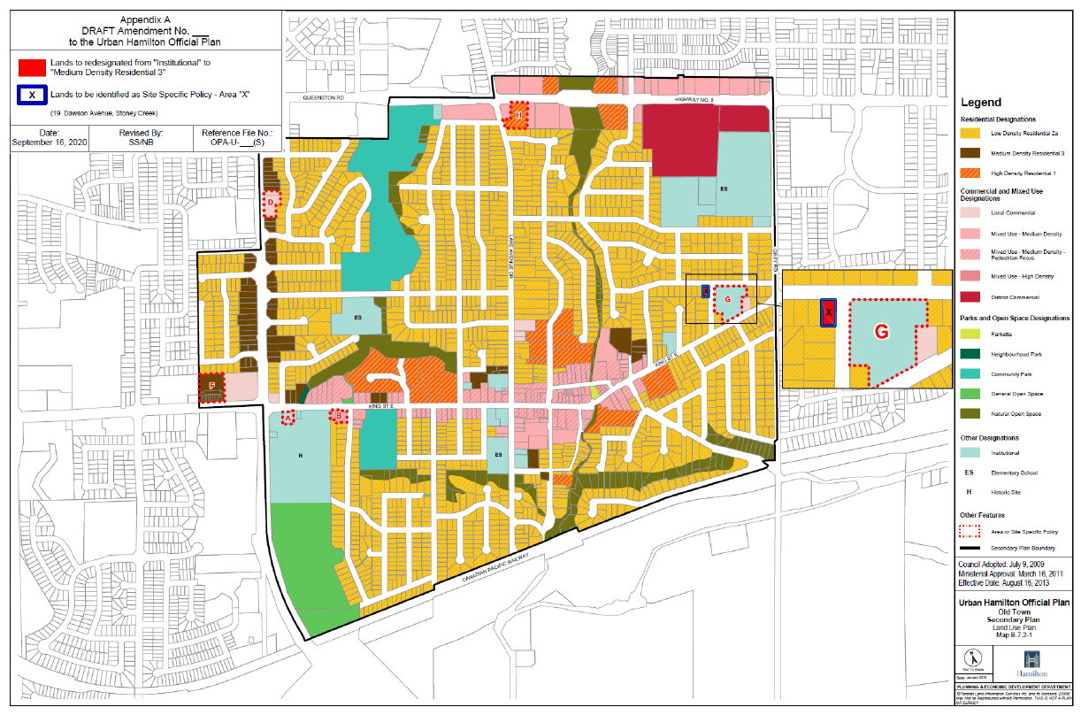
SCHEDULE B

CITY OF HAMILTON

BY-LAW NO.

To Amend Zoning By-law No. 3692-92 (Stoney Creek)
Respecting Lands located at 19 Dawson Avenue, Stoney Creek

WHEREAS the City of Hamilton Act, 1999, Statutes of Ontario, 1999 Chap. 14, Schedule
C. did incorporate, as of January 1, 2001, the municipality “City of Hamilton”;

AND WHEREAS the City of Hamilton is the successor to certain area municipalities, including the former municipality known as the “The Corporation of the City of Stoney Creek” and is the successor to the former regional municipality, namely, “The Regional Municipality of Hamilton-Wentworth”;

AND WHEREAS the City of Hamilton Act, 1999 provides that the Zoning By-laws and Official Plans of the former area municipalities and the Official Plan of the former regional municipality continue in full force in the City of Hamilton until subsequently amended or repealed by the Council of the City of Hamilton;

AND WHEREAS Zoning By-law No. 3692-92 (Stoney Creek) was enacted on the 8th day of December, 1992, and approved by the Ontario Municipal Board on the 31st day of May, 1994;

AND WHEREAS the Council of the City of Hamilton, in adopting Item of Report 20- 195 of the Planning Committee, at its meeting held on the 3rd day of November 2020, recommended that Zoning By-law No. 3692-92 (Stoney Creek), be amended as hereinafter provided; and,

AND WHEREAS this By-law will be in conformity with the Urban Hamilton Official Plan upon the approval of Official Plan Amendment No.

NOW THEREFORE the Council of the City of Hamilton enacts as follows:

- That Map No. 5 of Schedule “A”, appended to and forming part of Zoning By- law No. 3692-92 (Stoney Creek), is amended by changing the zoning from Small Scale Institutional “IS” Zone to Multiple Residential “RM2-46” Zone, the extent and boundaries of which are shown on a plan hereto annexed as Schedule “A”.

- That Subsection 6.9.6 Special Exemptions of Section 6.9, Multiple Residential “RM2” Zone, of Zoning By-law No. 3692-92 (Stoney Creek) be amended by adding Special Exemption “RM2-46”, as follows:

“RM2-46” 19 Dawson Avenue, Schedule “A” Map No. 5

Notwithstanding the provisions of Paragraphs (a), (b), (c), (d), and (e) of Subsection 6.9.3 of Section 6.9, Multiple Residential “RM2” Zone, on those lands zoned “RM2-46” by this By-law, the following shall apply:

(a) | Minimum Lot Area:
 | Interior Unit | 123 square metres
 | End Unit | 150 square metres
 | Corner Unit | 158 square metres
(b) | Minimum Lot Frontage:
 | Interior Unit | 6.0 metres
 | End Unit | 8.0 metres
 | Corner Unit | 8.9 metres
(c) | Minimum Front Yard: | 3.0 metres to the main wall of building or a porch and 6.0 metres to an attached garage.
(d) | Minimum Side Yard:
 | End Unit | 2.0 metres
 | Corner Unit | 2.28 metres
(e) | Minimum Rear Yard: | 5.33 metres
(h) | Maximum Building Height | 11 metres and 2½ storeys

For the purposes of this by-law, “Storey-One-Half” means the portion of the building situated wholly or in part within the roof and having its floor level not less than 1.2 metres below the line where the roof and outer wall meet and in which there is sufficient space to provide distance between finished floor and finished ceiling of at least 2 metres over a floor area equal to at least 50 percent of the area of the floor next below. The total dormer wall length shall not exceed 55% of the total wall length at roof along which the dormers are located.

Notwithstanding Section 4.13.1, a minimum setback of 1.3 metres from the hypotenuse of the daylight triangle shall be permitted.

Notwithstanding Section 4.19.1, balconies shall not be permitted within the rear yard of the townhouse development.

3. No building or structure shall be erected, altered, extended or enlarged, nor shall any building or structure or part thereof be used, nor shall any land be used, except in accordance with the Multiple Residential “RM2” Zone provisions, subject to the special requirements referred to in Section 2 of this
By-law.

4. That the Clerk is hereby authorized and directed to proceed with the giving of notice of the passing of this By-law, in accordance with the Planning Act.

PASSED and ENACTED this day of , 2022.

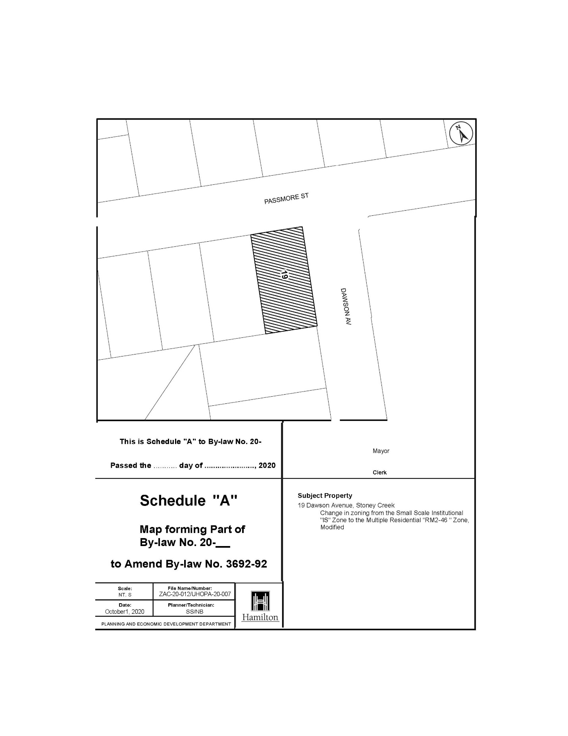

SCHEDULE C

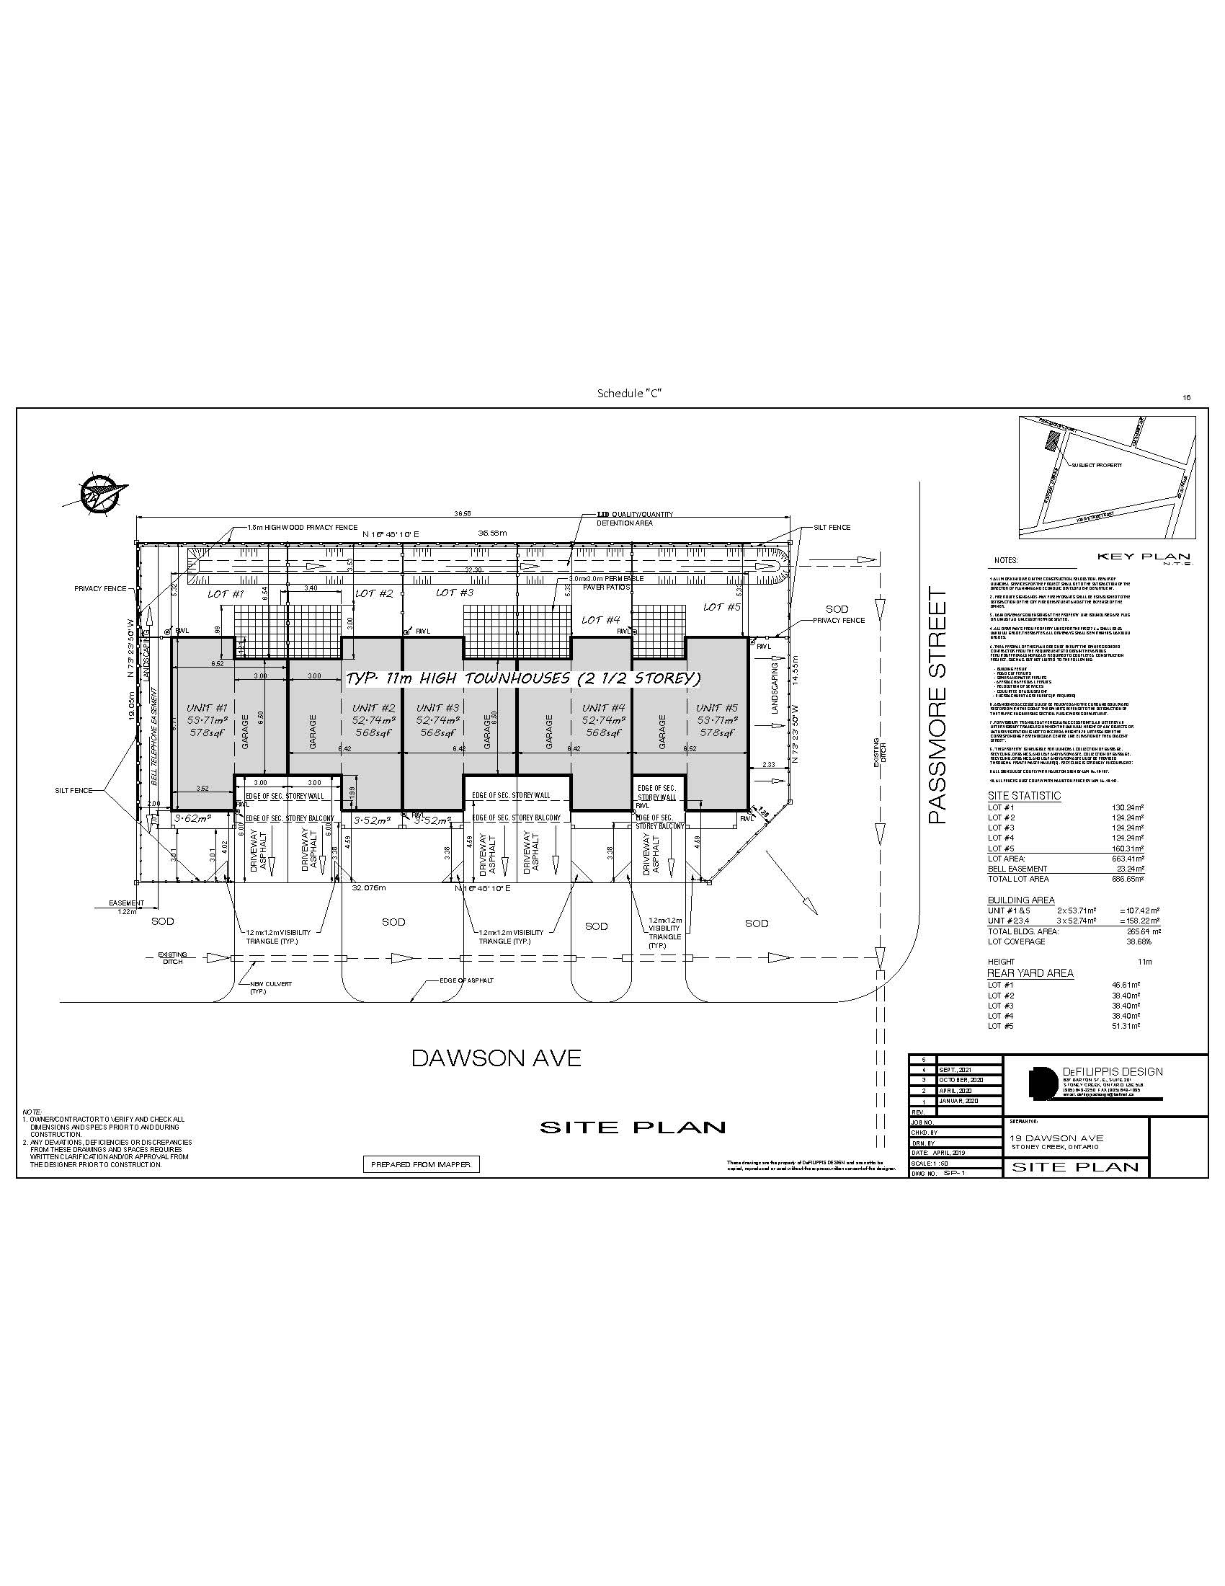

SCHEDULE D

